**Online Auction System**



**Team ID-CSFP-21-01-30**

**Session: BSCS 2015-2019**

**Project Advisor: Sir Hassan Shabir Gilani**

**Submitted By:**

Hadi Zulfiqar 19942

Hafiz Shah Nawaz 19983

Zain Arif Babu 20194

University of South Asia

Department of Computer Science

**STATEMENT OF ACCEPTANCE**

This is to certify that Hafiz Shah Nawaz Roll No. (B-19983), Hadi Zulfiqar Roll. No (B-19942) and Zain Arif Babu Roll No. (B-20194) have successfully completed the final Year Project named as: Online Auction System, at University of South Asia to fulfill the partial requirement of the degree of BS in Computer Science.

**Project ID-CSFP-21-01-30**

**Online Auction System**

Sir Hassan Shabir Gilani Sir Masroor Hussain

Project Primary Adviser Projects’ Convener Department of Computer Science Department of Computer Science University of South Asia. University of South Asia.

_____________________

Sir Ilyas Butt

HOD. Department of Computer Science.

University of South Asia.

## Proofreading Certificate

## It is to certify that I have read the document meticulously and circumspectly. I am convinced that the resultant project does not contain any spelling, punctuation or grammatical mistakes as such. All in all I find this document well organized and I am in no doubt that its objectives have been successfully met.

## _____________________

Sir Hassan Shabir Gilani

Project Primary Adviser

University of South Asia Lahore.

**Acknowledgement**

We give thanks and praises to **Allah** (SWT) for the successful completion of this work, as it is only by His might that all conceived ideas of men are possible and realizable. Likewise, I am eternally grateful to my parents for their care and support.

We truly acknowledge the cooperation and help make by **Sir. Hassan Shabiar Gilani** Lecturer at University of South Asia, for the completion of our project and many persons directly or indirectly assisted me. He has been a constant source of guidance throughout the course of this project. We are also thankful to the fellows who provided us a friendly and knowledgeable environment through which we learned a lot.

1- Hadi Zulfiqar

2- Hafiz Shah Nawaz

3- Zain Arif Babu

**Date:**

August 2021

**Project Abstract**

We are developing “Online Auction System” which will help to improve the traditional Auction system. It will cover all the aspects related to the auctions and bidding.

Our project is a web and android based application, which will provide these facilities given below:

• Auction

• Bidding

• Auction Management

This Product is also for organization Employees to maintain records, keep data of auctions, create reports of auctioneer and bidder, handle multiple auctions at same time conduct multiple auctions, get feedbacks and complaints of system users, and management and progress report generation of the user and organization.

Table of Contents

Chapter 01 : Introduction 1

1. Introduction 2

1.1 Project/Product Feasibility Report 2

1.1.1 Technical Feasibility 2

1.1.2 Operational Feasibility 2

1.1.3 Economic Feasibility 2

1.1.4 Schedule Feasibility 2

1.1.5 Specification Feasibility 3

1.1.6 Information Feasibility 3

1.1.7 Motivational Feasibility 3

1.1.8 Legal & Ethical Feasibility 3

Chapter 02 : Project Scope 4

1.2 Project Scope 5

1.2.1 Project Methodology 5

1.2.3 Architecture 6

1.2.4 Milestones 7

1.2.5 Project Deliverables 7

1.2.6 Project Type 7

Chapter 03 : Product Scope 8

1.3 Product Scope 9

1.3.1 Product Features 10

1.3.2 Product deliverables and Sub Deliverables 11

1. Android Application 11

2. Website 13

1.3.3 Product Modules 16

Chapter 04 : Cost Estimation 18

1.4 Project/Product Costing 19

1.4.1 Project Cost Estimation by Function Point Analysis (FPA): 19

1.4.2 Value Adjustment Factor (VAF) 21

1.4.3 Adjusted Value Adjustment Factor (AVAF) 22

1.5 Project Cost Estimation by using COCOMO 23

1.5.1 Project Effort (Man Months) 23

1.5.2 Development Time 24

1.5.3 Team Members 24

1.5.4 Development Cost 24

Chapter 05 : CPM (Critical Path Method) 25

1.6 CPM-Critical Path Method 26

1.6.1 Work Breakdown Structure 26

1.6.2 Chart of Activity (PERT) 29

1.6.3 Activity Chart 30

1.6.4 Activity Network Diagram 31

1.6.5 Critical Path Network Diagram 33

1.6.5 Critical Paths 34

1.6.6 Gantt Chart 35

Chapter 06 : Team Intro 36

1.7 Introduction to Team member and their skill set 37

Chapter 07 : Tools and Technology 38

1.8 Tools and Technology with reasoning 39

Chapter 08 : Vision Document 41

1.9 Vision Document 42

1.9.1 Purpose 42

1.9.2 Scope 42

1.9.3 Advantage of online auction system for organization 42

1.9.4 Problem Statement 43

1.9.5 Product Position Statement 43

1.9.6 User Summary 44

1.9.7 User Profile 44

1.9.8 Key Users’ Needs 45

1.9.10 Product features 46

1.9.11 Features’ Priority 46

1.10 Other Product Requirements 47

a) Application Standard 47

b) Hardware and software specification 47

c) Performance Requirements 47

d) Environmental Requirements 47

1.10.1 Documentation Requirement 47

Chapter09 : Requirement Analysis 48

1. Introduction 49

1.1 System Specification 49

1.2 Identifying External Actors 56

1.3 Capture “Shall” Statement 57

1.4 Allocate Requirements 60

1.5 Priorities requirement 62

1.6 Requirement Traceability Matrix 65

Chapter 09 : High Level Use-Cases 68

1.7 High Level Use Case Diagram 69

Chapter 10 : Use Cases and Sequence Diagrams 73

2. Use Case Diagrams and Description 74

2.1 UC_Login 74

2.2 UC_Add_Employee 75

2.3 UC_View_Employee 76

2.4 UC_Update_Employee 77

2.5 UC_Search_Employee 78

2.6 UC-Delete_Employee 79

2.7 UC-User_SignUp 80

2.8 UC-Add_User 81

2.9 UC-Add_Auction 82

2.10 UC-View_User_Record 83

2.11 UC-View_User_Data 84

2.12 UC-Update_Auction 85

2.13 UC-Delete_User_Data 86

2.14 UC-View_User_Dashboard 87

2.15 UC-Generate_Report 88

2.16 UC-Generate_Organization_Report 89

2.17 UC_Generate_User_report 90

2.18 UC-Manage_Feedback 91

2.19 UC-Verify_User 92

2.20 UC-Add_Auctioneer 93

2.21 UC-Add_Bidder 94

2.22 UC-Update_Auctioneer_Record 95

2.23 UC-View_Auctioneer_Record 96

2.24 UC-Delete_Customer_Record 97

2.25 UC-Start_User_Auction 98

2.26 UC-View_Customer_Reports 99

2.27 UC-Respond_Verification_Request 100

2.28 UC-View_block_User 101

2.29 UC-Add_User_To_Block 102

2.30 UC-Delete_Block_User 103

2.31 UC-Unblock_User 104

2.32 UC-Admin_Generate_Report 105

2.33 UC-View_Auctioneer 106

2.34 UC-Auctioneer_Auction 107

2.35 UC-Auction_Location 108

2.36 UC-Add_Auction_Time 109

2.37 UC-Request_Report 110

2.38 UC-Auction_Picture_Post 111

2.39 UC-Select_Location 112

2.40 UC-View_Auction_Categories 113

2.41 UC_View_Location_Vise 114

2.42 UC_Select_Auction 115

2.43 UC-View_selected_Auction 116

2.44 UC-Bid_On_Auction 117

2.45 UC-Withdraw_Bid 118

2.46 UC-View_Auction_start_Time 119

2.47 UC-View_Auctioneer_Profile 120

2.48 UC-Win_Auction 121

2.49 UC-Update_Profile 122

2.50 UC-View_Support 123

2.51 UC-Request_Bidder_Report 124

2.52 UC-View_Winning_Auction 125

2.53 UC-View_Bids 126

2.54 UC-Manager_Auction_Start 127

2.55 UC-Offer_To_Bid_Winner 128

2.56 UC-View_Bidder_Profile 129

2.57 UC-Give_Rating_To_Seller 130

2.58 UC-Give_Rating_To_Buyer 131

3. Sequence Diagrams 132

3.1 SD-Login 132

3.2 SD-Add_Employee 136

3.3 SD-View_Employee 137

3.4 SD-Update_Employee 138

3.5 SD-Search_Employee 139

3.6 SD-Delete_Employee 140

3.7 SD-SignUp 141

3.8 SD-Add_User 142

3.9 SD-Add_Auction 143

3.10 SD-View_User_Record 144

3.11 SD-View_User_Data 145

3.12 SD-Update_Auction 146

3.13 SD-Delete_User 147

3.14 SD-View_dashboard 148

3.15 SD-Generate_Report 149

3.16 SD-Generate_organization_report 150

3.17 SD-Generate_User_Report 151

3.18 SD-Manage_Feedback 152

3.19 SD-Verify_User 153

3.20 SD-Add_Auctioneer 154

3.21 SD-Add_Bidder 155

3.22 SD-View_Auctioneer_Record 156

3.23 SD-Update_Auctioneer_Record 157

3.24 SD-Delete_Customer_Record 158

3.25 SD-Add_Auction 159

3.26 SD-View_Customer_Report 160

3.27 SD-Respond_Verification_Request 161

3.28 SD-View_Block_User 162

3.29 SD-Add_User_To_Block 163

3.30 SD-Delete_Block_User 164

3.31 SD-UnBlock_User 165

3.32 SD-Admin_Generate_Report 166

3.33 SD-View_Categories 167

3.34 SD-Auctioneer_Auction 168

3.35 SD-Auction_Location 169

3.36 SD-Add_Auction_Time 169

3.37 SD-Request_Report 170

3.38 SD-Auction_Picture_Post 170

3.39 SD-Select_location 171

3.40 SD-View_Auction_Categories 171

3.41 SD-View_Location_Vise 172

3.42 SD-Select_Auction 173

3.43 SD-View_Selected_Auction 173

3.44 SD-Bid_On_Selected_Auction 174

3.45 SD-Withdraw_Bid 175

3.46 SD-View_Auction_Time 176

3.47 SD-View_Auctioneer_Profile 177

3.48 SD-Win_Auction 178

3.49 SD-Update_Profile 179

3.50 SD-View_Support 180

3.51 SD-Bidder_Request_Report 181

3.52 SD-View_Winning_Auction 181

3.53 SD-View_Bids 182

3.54 SD-Offer_To_Winner 183

3.55 SD-View_Bidder_Profile 184

3.56 SD-Manager_Auction_start 185

3.57 SD-Give_Rating_To_Seller 186

3.58 SD-Give_Rating_To_buyer 187

Chapter 11 : Class Diagrams 188

4. Class Diagram 189

4.1 Class Diagram Auction 189

4.2 Class Diagram User 190

4.3 Class Diagram 191

Chapter 12 : Data Model 192

5. Data Model 193

5.1 ERD (Entity Relationship Diagram) 193

5.2 ERD Diagram 194

5.3 Relational Schema (a) 195

5.4 Relational Schema (b) 196

Chapter 13 : Conclusion 197

6.1 Conclusion: 198

# 

# Chapter 01 : Introduction

## 1. Introduction

Auction is the process of sell and buying things, services or goods by bidding process. Online Auction system provide services through internet anywhere in the world like selling and purchasing services or products and access by using your smartphones and personal computers. Easy to sell and purchase at best price by bidding all over the planet without having a physical location or auction conducting physical place.

## 1.1 Project/Product Feasibility Report

Basically we want to develop a system for our organization which is unique product for our organization and solve problem with conventional auction system through online auction system.

Online auction will be a type of product in which the items are sold through price bidding. Usually bidding have start price and ending time. Actual buyers in auction and the winner is the one who bids the item for highest price. For buying product online through auction first user have to provide his personal details like email address, license number, National identity number. Only the valid user will have authority to bid. This help us to prevent various hurdles and frauds happened in online shopping like managing and organizing auctions online effectively. Online Auction system provide services through internet anywhere in the world like selling and purchasing services or products and access by using your smartphones and personal computers. Easy to sell and purchase by auction and bidding in the world without having a physical location and place.

### 1.1.1 Technical Feasibility

We develop that system using dot net framework technology alongside with the database. We have knowledge and experience to build that kind of system and publish it on the live platform like host on live server and run it on the android operating system. This project is building on visual studio and android studio, we have machine which can handle these software’s in the developing phases.

### 1.1.2 Operational Feasibility

It is very easy to operate, manage and handle auction system online instead of physical and conventional record keeping is difficult to handle, end user facilitate by using this system because this system do many things auto for them like keeping record and saving data.

### 1.1.3 Economic Feasibility

Using our online system is easily manage multiple auction on their platform and save cost and time spend on looking physical place where they conduct auction. Clients of the organization has to present there to take part in it cause waste of time any for both customer and organization.

### 1.1.4 Schedule Feasibility

This project is based on iterative process and use V-Shaped model in which we deliver it through modules verify it as it released of every part. First of all we are going to build basic customer view and functionality in that way meet deadlines and milestones very easy to achieve.

### 1.1.5 Specification Feasibility

Requirements are clear that organization need an online system which is capable of doing online auction and handle all auction process through online services like website and apps and system able to keep the record of auction data.

### 1.1.6 Information Feasibility

Online project solution provide whole auction process through internet using mobile phone and web base. Easily useable every time anywhere.

### 1.1.7 Motivational Feasibility

Client with the basic knowledge and experience of computer system operator can operate online auction system efficiently.

### 1.1.8 Legal & Ethical Feasibility

Our web and android app does not keep record of user private data and system is built from scratch to avoid any copyright laws.

Legal liability that an online platform may be required to bear, a comprehensive determination needs to be carried out based on the qualifications of the online provider, its service type, and whether it was subjectively willful and proactive, whether there was joint infringement, whether it performed its duty of reasonable care. The fairness and impartiality of the law can thus be reflected and its function of protector of economic development activated.

# 

# Chapter 02 : Project Scope

## 1.2 Project Scope

Project Scope Phases defines in following paragraphs with elaboration how our project start to end product:

### 1.2.1 Project Methodology

We are using V-Shaped Model (Also known as the Verification and Validation model, the V-shaped model grew out of Waterfall and is characterized by a corresponding testing phase for each development stage. Like Waterfall, each stage begins only after the previous one has ended.

A schedule can be set with deadlines for each stage of development and a project can proceed through the development process model phases one by one. Development process moves from concept, through design, implementation, testing, installation, troubleshooting, and ends up at operation and maintenance and testing and verification of every process end.

In V-shaped model we have, following steps used to develop our project include testing and verification with every phase:

* Requirement analysis
* System design
* Implementation
* Testing
* Deployment
* Maintenance

### 1.2.3 Architecture

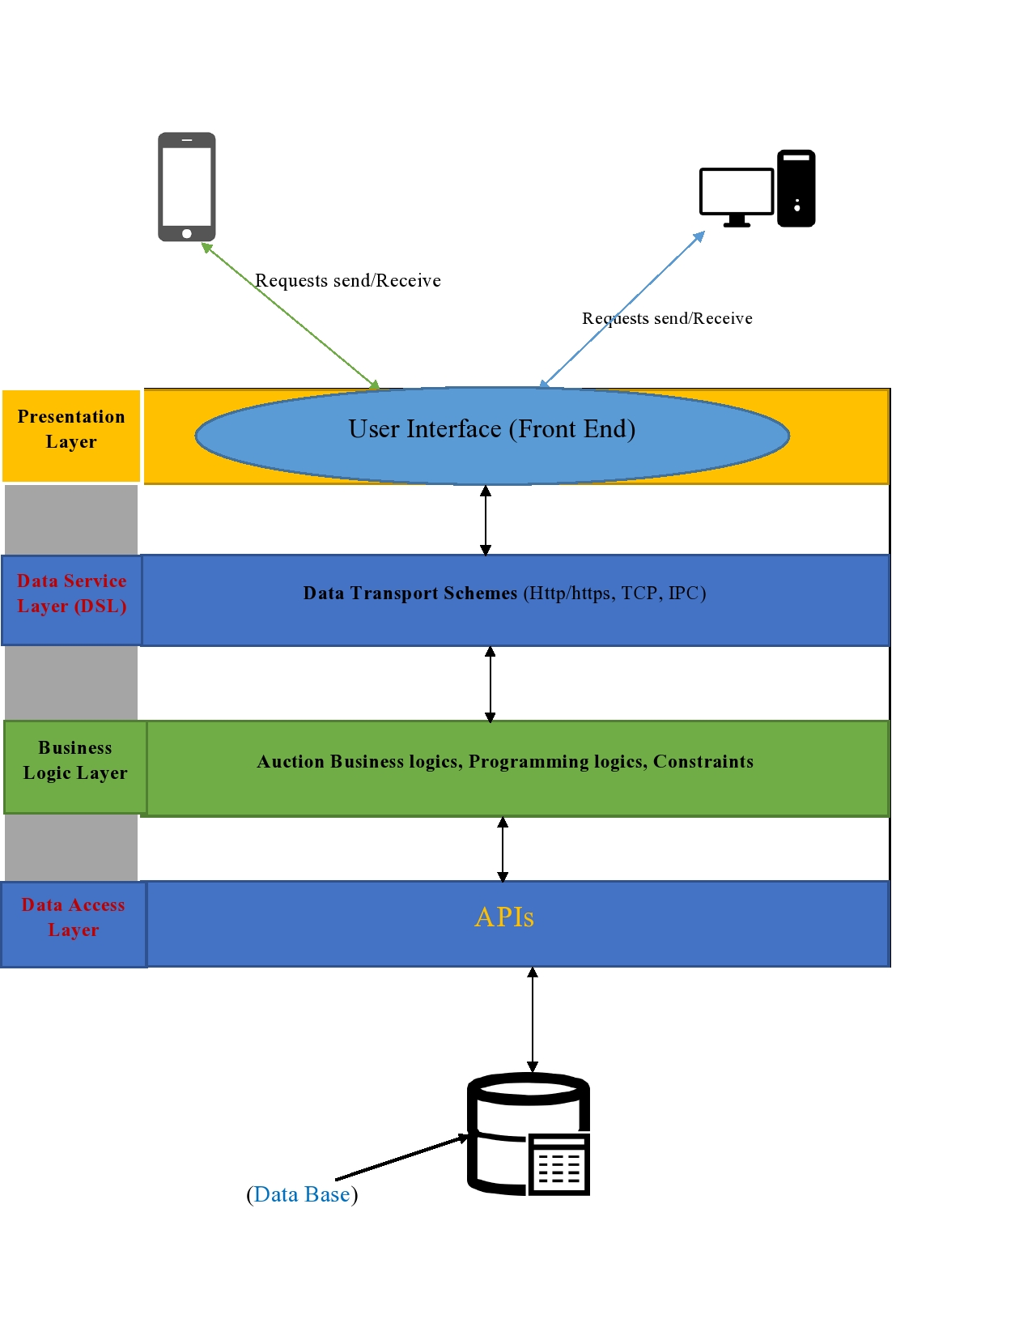

(Application Architecture Diagram 01)

### 1.2.4 Milestones

* Requirement analysis
* Project scope management
* Risk management
* Customer management module
* Admin Portal module
* Web and app visitors management module
* Auction management module
* Manager portal module
* Seller and buyer module

### 1.2.5 Project Deliverables

* Project scheduling
* Project scope
* Requirement gathering
* Requirement analysis
* Project design (Prototypes, ERD’s, UCD’s, Relational schemas)

### 1.2.6 Project Type

Android and Web based solution using object-oriented programming development.

# Chapter 03 : Product Scope

## 1.3 Product Scope

We are creating a website and the android app for our project to do online bidding, provide effective online auction through our online auction system. We are using one domain hosting to run website and application and one common database for both access through APIs. For online auction we provide all major categories in which you can do the auction like Electronics, Automobile, Antiques, Contracts, Services or Skills. User post their products or service on our system for budding and start bidding by selecting things like start and end time of auction and selecting the bidding methods like normal auction or reverse auction. Buyer and seller can chat to each other and can give rating how their experience goes with each other. The use of information technology within the auction domain is increasing day by day all over the world. Previously, mainly devolved countries were using computers and their devices within the auction domain. But nowadays developing countries are also moving towards it. Therefor our organization “Goga Nilam Gar” is going online and use latest technologies in their organization to organize and handle all auction process online. Coverage of mobile networks in most of all areas in a country makes everyone interested to use mobile phones. And within the last few years the uses of smart phones drastically increased. Due to this change, developer community is going for development of mobile applications. Now user can use most of all desktop applications in their smart phones. Even auction service providers and participants are feeling comfortable to use mobile devices for auction records and auction process. The use of mobile phone within the auction domain is called online auction system or e-auction. An online auction system can be used by auctioneer and bidder as well as by organization “Goga Nilam Gar” administrator department.

* Usually online Auction have standard time of ten days which take a long time to deliver product to successful bidder to stop this we having the feature of maximum 2 days auction , after that auction close automatically and highest bidder among all is the winner of auction, this feature save time product shipped early.
* Provide more all major categories like furniture, electronics, assets, antiques clothes, services, skills and automobile.
* User is manually add by admin or manager and then only verified and Bidder only can bid if they are login and verify their identity.
* By default English and reverse auction available benefit both seller and buyer.
* We penalize the bidder for withdrawing 3 continuously bids.
* Auctioneer cannot withdraw an auction when auction have some bids on it.
* First sealed bid have only one bid and auction is finish , so we do not available it for the auctioneer , they have “only Second sealed” bid option in which there are 2 bids, bid price of second bidder given to the first bidder and he/she win.
* We also providing Private value model in which seller can also enable the private bidding system for their auction.
* We also providing whole Auction and bidding process through mobile phone as well as website by building Android phone application and dot net razor pages web application on which you not only monitor auctions and bids more of that you can start auction and do bid through your mobile phone application and web application.

### 1.3.1 Product Features

* English Auction
* Reverse Auction
* Second Price Sealed Auction
* Private Auction
* Auction Categories
* Product Tracking
* Auction Menu
* User Dashboard
* Withdraw Auction
* Delete Bid
* Admin Portal
* Manager Panel
* Auto Auction Timer
* Auction Location
* User Report
* Organization Report
* Customer Inquiries

### 1.3.2 Product deliverables and Sub Deliverables

### 1. Android Application

#### App Sub deliverables

Android Application Start Logo View:

**Service:**

Android App Start screen comes up with logo of “online Auction system”.

**Output:**

Display our logo on start of app.

View of Auctions:

**Service:**

Android App after Start screen shows all auction that taking place.

**Output:**

Display front page all auctions.

Login:

**Service:**

After the start screen logo animation show login page for registered user to login. Credentials.

**Output:**

Authentication user data and show logged in menu.

Sign up button:

**Service:**

Take user to sign up page.

**Output:**

User fill form for verification and after take part in the auction.

Auction Category list View:

**Service:**

User can look at the category list for the available facilities on the “online auction system”.

**Output:**

By using this feature user will be able to get facilitated by the features of the app, view all available categories for auction.

**Side bar Menu:**

**Service**

Customer can swipe left to right to open side bar menu in the app.

**Output:**

User able to see the menu list and links like about us and contact us.

Start Auction**:**

**Service:**

User can start an auction through it.

**Output:**

This feature provides the facility to the user to start an auction for bidding.

Notification Bar Notified Service:

**Service:**

In this feature customer will be notified if there is any new auction going to star.

**Output:**

Alert bidder about new auction.

Select auction type:

**Service:**

Give facility to the seller to choose specific type of auctions in the drop down menu.

**Output:**

User start the auction of their choice.

Bid on Auction:

**Service:**

Facilitate the buyer or bidder to bid on an auction.

**Output:**

User can bid on the auction.

Auction View:

**Service:**

Facilitate the buyer or bidder to check the auction of their interest and know more about service or thing that are being auctioning.

**Output:**

User now have information about a specific auction.

Withdraw Auction:

**Service:**

Provide ability to the user to finish auction before the time end.

**Output:**

User ended the auction.

Request Generate Report**:**

**Service:**

Give facility to the user to request admin to generate their report of previous auction auctions and bids.

**Output:**

Admin generate and send report to user on their verify email address.

Logout:

**Service:**

Provide ability to the user to logout from the app.

**Output:**

User logged out.

### 2. Website

#### Website Sub Deliverables

Admin Panel:

**Service:**

By this feature admin will be able to see and modify data of auctions, products, buyer or bidder and seller.

**Output:**

Admin can view all the data and activities going on the web.

View of Auctions:

**Service:**

Web App after loading shows all auction that taking place.

**Output:**

Display Home Page to the user.

Login:

**Service:**

Login page for registered user to login on the website.

**Output:**

Authentication user data and show logged in menu.

Sign up button:

**Service:**

Take user to sign up page.

**Output:**

User fill form for verification and after take part in the auction.

Add User:

**Service:**

Admin can add new user manually through this function.

**Output:**

By using this feature Admin can add new users.

Delete or block User from panel**:**

**Service:**

Admin can delete fake or the user who are not following rules.

**Output:**

Admin can delete profile of any user or block user.

Generate Report**:**

**Service:**

Give facility to the admin to generate the report of user or auctions.

**Output:**

Admin can generate and view the organize data of users and auctions.

Auction Category list View:

**Service:**

User can look at the category list for the available facilities on the “online auction system”.

**Output:**

By using this feature user will be able to get facilitated by the features of the app, view all available categories for auction.

**Website Menu:**

**Service**

Show customer the home page navigation menu.

**Output:**

User able to see the menu list to navigate on the web pages.

Start Auction**:**

**Service:**

User can start an auction through it.

**Output:**

This feature provides the facility to the user to start an auction for bidding.

Select auction type:

**Service:**

Give facility to the seller to choose specific type of auctions in the drop down menu.

**Output:**

User start the auction of their choice.

Bid on Auction:

**Service:**

Facilitate the buyer or bidder to bid on an auction.

**Output:**

User can bid on the auction.

Auction View:

**Service:**

Facilitate the buyer or bidder to check the auction of their interest and know more about service or thing that are being auctioning.

**Output:**

User now have information about a specific auction.

Withdraw Auction or Bid:

**Service:**

Provide ability to the user to finish auction or withdraw bid before the time end.

**Output:**

User ended the auction or withdraw bid.

Tracking:

**Service:**

We facilitate user to track the service or product where are.

**Output:**

User know their thing tracking status.

Request Generate Report**:**

**Service:**

Give facility to the user to request admin to generate their report of previous auction auctions and bids.

**Output:**

Admin generate and send report to user on their verify email address.

Add Payment Method:

**Service:**

User add their payment method and verify their payment way here.

**Output:**

Now user can bid and start auctions.

Logout:

**Service:**

Provide ability to the user to logout from the web.

**Output:**

User logged out from the web.

### 1.3.3 Product Modules

Following are the modules of online auction system that can be functioned independently.

#### 1. Admin:

* Create new account.
* Delete your Account.
* View all account detail.
* Update all account and other detail.
* Update seller detail and check detail.
* Auction detail and add update.
* Logout.
* Manage user Accounts.
* Check account history.
* Mange all data server.
* Generate reports.

#### 2. Seller:

* login
* Start new auction.
* Provide Auction detail.
* Check history of auction by requesting report.
* Receive notification after create a new auction.
* Receive message from manager and bidders.
* Manage Account.
* Logout.

#### 3. Buyer:

* Login.
* View all account detail.
* Check account history by asking manger to generate report.
* Monitoring summary view of the auctions.
* View auctions details.
* View of others bids on an auction.
* Show prediction panel.
* Send Message to the auctioneer.
* Update sell detail and check detail.
* Order detail and add update.
* Track product.
* Manage Account.
* Receive notification from seller and admin.
* Logout.

#### 4. Manager/Moderator:

* Create new account of seller and buyer.
* Verify buyer account.
* View, Delete, update user Account.
* View all account detail.
* Check auction detail.
* Update and create auction.
* Logout.
* Generate a report of user account.
* Manage Account.
* Check user account history.

# 

# Chapter 04 : Cost Estimation

## 1.4 Project/Product Costing

Cost estimation done by methodology (FPA).

### 1.4.1 Project Cost Estimation by Function Point Analysis (FPA):

**Number of user inputs:** 20

**Number of user outputs:** 20

**Number of user inquiries:** 15

**Number of files:** 7

**Number of external interfaces:** 6

**Degree of Influence:**

1. Data communications = 5

2. Distributed data processing = 5

3. Performance = 5

4. Heavily used configuration = 3

5. Transaction rate = 5

6. On-Line data entry = 3

7. End-user efficiency = 5

8. On-Line update = 5

9. Complex processing = 4

10. Reusability = 5

11. Installation ease = 5

12. Operational ease = 5

13. Multiple sites = 2

14. Facilitate changes=2

|  |  |  |
| --- | --- | --- |
| **Components** | **Complexity** | **Values** |
| Inputs (EI) | High | 20 |
| Outputs (EO) | Low | 20 |
| Data files (ILF) | High | 7 |
| Interfaces (EIF) | Average | 6 |
| Inquires (EQ) | Average | 15 |
|  | | **U.F.P.C = 68** |

**U.F.P.C = 68**

### 1.4.2 Value Adjustment Factor (VAF)

|  |  |  |
| --- | --- | --- |
| **Characteristics** | **Degree of Influence (DI)** | **Values** |
| Data Communication | Moderate | 5 |
| Distributed Processing | None | 5 |
| Performance | Average | 5 |
| Heavily-used Configuration | Moderate | 3 |
| Transaction Rate | None | 5 |
| Online-data Entry | Moderate | 3 |
| End-user Efficiency | Moderate | 5 |
| Online-updates | Moderate | 5 |
| Complex Processing | Significant | 4 |
| Reusability | Significant | 5 |
| Installation Ease | Moderate | 5 |
| Operational Ease | Average | 5 |
| Multiple Sites | Significant | 2 |
| Facilitate Change | Strong | 2 |
|  | | **Total DI = 59** |

**TDI = 59**

**∵ V.A.F = (TDI x 0.01) + 0.65**

V.A.F = (59 x 0.01) + 0.65

**V.A.F = 1.24**

### 1.4.3 Adjusted Value Adjustment Factor (AVAF)

A.F.P.C = U.F.P.C x V.A.F

**∵ U.F.P.C = 68**

**∵ V.A.F = 1.24**

A.F.P.C = 68 x 1.24

**A.F.P.C = 84.32**

## 1.5 Project Cost Estimation by using COCOMO

**KDSI (Delivered Source Instruction)**

|  |  |
| --- | --- |
| **Modules** | **Size (KDSI)** |
| Customer management module | 0.7 |
| Admin Portal module | 0.8 |
| Web visitors management module | 0.5 |
| Auction management module | 0.7 |
| Android visitors management module | 1.3 |
| Manager portal module | 0.3 |
| Seller management module | 1 |
| Buyer management module | 1 |
| Generate Report Module | 0.7 |
|  | **Total KDSI = 7** |

**KDSI = 7**

**Equations for basic COCOMO model**

|  |  |  |  |  |
| --- | --- | --- | --- | --- |
| **Project mode** | **a** | **b** | **c** | **d** |
| **Organic** | **2.4** | **1.05** | **2.5** | **0.38** |
| Semi-detached | 3.0 | 1.12 | 2.5 | 0.25 |
| Embedded | 3.6 | 1.20 | 2.5 | 0.32 |

### 1.5.1 Project Effort (Man Months)

MM = a x (KDSI) b

**∵ a = 2.4., b = 1.05**

**∵ KDSI = 7**

MM = 2.4 x (7) 1.05

MM = 18.5

**MM** ≈ **19 Man Months**

### 1.5.2 Development Time

T dev = c x (MM) d

**∵ c = 2.5**

**∵ d = 0.38**

T dev = 2.5 x (19) 0.38

T dev = 7.6

**T dev** ≈ **8 Months**

### 1.5.3 Team Members

Number of people = MM / T dev

**∵ MM = 19**

**∵ T dev = 7.6**

Number of people = 19 / 7.6

Team Size = 2.5

**Team Size ≈ 3 people**

### 1.5.4 Development Cost

Cost = Team size * Working hours * Rate

**∵ Development rate = 1000 PKR**

**∵ Working hours = 176 / Month**

Cost = 3 * 176 * 1000

**Cost = 528,000 PKR**

# Chapter 05 : CPM (Critical Path Method)

## 1.6 CPM-Critical Path Method

### 1.6.1 Work Breakdown Structure

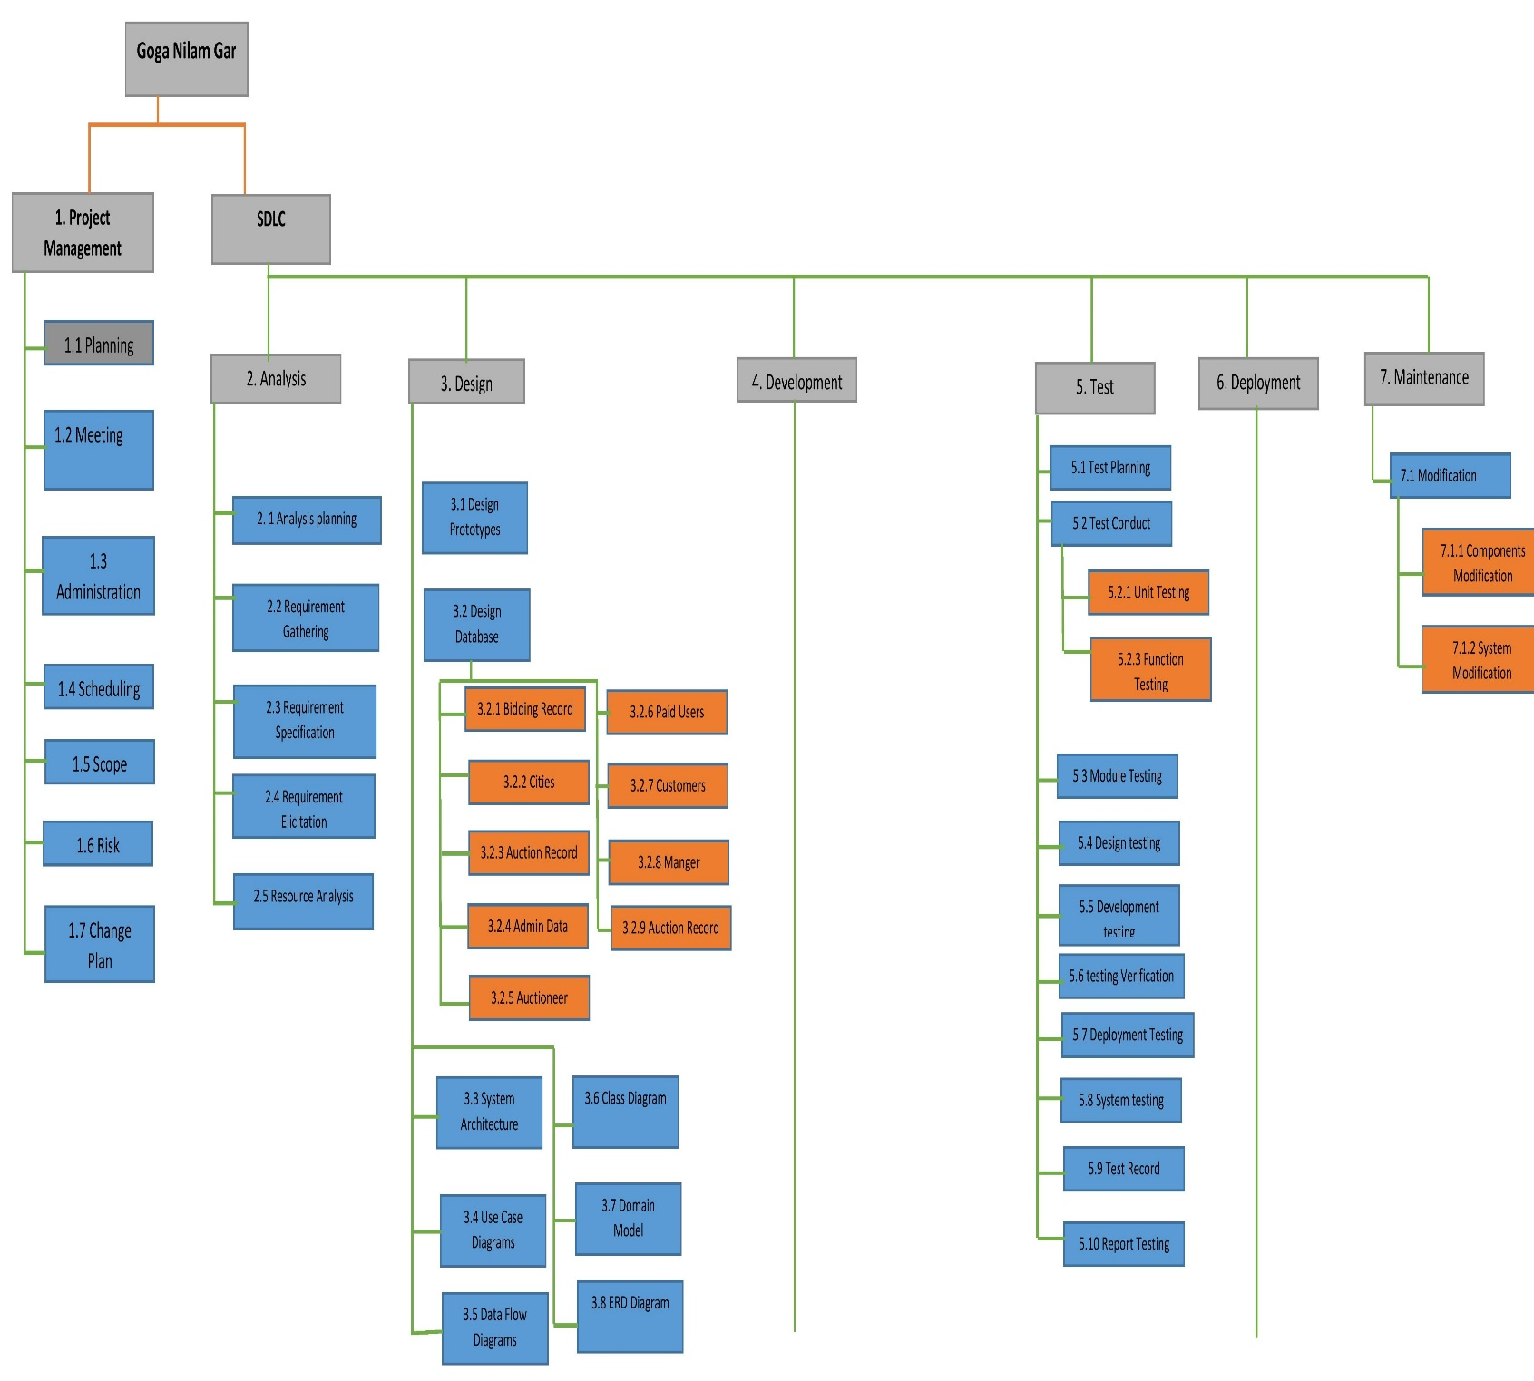

**(Work Break-Down Structure Diagram: 01)**

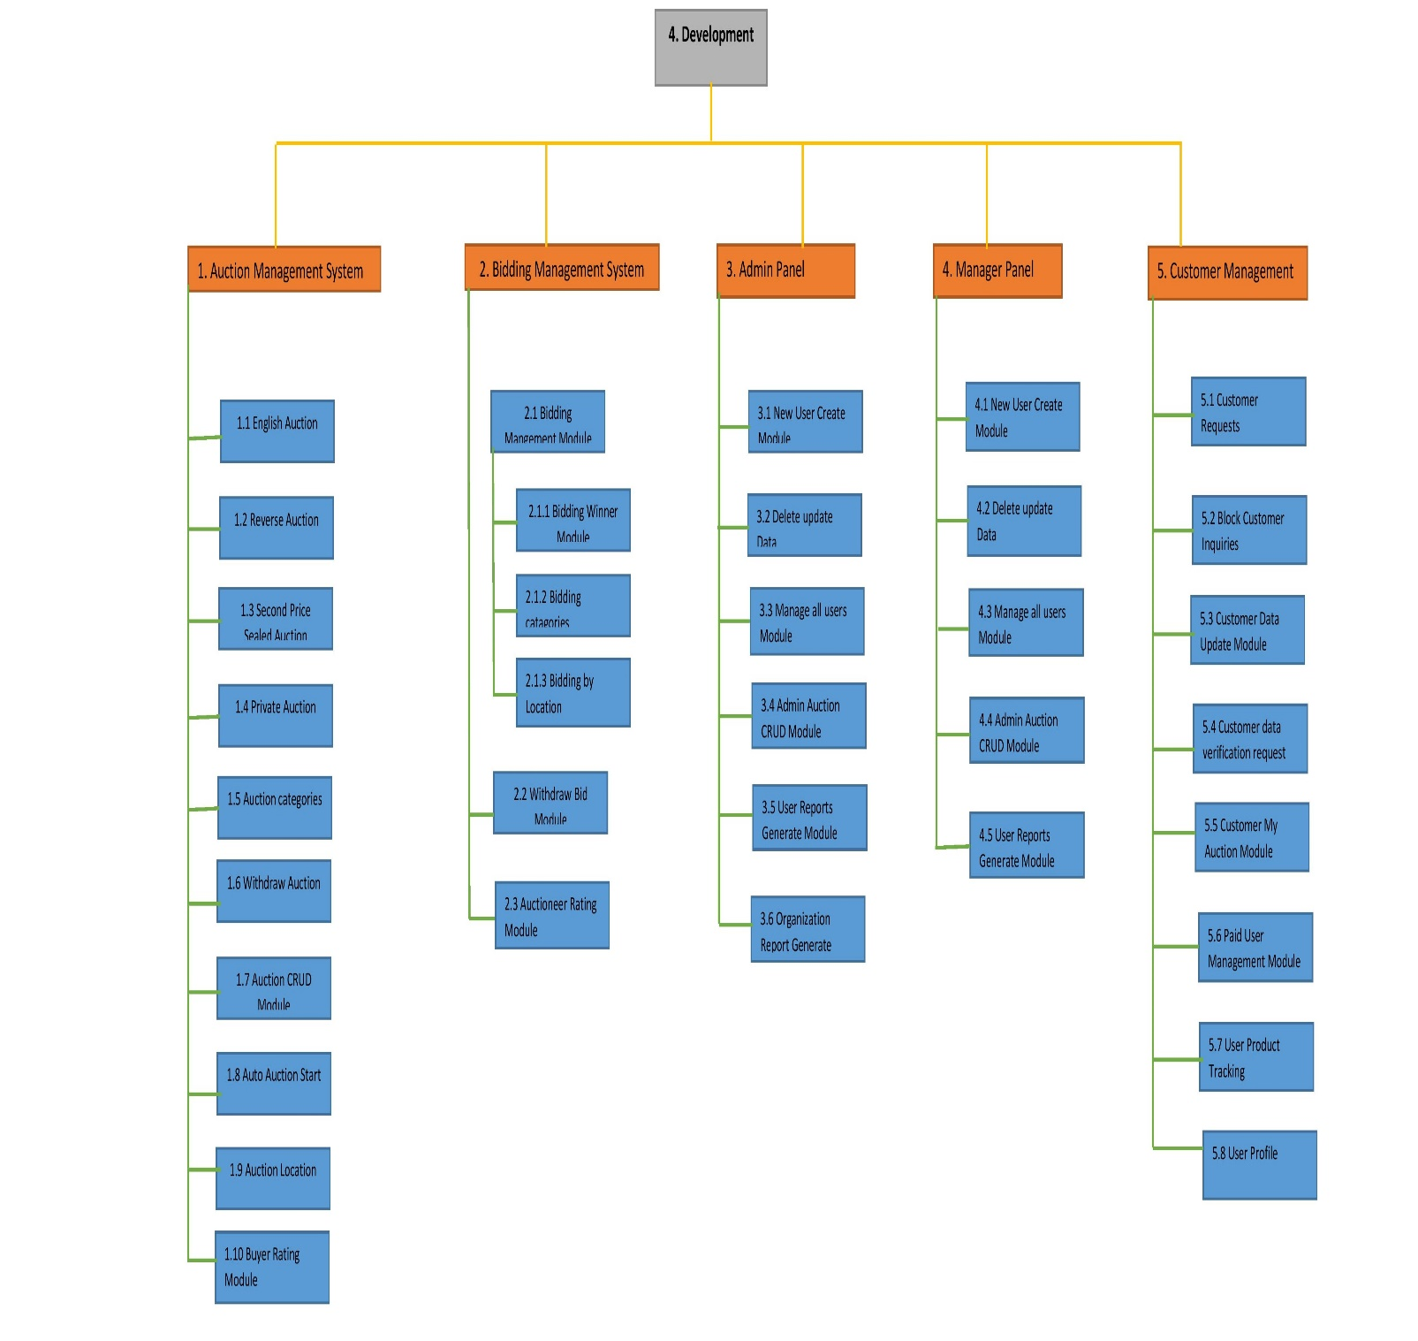

**(Work Break-Down Structure Diagram: 02)**

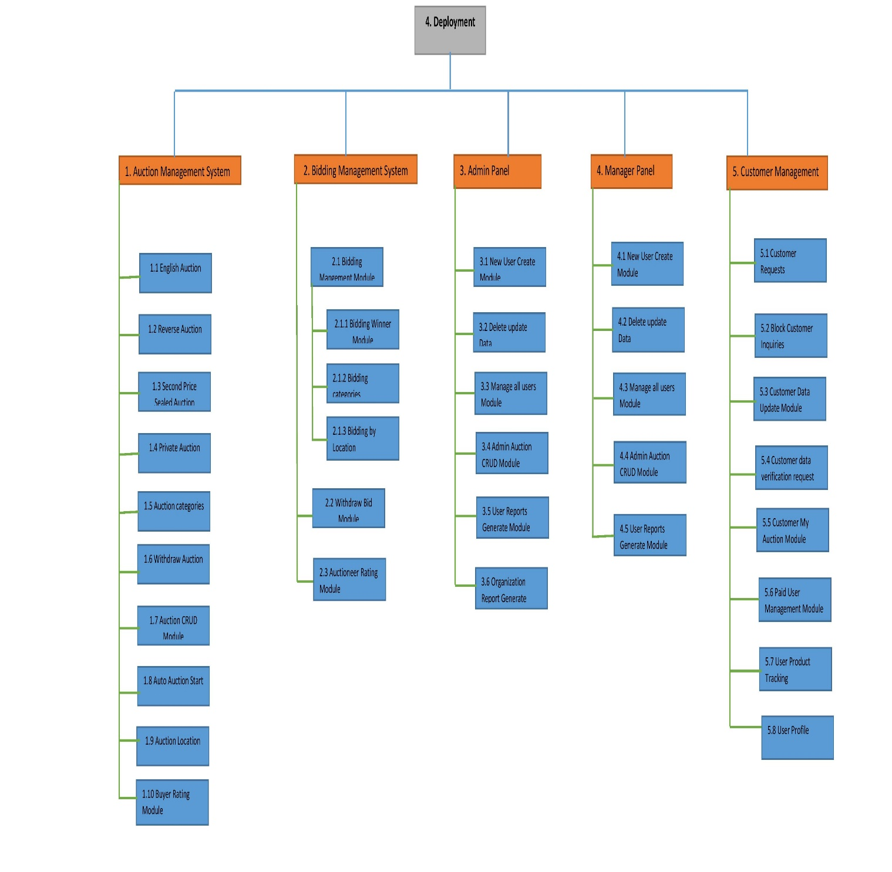

**(Work Break-Down Structure Diagram: 03)**

### 1.6.2 Chart of Activity (PERT)

|  |  |  |  |  |  |
| --- | --- | --- | --- | --- | --- |
| **Activity Description** | **Immediate Predecessor** | **Time Estimate** | | | **Expected Time**  D=(to+4tm+tp) / 6  **(Weeks)** |
| **to** | **tm** | **tp** |
| **A:** Project planning | None | 2 | 3 | 4 | **3** |
| **B:** Meetings | A | 1 | 2 | 3 | **3** |
| **C:** Project scheduling | B | 2 | 3 | 6 | **2** |
| **D:** Scope management | C | 1 | 2 | 3 | **4** |
| **E:** Risk management | C | 1 | 2 | 5 | **2** |
| **F:** Requirement gathering | D,E | 12 | 16 | 15 | **5** |
| **G:** Requirement specification | F | 8 | 10 | 10 | **4** |
| **H:** Designing prototypes | G | 2 | 4 | 6 | **5** |
| **I:** Designing database | G | 4 | 5 | 8 | **6** |
| **J:** Designing document | G | 19 | 20 | 22 | **5** |
| **K:** Development planning | H,I,J | 1 | 2 | 3 | **2** |
| **L:**Customer management module | K | 22 | 25 | 27 | **4** |
| **M:**Admin Portal module | K | 4 | 5 | 6 | **5** |
| **N:**Web visitors management module | K | 3 | 4 | 6 | **5** |
| **O:**Auction management module | L,M,N | 18 | 20 | 22 | **6** |
| **P:**Android visitors management module | O | 14 | 15 | 16 | **4** |
| **Q:**Manager portal module | O | 2 | 3 | 4 | **3** |
| **R:**Seller management module | P,Q | 18 | 19 | 19 | **8** |
| **S:**Buyer management module | Q | 22 | 25 | 27 | **5** |
| **T:**Generate Report Module | R,S | 14 | 15 | 16 | **5** |
| **U:** Testing | T | 12 | 15 | 18 | **4** |
| **V:** Deployment | U | 1 | 3 | 5 | **2** |

**Activity Chart: Table 01**

### 1.6.3 Activity Chart

|  |  |  |
| --- | --- | --- |
| **Activity** | **Immediate predecessor** | **Duration (Weeks)** |
| A | None | **3** |
| B | A | **3** |
| C | B | **2** |
| D | C | **4** |
| E | C | **2** |
| F | D,E | **5** |
| G | F | **4** |
| H | G | **5** |
| I | G | **6** |
| J | G | **5** |
| K | H,I,J | **2** |
| L | K | **4** |
| M | K | **5** |
| N | K | **5** |
| O | L,M,N | **6** |
| P | O | **4** |
| Q | O | **3** |
| R | P,Q | **8** |
| S | Q | **5** |
| T | R,S | **5** |
| U | T | **4** |
| V | U | **2** |

**Activity Chart: Table 02**

### 1.6.4 Activity Network Diagram

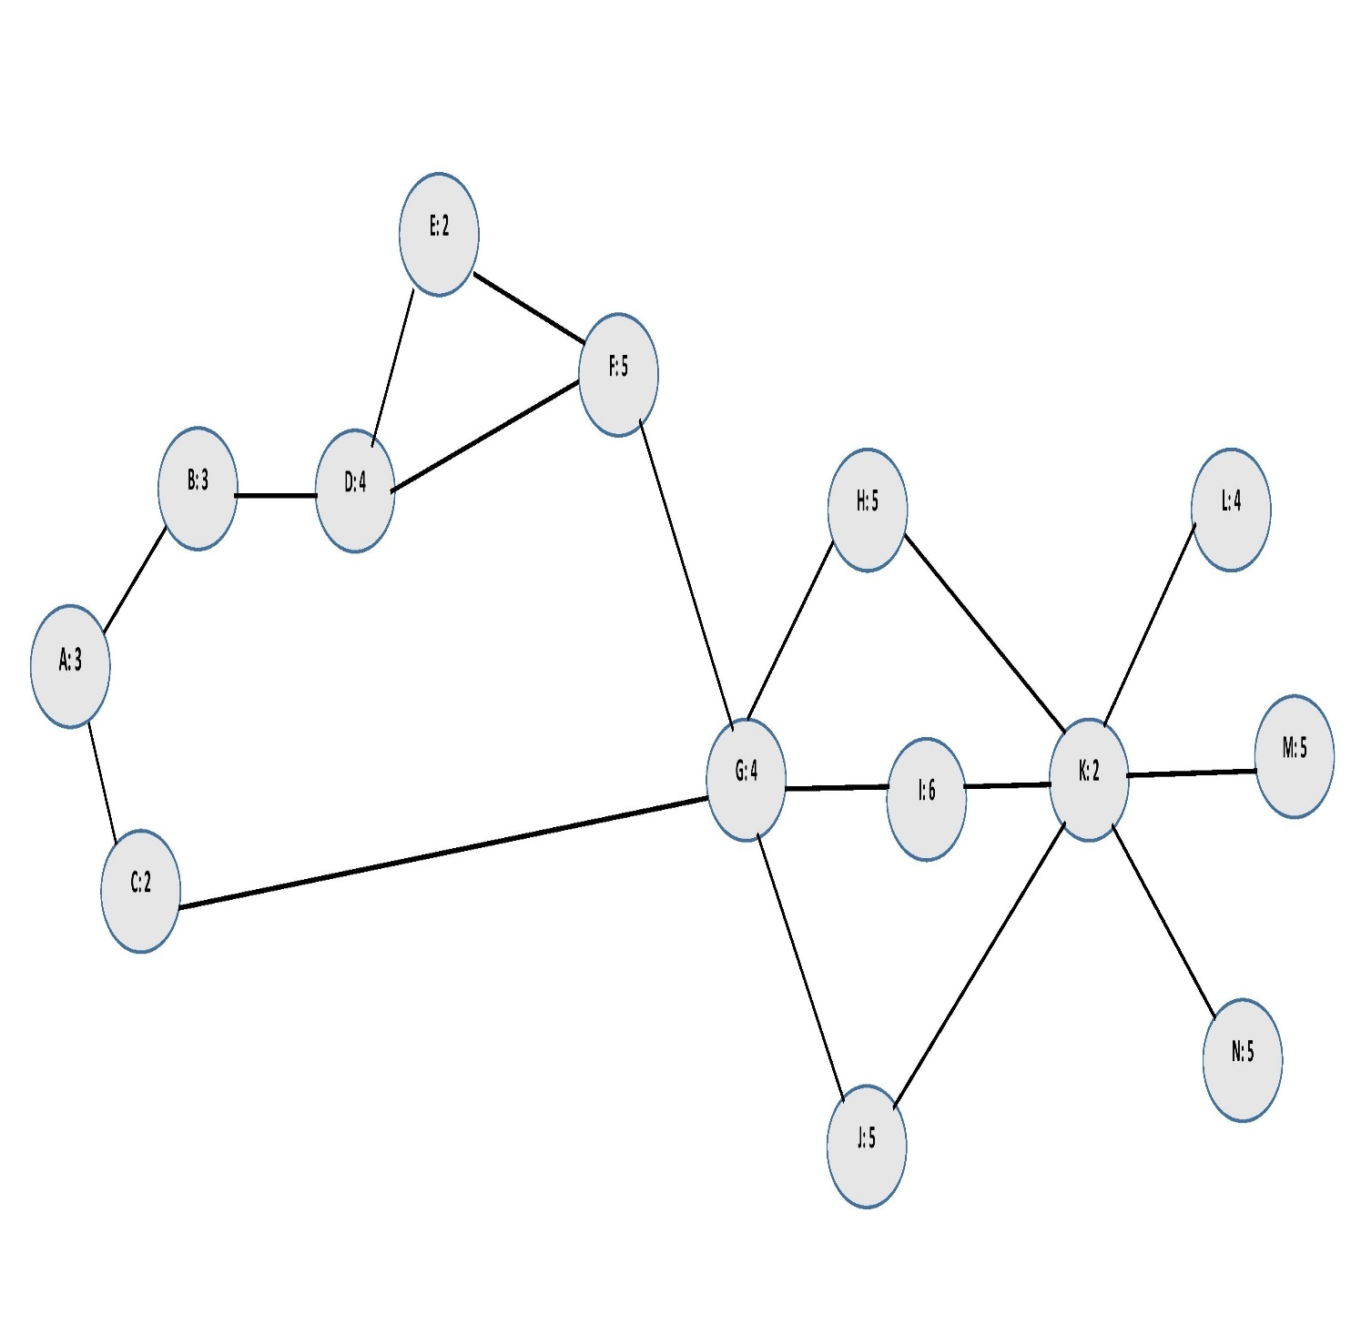

**Activity Network Diagram 01**

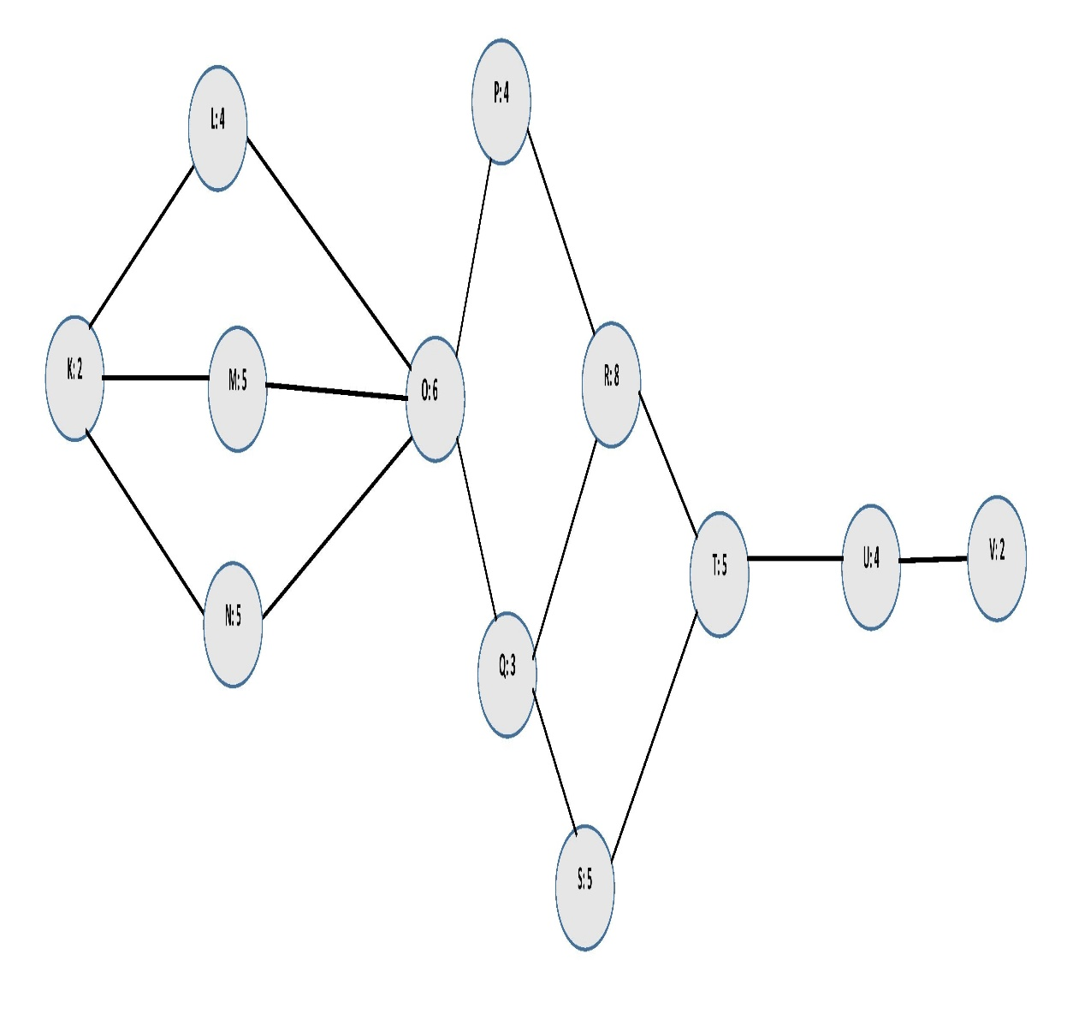

**Activity Network Diagram 02**

### 1.6.5 Critical Path Network Diagram

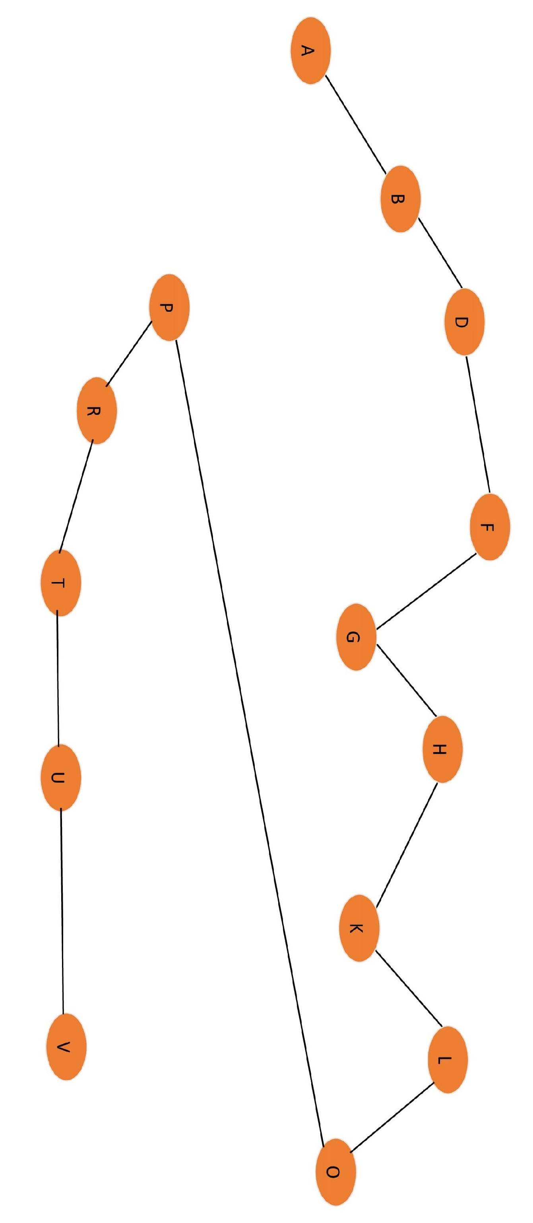

**Critical Path Network Diagram 01**

### 1.6.5 Critical Paths

**Path 1:** A=>B=>D=>F=G=>H=>K=>L=>O=>P=>R=>T=>U=>V

= 3+3+4+5+4+5+2+4+6+4+8+5+4+2 = 59Weeks **(Critical Path)**

**Path 2:** A=>C=>G=>I=>K=>M=>O=>P=>R=>T=>U=>V

= 3+2+4+6+2+5+6+4+8+5+4+2 = 51Weeks

**Path 3:** A=>C=>G=>J=>K=>N=>O=>Q=>S=>T=>U=>V

= 3+2+4+5+2+5+6+3+5+5+4+2 = 46 Weeks

### 1.6.6 Gantt Chart

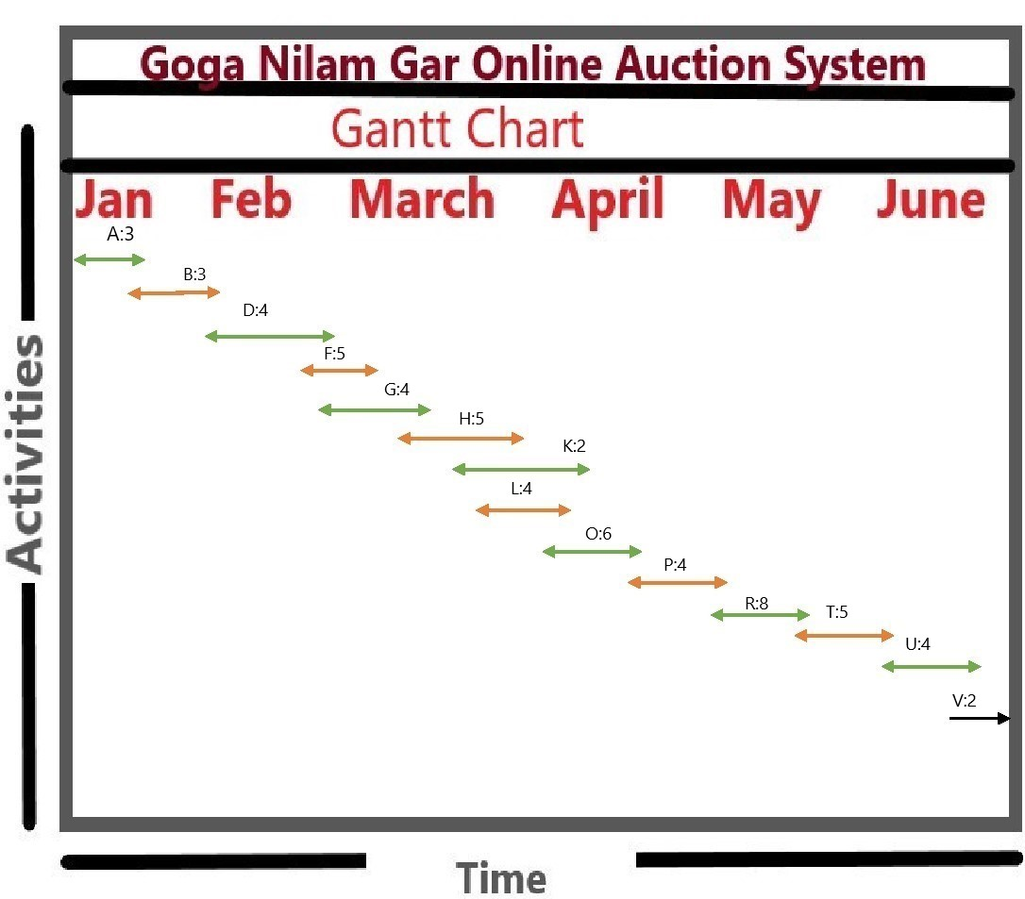

**(Gantt chart Diagram 01)**

# Chapter 06 : Team Intro

## 1.7 Introduction to Team member and their skill set

#### Member 1

|  |  |
| --- | --- |
| Name | Hafiz Shah Nawaz |
| Roll no | B-19983 |
| Email | Shahnawazwarriach2323@gmail.com |
| Phone no | 0304-6746187 |
| Introduction | I am a Student of CS department at University of South Asia. My skills are in, HTML, CSS, My SQL, WordPress and C#. On the other hand, I have skills in Microsoft Paint 3D and Microsoft office. I am also good in designing front end of websites and documentation. While doing this project I learned dot net and MVC concepts. |
| Signature |  |

#### Member 2

|  |  |
| --- | --- |
| Name | Hadi Zulfiqar |
| Roll no | B-19942 |
| Email | Hadizulfiqar3@gmail.com |
| Phone no | 0333-4248267 |
| Introduction | I am a Student of CS department at University of South Asia. Currently I am doing job at a software house where my skills are in ASP.NET also expert in backend and frontend developing. |
| Signature |  |

#### Member 3

|  |  |
| --- | --- |
| Name | Zain Arif Babu |
| Roll no | B-20194 |
| Email | Chandchudary@gmail.com |
| Phone no | 0301-6343654 |
| Introduction | I am a Student of CS department at University of South Asia. I am a final year student doing my FYP project. My skills are in Database, Microsoft office and designing plus front end developing. |
| Signature |  |

# 

# Chapter 07 : Tools and Technology

## 1.8 Tools and Technology with reasoning

#### 1.8.1 Development Tools

* Visual Studio for Razor pages developing and testing.
* Android Studio for App development.
* Atom code editor.
* SQL Lite as a database browser.
* Microsoft MySQL Management Studio.
* Xamarian for App development.
* MS office for documentation and presentation.
* Microsoft Pain 3D for creating diagrams and shapes.
* Star UML for data modeling.
* Web Browser for web page testing.
* Android Emulator for android app testing.

#### 1.8.2 Target Platforms

Following platform are compatible with our application:

* Web Browser (Google Chrome , Mozilla Firefox, Apple Safari, Microsoft Edge)
* Android Devices with 5.0 version or higher.

#### 1.8.3 Hardware Specification

* Devices with browsers efficiently runs websites.
* Android devices with 1 or more than 1GB of RAM.

#### 1.8.4 Front End

* Html
* CSS
* JavaScript
* XML
* JQuery
* Vue.JS

#### 1.8.5 Back-End

* C#
* MVC
* Dot net MVC framework

# 

# Chapter 08 : Vision Document

## 1.9 Vision Document

### 1.9.1 Purpose

The purpose of this document is to collect, analyze, and define high-level needs of our system and features of “online auction system” for Goga Nilam Gar. The vision document focuses on the requirements of the stakeholders and the target users, and also why these needs exist to develop the required system. The details of “Online Auction System for Goga Nilam Gar” how fulfills needs of organization and what is the use-case and other system specifications.

### 1.9.2 Scope

“Online Auction System” will provide a way for users to easily start auctions and conduct auctions online for auctioneer users and bidders to bid on products to purchase things online through auction. Plus as well as for organization employees to manage auctions and keep record of auctions easily at one place.

### 1.9.3 Advantage of online auction system for organization

Basically we want to develop a system for our organization which is unique product for our organization and solve problem with conventional auction system by adding online auction system website and android application which save cost and time plus additionally increase efficiency.

Online auction will be a type of product in which the items are sold through price bidding. Usually bidding have start price and ending time. Actual buyers in auction and the winner is the one who bids the item for highest price. For buying product online through auction first user have to provide his personal details like email address, license number, National identity number. Only the valid user will have authority to bid. This help us to prevent various hurdles and frauds happened in online shopping like managing and organizing auctions online effectively. Online Auction system provide services through internet anywhere in the world like selling and purchasing services or products and access by using your smartphones and personal computers. Easy to sell and purchase by auction and bidding in the world without having a physical location and place.

### 1.9.4 Problem Statement

|  |  |
| --- | --- |
| **The problem of** | * Conducting auction on the physical places is very difficult to manage * Difficult to manage the customer record manually. * Difficult to store the previous record of auctions and details. * Cause more cost and waste a lot of time |
| **Affects** | * Customer * Employee * Auctioneer * Bidder |
| **The impact of which is** | More time and struggle is required with old conventional methods. |
| **A successful solution would be** | A simple online web and mobile application, which can be easy to use anywhere any time for employees, auctioneer and bidder, is the solution. |

### 1.9.5 Product Position Statement

|  |  |
| --- | --- |
| **For** | * Employee * Auctioneer * Bidder |
| **Who** | * Works in the organization. * Take part in the auction. |
| **Online Auction System for Goga Nilam Gar** | * Web and android application based solution. |
| **That** | * With that easy to administrate, manage and take part in the auctions and keep records. * Helps the auctioneer and bidder to easily conduct auctions at their time of ease. * To organize and run multiple auctions at once is possible. |
| **Unlike** | Currently available method handle the record manually and need physical place to organize an auction. |
| **Our Product** | * Will minimize the effort of employees who manages organization tasks. * Will help the auctioneers to easily conduct auctions. * Bidder easily can bid on the required products online. |

### 1.9.6 User Summary

|  |  |  |
| --- | --- | --- |
| **Name** | **Description** | **Responsibility** |
| Admin | Primary End user of the system. | Use application to manage online auctions and keep record of auctions. |
| Auctioneer | End user of the system. | Use system to conduct and organize auction to sell products online. |
| Bidder | End user of the system. | Use application to take part in auctions by bidding. |
| Manager/Employee | End User of System | Manage the user of our system. |

### 1.9.7 User Profile

#### 1. Admin

|  |  |
| --- | --- |
| **Description** | A person who uses system with admin privileges. |
| **Type** | Organization administration who have experience to use the system. |
| **Responsibilities** | Use application to manage online auctions and employee’s record. |
| **Success Criteria** | The success is defined as the System fulfils the requirements of Admin. |
| **Involvement** | We will have feedback from Admins to evaluate our system, which will guide our through entire development. |
| **Comments** | None |

#### 2 Manager

|  |  |
| --- | --- |
| **Description** | Organization employees who uses the system. |
| **Type** | This is a manager user or employee user of our system. |
| **Responsibilities** | Use application to monitor auctions and mange auctions and auction users. |
| **Success Criteria** | The success is defined as the System fulfils the requirements of Employee or manger. |
| **Involvement** | We will have sample Employees to evaluate our system, which will give feedback throughout the development process. |
| **Comments** | None |

#### 3. Auctioneer

|  |  |
| --- | --- |
| **Description** | A person who want to do online auction. |
| **Type** | A casual user who want to use our system. |
| **Responsibilities** | Use application conduct an auction. |
| **Success Criteria** | The success is defined as the user continuing to use our system. |
| **Involvement** | We will have to evaluate our system according to user needs by involving user. |
| **Comments** | None |

#### 4. Bidder

|  |  |
| --- | --- |
| **Description** | A person who want to take part in the auction. Or want to bid on an auction. |
| **Type** | A casual user OR Bidder |
| **Responsibilities** | Use application to bid on auctions. |
| **Success Criteria** | The success is defined as the bidder continuing to use our system. |
| **Involvement** | We will have to evaluate our system according to user needs by involving user. |
| **Comments** | None |

### 1.9.8 Key Users’ Needs

|  |  |  |  |
| --- | --- | --- | --- |
| **Need** | **Priority** | **Concerns** | **Proposed Solution** |
| Manage Users and Auctions data. | High | Ability to manage the resources and data. | Provides features to manage resources with easy menus. |
| Organize Auctions | Moderate | Ability to start and manage the auctions. | Provide facility to do auction online. |
| Monitor and Manage auctions and users. | High | Ability to monitor system. | Provides features to do and view auctions with easy menus |
| Take part in the auctions/ bids on the auction. | Moderate | Ability to use the system. | Provide features to the user to become part of our system and use the system. |

### 1.9.10 Product features

1. English Auction
2. Reverse Auction
3. Second Price Sealed Auction
4. Private Auction
5. Auction Categories
6. Product Tracking
7. Auction Menu
8. User Dashboard
9. Withdraw Auction
10. Delete Bid
11. Admin Portal
12. Manager Panel
13. Auto Auction Timer
14. Auction Location
15. User Report
16. Organization Report
17. Customer Inquiries

### 1.9.11 Features’ Priority

|  |  |
| --- | --- |
| **Priority** | **Feature Number (As above # 10.7)** |
| High | 1,2,4,8,7,11,14,15 |
| Medium | 3,5,9,12,13,16,17 |
| Low | 6,10 |

## 1.10 Other Product Requirements

### a) Application Standard

Our System must follow the existing standards for application development.

**System Requirements**

* **Target platform**

The application will be compatible for the following platforms:

* Android Device (5 or higher)
* Latest Standard Web Browsers

### b) Hardware and software specification

* **Web Browser on the machine**

With at least 1GB of RAM and 4GB of ROM

* **9.3.2 Android OS**

Android devices with 5.0 or higher version having at least 1GB of RAM

### c) Performance Requirements

None specified

### d) Environmental Requirements

None specified

### 1.10.1 Documentation Requirement

#### a) User Manual

A short user manual can be provided with the application for users of the system.

# Chapter09 : Requirement Analysis

## 1. Introduction

### 1.1 System Specification

#### 1.1.1 Introduction of System

Online Auction System will be used by Goga Nilam Gar administration, employees, customer, auctioneer and bidder. The system will help the administration and users to organize and conduct online auctions and take part in online auctions by providing following facilities:

* Employee/Manager Management.
* Auction Management.
* Bidding Management.
* Reports Management.
* Customer/Users Management.
* Auctioneer Management.

**Goga Nilam Gar**

Goga Nilam Gar locate at Ferozepur Road Lahore and deals in the sell and purchase of furniture and electronics through auction system. Goga Nilam Gar have used and new furniture like office and house furniture. Goga Nilam Gar uses the departmental approach structure and departments are sales, accounting, marketing, finance, research and production. Goga Nilam Gar using traditional way to auction in which you need physical place and keep records on the register, which need to be updated to the new world technology to do auction in a way that fits well with particular needs, activities and plans. First of all we need to eliminate physical location barrier and do the all the process online. At the time to conduct the auction with “Goga Nilam Gar” or taking part in the auction you have to submit application with your details and they notify you on every occasion through call where and when auction conduct manually.

#### 1.1.2 Scope of the system

Goga Nilam Gar Online Auction System is divided into six phases given below:

**a) Phase-I**

Phase I involves the administration or admin to manage the following areas:

* Admin dashboard
* Employee/Manger management
* User management
* Verify Users management
* Auction detail management
* Paid User Management
* Organization Report management
* User Report Management
* Customer Feedback Management

**b) Phase-II**

Phase II involves the Employees or Manager to manage the following areas:

* Manager Dashboard
* User management
* Create Users management
* Auction detail management
* Paid User Management
* User Report Management
* Customer Feedback Management

**c) Phase-III**

Phase III involves the Auction management module to manage the following areas:

* Select Auction Location.
* Select Auction Bidding Location.
* Start Auction
* Winning Auctions
* Auction Categories

**d) Phase-IV**

Phase IV involves the Auctioneer to manage the following areas:

* Start Auction
* My Auctions
* Monition Auctions bidding.
* Feedback/rating to bidder.

**e) Phase-V**

Phase V involves the Bidder to manage the following areas:

* + View Auctions
  + Winning Auctions
  + View Bidding on ongoing Auctions.
  + Rate seller

**e) Phase-VI**

Phase VI involves the Customer management module to do the following actions:

* + Submit data to verify.
  + User Verification.
  + Request User Report.
  + Send Inquiries.

#### 1.1.3 Summary of Requirements (Initial Requirements)

The purposed system must fulfill following requirements as follow:

**1) Employee/Manager Management**

**Admin login**

1. Only registered users (Admin) can access this feature. Therefore, it is a by default user with admin rights who can handle, manage and monitor system.
2. Admin could be able to add new employees or system manager to manage the system. View and find employee record, update record, delete record.
3. Admin could be able to add new user.
4. Admin able to verify user and user data on sign up and can be able to view, update, delete user data
5. Admin could be able to view auctions detail post by users or able to update or remove auctions.
6. Admin could be able to generate the reports of the user or organization reports.
7. Admin could be able to view performance of online auction system on the basis auctions and bids record per month or year wise.
8. Admin should able to manage customer’s feedbacks.
9. Admin should generate report on auctioneer or bidder previous data.
10. Admin Should be able to verify paid users requests.
11. Admin can start auction on the behalf of user.

**2) User Management**

**Admin login**

1. Only registered users (Admin) can access this feature. Therefore, it is a by default user with admin rights who can handle, manage and monitor system.
2. Admin could add new users and view and search records, update records and delete user records.
3. Admin could view the auctions and bids
4. Admin could view the user record and able to block or unblock user.
5. Admin could be able to create employee or manager users to organize the system.
6. Admin could view pending and completed user verification requests.
7. Admin could be able to generate user reports.

**User login**

1. Only registered users or customers can access this feature.
2. Auctioneer could be able to start auction.
3. Bidder could be able to bid on the system.
4. Bidder could able to view their winning auction.
5. Auctioneer could be able to post auctions ads by choosing default location of the product.
6. Bidder could be able to view auctions ads by location and categories filter.

**Manager Login**

1. Only registered users as manager can access this feature.
2. Manager could be able to view and update the user data.
3. Manager could be able to add new user (Customers).
4. Manager able to verify user and user data on sign up and can be able to view, update, delete user data.
5. Manager could be able to view auctions detail post by users or able to update or remove auctions.
6. Manager could be able to generate the reports of the user only.
7. Manager could be able to view performance of online auction system on the basis of auctions and bids record per month or year wise.
8. Manager should able to manage customer’s feedbacks.
9. Manager should generate report on auctioneer or bidder previous data.
10. Manager should be able to verify paid users requests.
11. Manager should able to start auction on the behalf of user.

**3) Auction Management**

**Admin login**

1. Only registered user Admin can access this feature. Therefore, there must be a method to register the user in order to manage resources and organize system.
2. Admin could be able to start auction.
3. Admin could be able to view auction and bids on that auction.
4. Admin could be able to update or delete the user auction.
5. Admin could be able to generate auctions reports.
6. Admin could also be able to block un-block user not follow auction rules.

**User login**

1. Only registered user customer can access this feature.
2. Customer can start an auction or take part in the auction after verification of their sign up data by admin.
3. User should be able to select location and time before start auction.
4. User could view auctions before then bid on the auction after becoming paid users.
5. Auctioneer can view and offer product to the highest bidder.

**Manager Login**

1. Only registered users as manager can access this feature.
2. Manager view, update or delete auction data.
3. Manager can start auction on the behalf of the user.

**4) Reports Management**

1. Only registered users (Admin) can access this feature. Therefore, there must be a method to register the user in order to manage parks’ assets.
2. Admin Could be able to view park assets (Canteen, Jogging track, platy ares, mosque etc.) on Google map.
3. Admin could be able to add new asset record, view, delete and update assets records.
4. Admin could generate report on parks assets.

**5) Customer Management**

**Admin login**

1. Only registered user (Admin) can access this feature. Therefore, it is a by default user with admin rights who can handle, manage and monitor system.
2. Admin could be able to add new employees or system manager to manage the system. View and find employee record, update record, delete record.
3. Admin could be able to add new user.
4. Admin able to verify user and user data on sign up and can be able to view, update, delete user data
5. Admin could be able to view auctions detail post by users or able to update or remove auctions.
6. Admin could be able to generate the reports of the user or organization reports.
7. Admin could be able to view performance of online auction system on the basis auctions and bids record per month or year wise.
8. Admin should able to manage customer’s feedbacks.
9. Admin should generate report on auctioneer or bidder previous data.
10. Admin Should be able to verify paid users requests.
11. Admin can start auction on the behalf of user.

**Employee/Manager login**

1. Only registered users as manager can access this feature.
2. Manager could be able to view and update the user data.
3. Manager could be able to add new user (Customers).
4. Manager able to verify user and user data on sign up and can be able to view, update, delete user data.
5. Manager could be able to view auctions detail post by users or able to update or remove auctions.
6. Manager could be able to generate the reports of the user only.
7. Manager could be able to view performance of online auction system on the basis of auctions and bids record per month or year wise.
8. Manager should able to manage customer’s feedbacks.
9. Manager should generate report on auctioneer or bidder previous data.
10. Manager should be able to verify paid users requests.
11. Manager should able to start auction on the behalf of user.

**6) Customer Feedback/inquiries Management**

1. Only registered user as admin or manager can able to access this feature.
2. Admin and manager could view customer requests, feedbacks and inquiries.
3. Admin and manger could be able to verify user.
4. Admin and manager could be able to verify users paid requests to become paid users.

### 1.2 Identifying External Actors

* Admin
* Manager
* Auctioneer/Seller
* Bidder/Buyer
* Employee
* Customer/user

### 1.3 Capture “Shall” Statement

|  |  |  |
| --- | --- | --- |
| **Para #** | **External Entity** | **Initial Requirements** |
| 1 | Admin, Employee, Manager, Auctioneer, Bidder | Admin, Employee, Customer “shall” login to access the system features. |
| 1 | Admin | Admin “shall” Add new employees/Manager. |
| 1 | Admin | Admin “shall” view Manger records. |
| 1 | Admin | Admin “shall” update Manager records. |
| 1 | Admin | Admin “shall” delete employee records. |
| 1 | Auctioneer/Bidder | Auctioneer/Bidder “shall” add with system by sign up. |
| 1 | Admin, Manager | Admin and Manager “Shall” add new user as buyers and sellers. |
| 1 | Admin, Manager | Admin and Manager “shall” start new auction for users. |
| 1 | Admin, Manager | Admin and Manager “Shall” able to view user data. |
| 1 | Admin, Manager | Admin and Manager “shall” update user data. |
| 1 | Admin ,Manager | Admin and Manager “shall” update user auctions. |
| 1 | Admin, Manager | Admin and Manager “shall” delete user data. |
| 1 | Admin, Manager | Admin and Manager “shall” view their portals. |
| 1 | Admin, Manager | Manager and Admin “shall” generate reports. |
| 1 | Admin | Admin “shall” generate organization reports. |
| 1 | Admin | Admin “shall” generate user report. |
| 1 | Admin, Manager | Admin and Manager “shall” manage feedbacks. |
| 1 | Admin, Manager | Admin and Manager “shall” verify user data on sign up submission. |
| 2 | Admin, Manager | Admin and Manager “shall” add auctioneer. |
| 2 | Admin, Manager | Admin and Manager “shall” add bidder. |
| 2 | Admin, Manager | Admin and Manager “shall” view auctioneer record. |
| 2 | Admin, Manager | Admin and Manager “shall” update auctioneer record. |

|  |  |  |
| --- | --- | --- |
| **Para #** | **External Entity** | **Initial Requirements** |
| 2 | Admin | Admin “shall” delete auctioneer and bidder records. |
| 2 | Admin | Admin “shall” start auctioneer auctions. |
| 2 | Admin, Manager | Admin and Manager view auctioneer and bidder performance. |
| 2 | Admin, Manager | Admin and Manager “shall” view and respond pending account verification requests. |
| 2 | Admin, Manager | Admin and Manager “shall” view block users. |
| 3 | Admin | Admin “shall” add users to block list on violation. |
| 3 | Admin | Admin “shall” delete block user account. |
| 3 | Admin | Admin “shall” unblock users. |
| 3 | Admin | Admin “shall” generate report for auctions and bidding on the system. |
| 4 | Admin, Manager, Customers | Admin and Customer “shall” view auction categories. |
| 4 | Auctioneer | Auctioneer “shall” add new auction. |
| 4 | Auctioneer | Auctioneer “shall” add location with auction. |
| 4 | Auctioneer | Auctioneer “shall” add time of the auction. |
| 4 | Auctioneer, Bidder | Admin “shall” request for generate report of their auctions biddings. |
| 5 | Auctioneer | Auctioneer “shall” post picture with auction add. |
| 5 | Bidder | Bidder “shall” select location to view auctions. |
| 5 | Bidder | Bidder “shall” view auction categories. |
| 5 | Bidder | Bidder “shall” view auctions location vise. |
| 5 | Admin | Bidder “shall” select auction. |
| 5 | Bidder | Bidder “shall” view selected auction. |
| 5 | Bidder | Bidder “shall” bid on the auction. |
| 5 | Bidder | Bidder “shall” withdraw bids. |
| 5 | Bidder | Bidder “shall” view auction start time. |
| 5 | Bidder | Bidder “shall” view auctioneer profile. |
| 5 | bidder | Bidder “shall” win auction with highest bid. |
| 5 | Admin, Manager, Bidder, Auctioneer | Admin, Manager, Bidder, Auctioneer “shall” update their profile. |
| 5 | Customer, Auctioneer, Bidder | Customer, Auctioneer and bidder “shall” view customer support page. |
| 5 | Bidder, Auctioneer | Bidder “shall” request report. |
| 5 | Bidder | Bidder “shall” view winning auctions. |
| 5 | Auctioneer | Auctioneer “shall” view bidder’s bid. |
| 6 | Auctioneer | Auctioneer “shall” send offer to auction winner. |
| 6 | Auctioneer | Auctioneer “shall” view buyer/bidder profile. |
| 6 | Manager | Manager “shall” start auctions for auctioneer/seller. |
| 6 | Bidder/buyer | Bidder “shall” rate auctioneer/seller profile after winning auction. |
| 6 | Auctioneer/seller | Auctioneer/seller “shall” give rating to bidder/buyer after sending offer. |

**Table 01: Capture “Shall” Statement**

### 1.4 Allocate Requirements

|  |  |  |
| --- | --- | --- |
| **Para #** | **Initial Requirements** | **Use Case Name** |
| 1 | Admin, Manager, Customer, “shall” login to access the system features. | UC_Login |
| 1 | Admin “shall” Add new employees/Manager. | UC_Add_Employee |
| 1 | Admin “shall” view Manger records. | UC_View_Employee |
| 1 | Admin “shall” update Manager records. | UC_Update_Employee |
| 1 | Admin “shall” search Manager records. | UC_Search_Employee |
| 1 | Admin “shall” delete Manager records. | UC_Delete_Employee |
| 1 | Auctioneer/Bidder “shall” add with system by sign up. | UC_SignUp_User |
| 1 | Admin and Manager “Shall” add new user as buyers and sellers. | UC_Add_User |
| 1 | Admin and Manager “shall” start new auction for users. | UC_Add_Auction |
| 1 | Admin and Manager “Shall” able to view user data. | UC_View_User_Record |
| 1 | Admin and Manager “shall” update user data. | UC_Update_User_Data |
| 1 | Admin and Manager “shall” update user auctions. | UC_Update_Auction |
| 1 | Admin and Manager “shall” delete user data. | UC_Delete_User_Data |
| 1 | Admin and Manager “shall” view their portals. | UC_View_Dashboard |
| 1 | Manager and Admin “shall” generate reports. | UC_Generate_Reports |
| 1 | Admin “shall” generate organization reports. | UC_Generate_Organization_Report |
| 1 | Admin “shall” generate user report. | UC_Generate_User_Report |
| 1 | Admin and Manager “shall” manage feedbacks. | UC_Manage_Feedback |
| 1 | Admin and Manager “shall” verify user data on sign up submission. | UC_Verify_User |
| 2 | Admin and Manager “shall” add auctioneer. | UC_Add_Auctioneer |
| 2 | Admin and Manager “shall” add bidder. | UC_Add_Bidder |
| 2 | Admin and Manager “shall” view auctioneer record. | UC_View_Auctioneer_Record |
| 2 | Admin and Manager “shall” update auctioneer record. | UC_Update_Auctioneer_Record |
| 2 | Admin “shall” delete auctioneer and bidder records. | UC_Delete_User_Record |
| 2 | Admin “shall” start auctioneer auctions. | UC_Start_User_Auction |
| 2 | Admin and Manager view auctioneer and bidder performance. | UC_View_User_Reports |
| 2 | Admin and Manager “shall” view and respond pending account verification requests. | UC_Respond_Verification_Request |

|  |  |  |
| --- | --- | --- |
| **Para #** | **Initial Requirements** | **Use Case Name** |
| 2 | Admin and Manager “shall” view block users. | UC_View_Block_User |
| 3 | Admin “shall” add users to block list on violation. | UC_Add_User_Block |
| 3 | Admin “shall” delete block user account. | UC_Delete_Block_User |
| 3 | Admin “shall” unblock users. | UC_Unblock_User |
| 3 | Admin “shall” generate report for auctions and bidding on the system. | UC_Admin_Generate_Report |
| 3 | Admin and User “shall” view auction categories. | UC_View_Categories |
| 3 | Auctioneer “shall” add new auction. | UC_Auctioneer_Auction |
| 4 | Auctioneer “shall” add location with auction. | UC_Auction_Location |
| 4 | Auctioneer “shall” add time of the auction. | UC_Add_Auction_Time |
| 4 | Admin “shall” request for generate report of their auctions biddings. | UC_Request_Report |
| 4 | Auctioneer “shall” post picture with auction add. | UC_Auction_Post_Picture |
| 4 | Bidder “shall” select location to view auctions. | UC_Select_Location |
| 5 | Bidder “shall” view auction categories. | UC_View_Categories |
| 5 | Bidder “shall” view auctions location vise. | UC_View_Location_vise |
| 5 | Bidder “shall” select auction. | UC_Select_Auction |
| 5 | Bidder “shall” view selected auction. | UC_View_Selected_Auction |
| 5 | Bidder “shall” bid on the auction. | UC_Bid_On_Auction |
| 5 | Bidder “shall” withdraw bids. | UC_Withdraw_Bid |
| 5 | Bidder “shall” view auction start time. | UC_View_Auction_Start_Time |
| 5 | Bidder “shall” view auctioneer profile. | UC_View_Auctioneer_Profile |
| 5 | Bidder “shall” win auction with highest bid. | UC_Win_Auction |
| 5 | Admin, Manager, Bidder, Auctioneer “shall” update their profile. | UC_Update_Profile |
| 5 | Customer, Auctioneer and bidder “shall” view customer support page. | UC_View_Support |
| 5 | Bidder “shall” request report. | UC_Request_Bidder_Report |
| 5 | Bidder “shall” view winning auctions. | UC_View_Winning_Auction |
| 5 | Auctioneer “shall” view bidder’s bid. | UC_View_Bids |
| 6 | Auctioneer “shall” send offer to auction winner. | UC_Offer_To_Bid_Winner |
| 6 | Auctioneer “shall” view buyer/bidder profile. | UC_View_Bidder_Profile |
| 6 | Manager “shall” start auctions for auctioneer/seller. | UC_Manager_Auction_Start |
| 6 | Bidder “shall” rate auctioneer/seller profile after winning auction. | UC_Give_Rating_To_Seller |
| 6 | Auctioneer/seller “shall” give rating to bidder/buyer after sending offer. | UC_Give_Rating_To_Buyer |

**Table 02: Allocate Requirements**

### 1.5 Priorities requirement

|  |  |  |  |
| --- | --- | --- | --- |
| **Para #** | **Rank** | **Initial Requirements** | **Use Case Name** |
| 1 | Highest | Admin, Manager, Customer, “shall” login to access the system features. | UC_Login |
| 1 | Highest | Admin “shall” Add new employees/Manager. | UC_Add_Employee |
| 1 | Highest | Admin “shall” view Manger records. | UC_View_Employee |
| 1 | Highest | Admin “shall” update Manager records. | UC_Update_Employee |
| 1 | Highest | Admin “shall” search Manager records. | UC_Search_Employee |
| 1 | Highest | Admin “shall” delete Manager records. | UC_Delete_Employee |
| 1 | Highest | Auctioneer/Bidder “shall” add with system by sign up. | UC_SignUp_User |
| 1 | Highest | Admin and Manager “Shall” add new user as buyers and sellers. | UC_Add_User |
| 1 | Highest | Admin and Manager “shall” start new auction for users. | UC_Add_Auction |
| 1 | Medium | Admin and Manager “Shall” able to view user data. | UC_View_User_Record |
| 1 | Medium | Admin and Manager “shall” update user data. | UC_Update_User_Data |
| 1 | Medium | Admin and Manager “shall” update user auctions. | UC_Update_Auction |
| 1 | Medium | Admin and Manager “shall” delete user data. | UC_Delete_User_Data |
| 1 | Highest | Admin and Manager “shall” view their portals. | UC_View_Dashboard |
| 1 | Highest | Manager and Admin “shall” generate reports. | UC_Generate_Reports |
| 1 | Highest | Admin “shall” generate organization reports. | UC_Generate_Organization_Report |
| 1 | Highest | Admin “shall” generate user report. | UC_Generate_User_Report |
| 1 | Highest | Admin and Manager “shall” manage feedbacks. | UC_Manage_Feedback |
| 1 | Highest | Admin and Manager “shall” verify user data on sign up submission. | UC_Verify_User |
| 2 | Medium | Admin and Manager “shall” add auctioneer. | UC_Add_Auctioneer |
| 2 | Medium | Admin and Manager “shall” add bidder. | UC_Add_Bidder |
| 2 | Medium | Admin and Manager “shall” view auctioneer record. | UC_View_Auctioneer_Record |
| 2 | Medium | Admin and Manager “shall” update auctioneer record. | UC_Update_Auctioneer_Record |
| 2 | Medium | Admin “shall” delete auctioneer and bidder records. | UC_Delete_User_Record |
| 2 | Medium | Admin “shall” start auctioneer auctions. | UC_Start_User_Auction |
| 2 | Highest | Admin and Manager view auctioneer and bidder performance. | UC_View_User_Reports |
| 2 | Highest | Admin and Manager “shall” view and respond pending account verification requests. | UC_Respond_Verification_Request |

|  |  |  |  |
| --- | --- | --- | --- |
| **Para #** | **Rank** | **Initial Requirements** | **Use Case Name** |
| 2 | Medium | Admin and Manager “shall” view block users. | UC_View_Block_User |
| 3 | Lowest | Admin “shall” add users to block list on violation. | UC_Add_User_Block |
| 3 | Lowest | Admin “shall” delete block user account. | UC_Delete_Block_User |
| 3 | Highest | Admin “shall” unblock users. | UC_Unblock_User |
| 3 | Highest | Admin “shall” generate report for auctions and bidding on the system. | UC_Admin_Generate_Report |
| 3 | Highest | Admin and user “shall” view auction categories. | UC_View_Categories |
| 3 | Highest | Auctioneer “shall” add new auction. | UC_Auctioneer_Auction |
| 4 | Highest | Auctioneer “shall” add location with auction. | UC_Auction_Location |
| 4 | Medium | Auctioneer “shall” add time of the auction. | UC_Add_Auction_Time |
| 4 | Medium | Admin “shall” request for generate report of their auctions biddings. | UC_Request_Report |
| 4 | Highest | Auctioneer “shall” post picture with auction add. | UC_Auction_Post_Picture |
| 4 | Highest | Bidder “shall” select location to view auctions. | UC_Select_Location |
| 5 | Highest | Bidder “shall” view auction categories. | UC_View_Categories |
| 5 | Highest | Bidder “shall” view auctions location vise. | UC_View_Location_vise |
| 5 | Medium | Bidder “shall” select auction. | UC_Select_Auction |
| 5 | Highest | Bidder “shall” view selected auction. | UC_View_Selected_Auction |
| 5 | Highest | Bidder “shall” bid on the auction. | UC_Bid_On_Auction |
| 5 | Lowest | Bidder “shall” withdraw bids. | UC_Withdraw_Bid |
| 5 | Lowest | Bidder “shall” view auction start time. | UC_View_Auction_Start_Time |
| 5 | Medium | Bidder “shall” view auctioneer profile. | UC_View_Auctioneer_Profile |
| 5 | Highest | Bidder “shall” win auction with highest bid. | UC_Win_Auction |
| 5 | Lowest | Admin, Manager, Bidder, Auctioneer “shall” update their profile. | UC_Update_Profile |
| 5 | Medium | Customer, Auctioneer and bidder “shall” view customer support page. | UC_View_Support |
| 5 | Medium | Bidder “shall” request report. | UC_Request_Bidder_Report |
| 5 | Highest | Bidder “shall” view winning auctions. | UC_View_Winning_Auction |
| 5 | Highest | Auctioneer “shall” view bidder’s bid. | UC_View_Bids |
| 6 | Highest | Auctioneer “shall” send offer to auction winner. | UC_Offer_To_Bid_Winner |
| 6 | Medium | Auctioneer “shall” view buyer/bidder profile. | UC_View_Bidder_Profile |
| 6 | Medium | Manager “shall” start auctions for auctioneer/seller. | UC_Manager_Auction_Start |
| 6 | Lowest | Bidder “shall” rate auctioneer/seller profile after winning auction. | UC_Give_Rating_To_Seller |
| 6 | Lowest | Auctioneer/seller “shall” give rating to bidder/buyer after sending offer. | UC_Give_Rating_To_Buyer |

**Table 03: Priorities requirement**

### 1.6 Requirement Traceability Matrix

|  |  |  |  |  |
| --- | --- | --- | --- | --- |
| **No.** | **Para #** | **Initial Requirements** | **Use Case Id** | **Use Case Name** |
| 1 | 1 | Admin, Manager, Customer, “shall” login to access the system features. | UC_01 | UC_Login |
| 2 | 1 | Admin “shall” Add new employees/Manager. | UC_02 | UC_Add_Employee |
| 3 | 1 | Admin “shall” view Manger records. | UC_03 | UC_View_Employee |
| 4 | 1 | Admin “shall” update Manager records. | UC_04 | UC_Update_Employee |
| 5 | 1 | Admin “shall” search Manager records. | UC_05 | UC_Search_Employee |
| 6 | 1 | Admin “shall” delete Manager records. | UC_06 | UC_Delete_Employee |
| 7 | 1 | Auctioneer/Bidder “shall” add with system by sign up. | UC_07 | UC_SignUp_User |
| 8 | 1 | Admin and Manager “Shall” add new user as buyers and sellers. | UC_08 | UC_Add_User |
| 9 | 1 | Admin and Manager “shall” start new auction for users. | UC_09 | UC_Add_Auction |
| 10 | 1 | Admin and Manager “Shall” able to view user data. | UC_10 | UC_View_User_Record |
| 11 | 1 | Admin and Manager “shall” update user data. | UC_11 | UC_Update_User_Data |
| 12 | 1 | Admin and Manager “shall” update user auctions. | UC_12 | UC_Update_Auction |
| 13 | 1 | Admin and Manager “shall” delete user data. | UC_13 | UC_Delete_User_Data |
| 14 | 1 | Admin and Manager “shall” view their portals. | UC_14 | UC_View_Dashboard |
| 15 | 1 | Manager and Admin “shall” generate reports. | UC_15 | UC_Generate_Reports |
| 16 | 1 | Admin “shall” generate organization reports. | UC_16 | UC_Generate_Organization_Report |
| 17 | 1 | Admin “shall” generate user report. | UC_17 | UC_Generate_User_Report |
| 18 | 1 | Admin and Manager “shall” manage feedbacks. | UC_18 | UC_Manage_Feedback |
| 19 | 1 | Admin and Manager “shall” verify user data on sign up submission. | UC_19 | UC_Verify_User |
| 20 | 2 | Admin and Manager “shall” add auctioneer. | UC_20 | UC_Add_Auctioneer |
| 21 | 2 | Admin and Manager “shall” add bidder. | UC_21 | UC_Add_Bidder |
| 22 | 2 | Admin and Manager “shall” view auctioneer record. | UC_22 | UC_View_Auctioneer_Record |
| 23 | 2 | Admin and Manager “shall” update auctioneer record. | UC_23 | UC_Update_Auctioneer_Record |
| 24 | 2 | Admin “shall” delete auctioneer and bidder records. | UC_24 | UC_Delete_Customer_Record |
| 25 | 2 | Admin “shall” start auctioneer auctions. | UC_25 | UC_Start_User_Auction |
| 26 | 2 | Admin and Manager view auctioneer and bidder performance. | UC_26 | UC_ View_Customer_Reports |
| 27 | 2 | Admin and Manager “shall” view and respond pending account verification requests. | UC_27 | UC_Respond_Verification_Request |

|  |  |  |  |  |
| --- | --- | --- | --- | --- |
| **No.** | **Para #** | **Initial Requirements** | **Use Case Id** | **Use Case Name** |
| 28 | 2 | Admin and Manager “shall” view block users. | UC_28 | UC_View_Block_User |
| 29 | 3 | Admin “shall” add users to block list on violation. | UC_29 | UC_Add_User_Block |
| 30 | 3 | Admin “shall” delete block user account. | UC_30 | UC_Delete_Block_User |
| 31 | 3 | Admin “shall” unblock users. | UC_31 | UC_Unblock_User |
| 32 | 3 | Admin “shall” generate report for auctions and bidding on the system. | UC_32 | UC_Admin_Generate_Report |
| 33 | 3 | Admin and User “shall” view auction categories. | UC_33 | UC_View_Categories |
| 34 | 3 | Auctioneer “shall” add new auction. | UC_34 | UC_Auctioneer_Auction |
| 35 | 4 | Auctioneer “shall” add location with auction. | UC_35 | UC_Auction_Location |
| 36 | 4 | Auctioneer “shall” add time of the auction. | UC_36 | UC_Add_Auction_Time |
| 37 | 4 | Auctioneer and bidder “shall” request for generate report of their auctions and biddings. | UC_37 | UC_Request_Report |
| 38 | 4 | Auctioneer “shall” post picture with auction add. | UC_38 | UC_Auction_Post_Picture |
| 39 | 4 | Bidder “shall” select location to view auctions. | UC_39 | UC_Select_Location |
| 40 | 5 | Bidder “shall” view auction categories. | UC_40 | UC_View_Categories |
| 41 | 5 | Bidder “shall” view auctions location vise. | UC_41 | UC_View_Location_vise |
| 42 | 5 | Bidder “shall” select auction. | UC_42 | UC_Select_Auction |
| 43 | 5 | Bidder “shall” view selected auction. | UC_43 | UC_View_Selected_Auction |
| 44 | 5 | Bidder “shall” bid on the auction. | UC_44 | UC_Bid_On_Auction |
| 45 | 5 | Bidder “shall” withdraw bids. | UC_45 | UC_Withdraw_Bid |
| 46 | 5 | Bidder “shall” view auction start time. | UC_46 | UC_View_Auction_Start_Time |
| 47 | 5 | Bidder “shall” view auctioneer profile. | UC_47 | UC_View_Auctioneer_Profile |
| 48 | 5 | Bidder “shall” win auction with highest bid. | UC_48 | UC_Win_Auction |
| 49 | 5 | Admin, Manager, Bidder, Auctioneer “shall” update their profile. | UC_49 | UC_Update_Profile |
| 50 | 5 | Customer, Auctioneer and bidder “shall” view customer support page. | UC_50 | UC_View_Support |
| 51 | 5 | Bidder “shall” request report. | UC_51 | UC_Request_Bidder_Report |
| 52 | 5 | Bidder “shall” view winning auctions. | UC_52 | UC_View_Winning_Auction |
| 53 | 5 | Auctioneer “shall” view bidder’s bid. | UC_53 | UC_View_Bids |
| 54 | 6 | Auctioneer “shall” send offer to auction winner. | UC_54 | UC_Offer_To_Bid_Winner |
| 55 | 6 | Auctioneer “shall” view buyer/bidder profile. | UC_55 | UC_View_Bidder_Profile |
| 56 | 6 | Manager “shall” start auctions for auctioneer/seller. | UC_56 | UC_Manager_Auction_Start |
| 57 | 6 | Bidder “shall” rate auctioneer/seller profile after winning auction. | UC_57 | UC_Give_Rating_To_Seller |
| 58 | 6 | Auctioneer/seller “shall” give rating to bidder/buyer after sending offer. | UC_58 | UC_Give_Rating_To_Buyer |

**Table 04: Traceability Matrix**

# Chapter 09 : High Level Use-Cases

### 1.7 High Level Use Case Diagram

#### 1. Admin and Manager Management

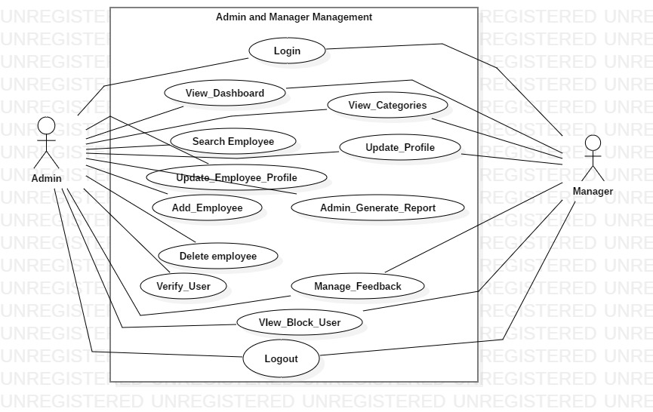

**(System Use Case Diagram: 01 “Admin and Manager Management”)**

#### 2. Auction Management

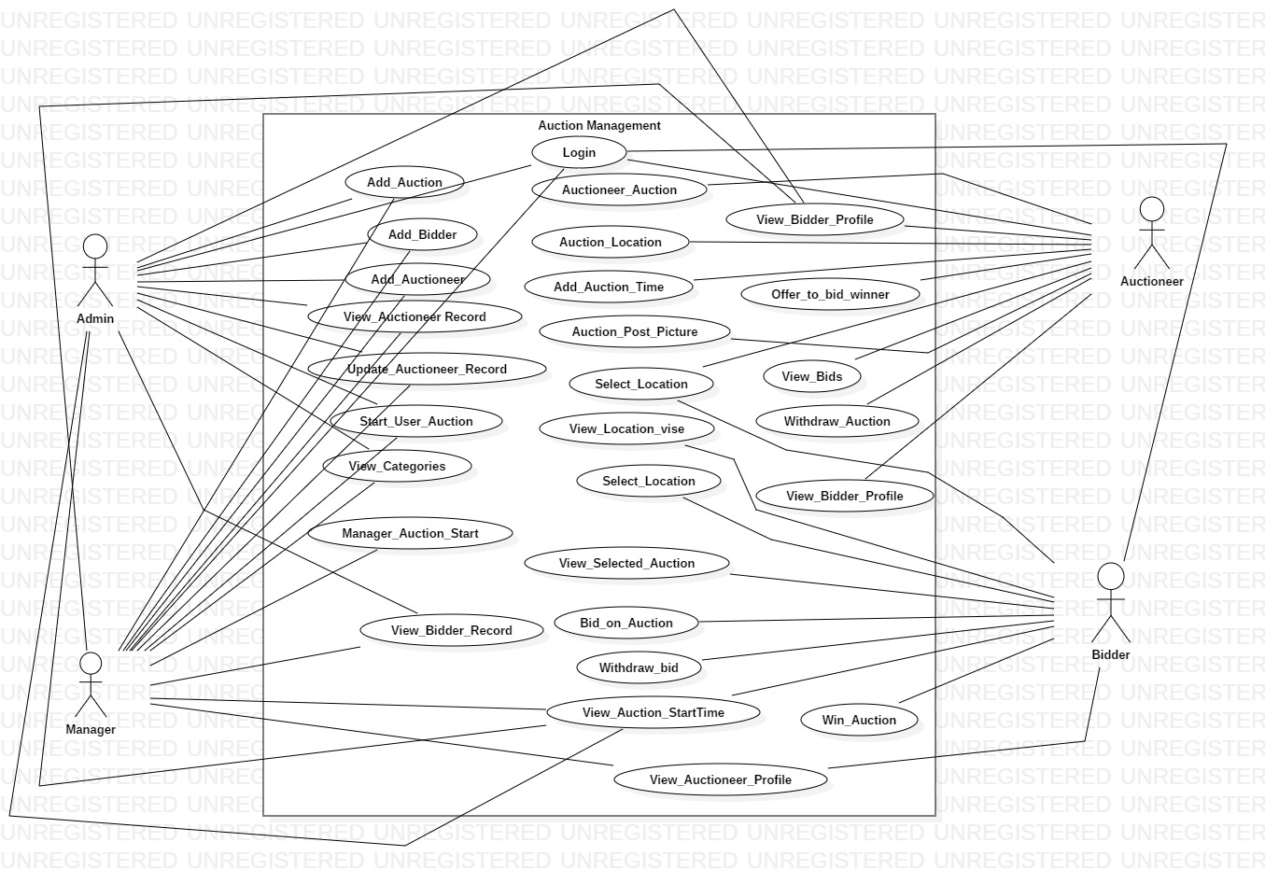

**(System Use Case Diagram: 02 “Auction Management”)**

#### 3. Customer Management

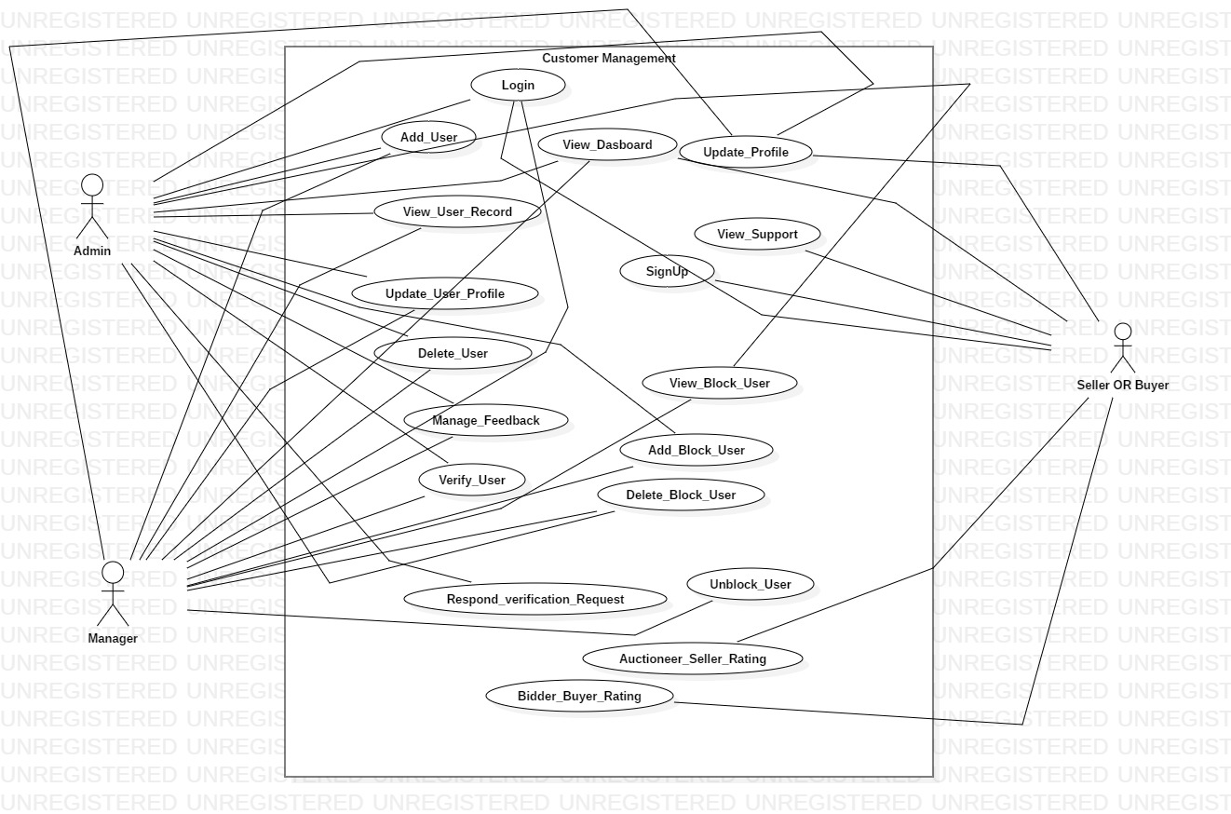

**(System Use Case Diagram: 03 “Customer Management”)**

#### 4. Report Management

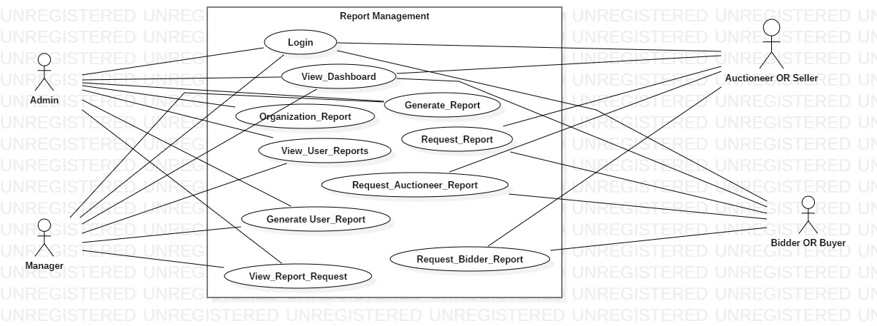

**(System Use Case Diagram: 04 “Report Management”)**

# Chapter 10 : Use Cases and Sequence Diagrams

## 2. Use Case Diagrams and Description

### 2.1 UC_Login

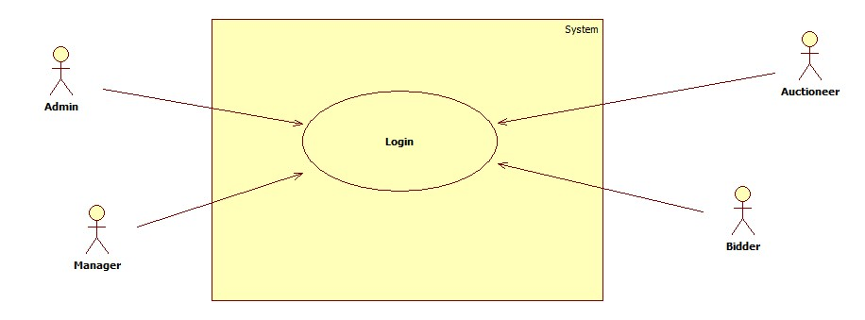

Diagram 01: UC_Login

|  |  |
| --- | --- |
| **UC-ID** | 01 |
| **UC-Name** | UC_Login |
| **UC-Actor** | Admin, Manager, Auctioneer, Bidder and user |
| **Description** | All user will sign in to access the system features. |
| **Pre-Condition** | There must be a registered id and password to login. |
| **Post-Condition** | All Actors will successfully sign in and they can use online auction. |
| **Success Scenario** | Actors successfully sign in. |
| **Alternative Scenario** | Actors entered wrong password then system will prompt a message (Invalid user name or password , try again) |

Table 01:UC_Login

### 2.2 UC_Add_Employee

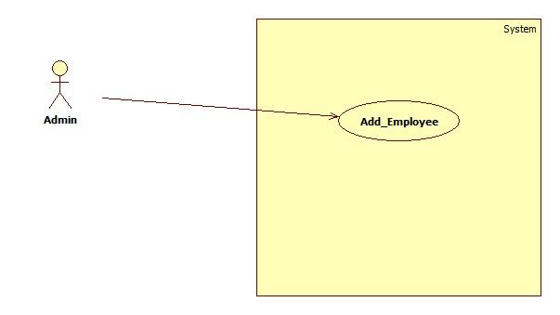

Diagram 02: UC_Add_Employee

|  |  |
| --- | --- |
| **UC-ID** | 02 |
| **UC-Name** | UC_Add_Employee |
| **UC-Actor** | Admin |
| **Description** | Admin will sign in to access the system features. |
| **Pre-Condition** | There must be a registered id and password to login. |
| **Post-Condition** | Admin successfully sign in and they can use services |
| **Success Scenario** | Admin successfully add new manager/employee system. |
| **Alternative Scenario** | If Admin entered wrong password then system will prompt a message (Invalid user name or password) OR User already exist. |

Table 02: UC_Add_Employee

### 2.3 UC_View_Employee

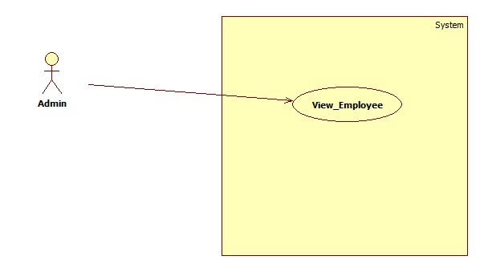

Diagram 03: UC_View_Employee

|  |  |
| --- | --- |
| **UC-ID** | 03 |
| **UC-Name** | UC_View_Employee |
| **UC-Actor** | Admin |
| **Description** | Admin will sign in to access the system features of view employee or manager. |
| **Pre-Condition** | There must be a registered id and password to login. |
| **Post-Condition** | Admin will successfully sign in and they can use service view employee. |
| **Success Scenario** | Admin successfully view employee which previously add to the system. |
| **Alternative Scenario** | If Admin entered wrong password then system will prompt a message (Invalid user name or password) |

Table 03: UC_View_Employee

### 2.4 UC_Update_Employee

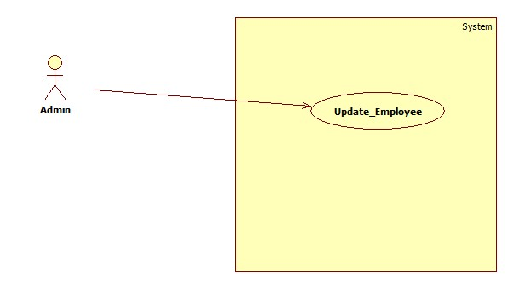

Diagram 04: UC_Update_Employee

|  |  |
| --- | --- |
| **UC-ID** | 04 |
| **UC-Name** | UC_Update_Employee |
| **UC-Actor** | Admin |
| **Description** | Admin will sign in to access the system feature of update employee. |
| **Pre-Condition** | There must be a registered id and password to login. |
| **Post-Condition** | Admin successfully sign in and they can performed update employee function. |
| **Success Scenario** | Admin successfully update employee form. |
| **Alternative Scenario** | If Admin entered wrong password then system will prompt a message (Invalid user name or password) |

Table 04: UC_Update_Employee

### 2.5 UC_Search_Employee

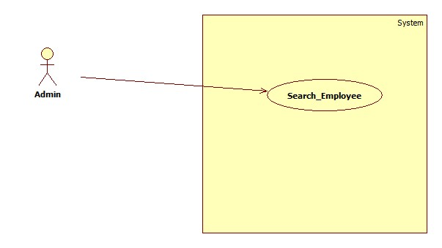

Diagram 05: UC-Search_Employee

|  |  |
| --- | --- |
| **UC-ID** | 05 |
| **UC-Name** | UC-Search_Employee |
| **UC-Actor** | Admin |
| **Description** | Admin will sign in to access the system feature search employee. |
| **Pre-Condition** | There must be a registered id and password to login. |
| **Post-Condition** | Admin will successfully sign in and search employee. |
| **Success Scenario** | Admin search for employee. |
| **Alternative Scenario** | If Admin entered wrong password then system will prompt a message (Invalid user name or password) |

Table 05: UC-Search_Employee

### 2.6 UC-Delete_Employee

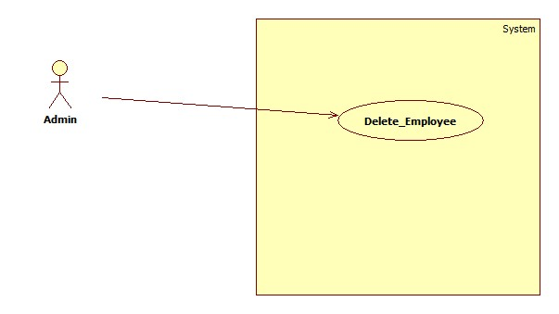

Diagram 06: UC-Delete Employee

|  |  |
| --- | --- |
| **UC-ID** | 06 |
| **UC-Name** | UC-Delete_Employee |
| **UC-Actor** | Admin |
| **Description** | Admin will sign in to access the system feature to delete employee. |
| **Pre-Condition** | There must be a registered id and password to login. |
| **Post-Condition** | Admin will successfully sign in and delete employee or manager. |
| **Success Scenario** | Admin successfully sign in and perform delete employee function. |
| **Alternative Scenario** | If Admin entered wrong password then system will prompt a message (Invalid user name or password) |

Table 06: UC-Delete_Employee

### 2.7 UC-User_SignUp

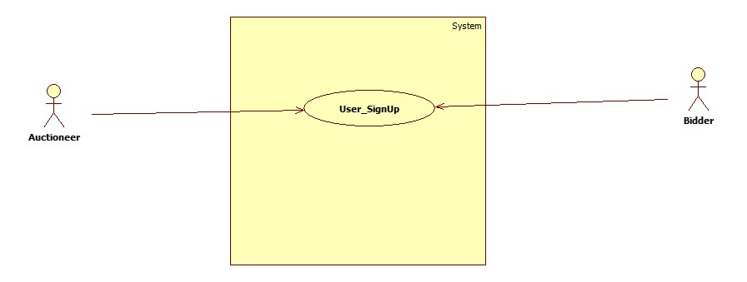

Diagram 07: UC-User_SignUp

|  |  |
| --- | --- |
| **UC-ID** | 07 |
| **UC-Name** | UC-User_SignUp |
| **UC-Actor** | Auctioneer, Bidder and user |
| **Description** | Auctioneer, Bidder and user will fill sign up form to access the system features. |
| **Pre-Condition** | Start the system to fill sign up form. |
| **Post-Condition** | Auctioneer, Bidder and user will successfully sign up and they wait for admin to verify data to use system feature. |
| **Success Scenario** | Auctioneer, Bidder and user will successfully sign up. |
| **Alternative Scenario** | Auctioneer, Bidder and user will try again and signup fill again. |

Table 07: UC-User_SignUp

### 2.8 UC-Add_User

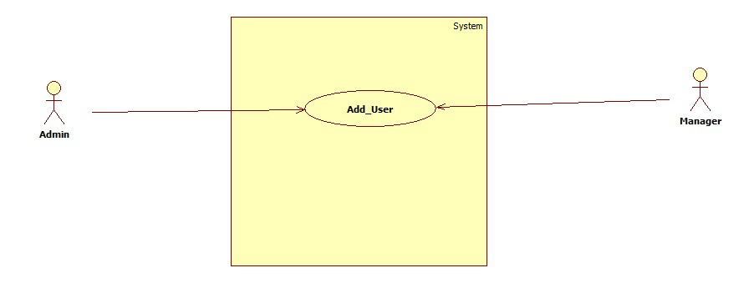

Diagram 08: UC-Add_User

|  |  |
| --- | --- |
| **UC-ID** | 08 |
| **UC-Name** | UC-Add_User |
| **UC-Actor** | Admin and Manager |
| **Description** | Admin and Manager will sign in to access the system features. |
| **Pre-Condition** | There must be a registered id and password to login. |
| **Post-Condition** | Admin and Manager will successfully sign in and they can use Add new users. |
| **Success Scenario** | Admin successfully Add user. |
| **Alternative Scenario** | If Admin or manager entered wrong password then system will prompt a message (Invalid user name or password) |

Table 08: UC-Add_User

### 2.9 UC-Add_Auction

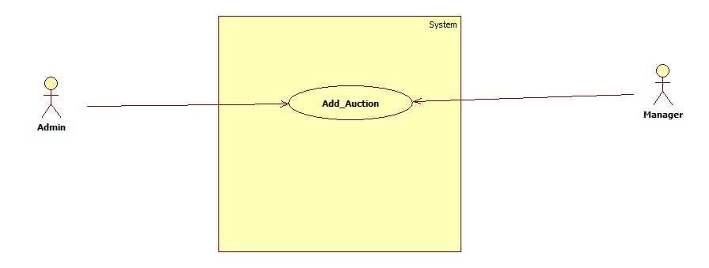

Diagram 09: UC-Add_Auction

|  |  |
| --- | --- |
| **UC-ID** | 09 |
| **UC-Name** | UC-Add_Auction |
| **UC-Actor** | Admin and Manager |
| **Description** | Admin and Manager will sign in to access this system features. |
| **Pre-Condition** | There must be a registered id and password to login. |
| **Post-Condition** | Admin and Manager will successfully sign in and they used Add Auction Feature. |
| **Success Scenario** | Admin and manger successfully add new auction on the system. |
| **Alternative Scenario** | If Admin or manager entered wrong password then system will prompt a message (Invalid user name or password) OR this id already have one auction complete it first to add new one. |

Table 09: UC-Add_Auction

### 2.10 UC-View_User_Record

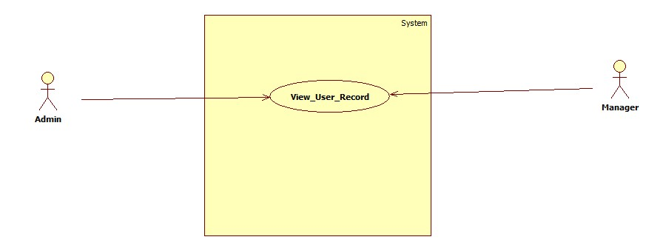

Diagram 10: UC-View_User_Record

|  |  |
| --- | --- |
| **UC-ID** | 10 |
| **UC-Name** | UC-View_User_Record |
| **UC-Actor** | Admin and Manager |
| **Description** | Admin and Manager will sign in to access this system feature. |
| **Pre-Condition** | There must be a registered id and password to login. And user is added on the system. |
| **Post-Condition** | Admin and Manager sign in and they can used view user record function. |
| **Success Scenario** | Admin and Manager successfully view user record. |
| **Alternative Scenario** | If Admin and Manager entered wrong password then system will prompt a message (Invalid user name or password) OR user record is unavailable. |

Table 10: UC-View_User_Record

### 2.11 UC-View_User_Data

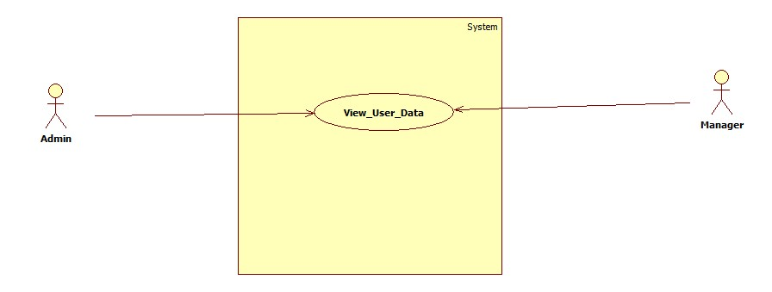

Diagram 11: UC-View_User Data

|  |  |
| --- | --- |
| **UC-ID** | 11 |
| **UC-Name** | UC-View_User_Data |
| **UC-Actor** | Admin and Manager |
| **Description** | Admin sign in to access the system features and view existing user data. |
| **Pre-Condition** | There must be a registered id and password to login. |
| **Post-Condition** | Admin will successfully view data of the user on the system. |
| **Success Scenario** | Admin and Manager successfully view data of the user on the system. |
| **Alternative Scenario** | If Admin or manager entered wrong password then system will prompt a message (Invalid user name or password) OR user not exist on the system. |

Table 11: UC-View_User Data

### 2.12 UC-Update_Auction

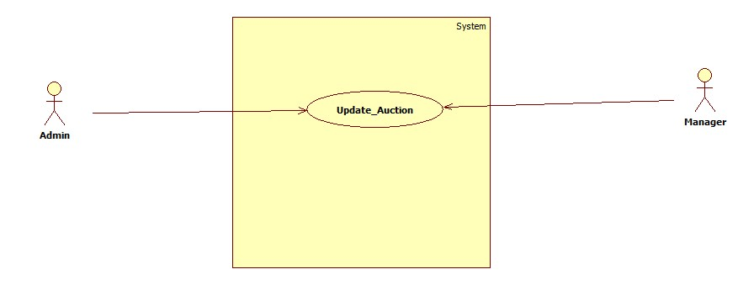

Diagram 12: UC-Update_Auction

|  |  |
| --- | --- |
| **UC-ID** | 12 |
| **UC-Name** | UC-Update_Auction |
| **UC-Actor** | Admin and Manager |
| **Description** | Admin and Manager login on the system and udate existing or ongoing auction. |
| **Pre-Condition** | There must be a registered id and password to login. |
| **Post-Condition** | Admin and manger will successfully sign in and they can use admin services. |
| **Success Scenario** | Admin and Manager successfully sign in and update an auction. |
| **Alternative Scenario** | If Admin or manager entered wrong password then system will prompt a message (Invalid user name or password) OR that auction which you are updating not exist on the system. |

Table12: UC-Update_Auction

### 2.13 UC-Delete_User_Data

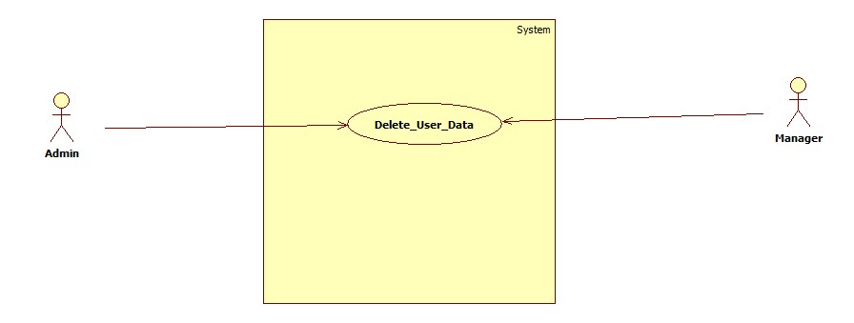

Diagram 13: UC-Delete User Data

|  |  |
| --- | --- |
| **UC-ID** | 13 |
| **UC-Name** | UC-Delete_User_Data |
| **UC-Actor** | Admin and Manager |
| **Description** | Admin and Manager login on the system and Delete selected user data on the system. |
| **Pre-Condition** | There must be a registered id and password to login. |
| **Post-Condition** | User data deleted on the system and that user not able to login without signup again. |
| **Success Scenario** | Admin and manager delete user data and user is unable to use system. |
| **Alternative Scenario** | If Admin entered wrong password then system will prompt a message (Invalid user name or password) OR you do not have enough permissions to delete that user contact with admin. |

Table 13: UC-Delete User Data

### 2.14 UC-View_User_Dashboard

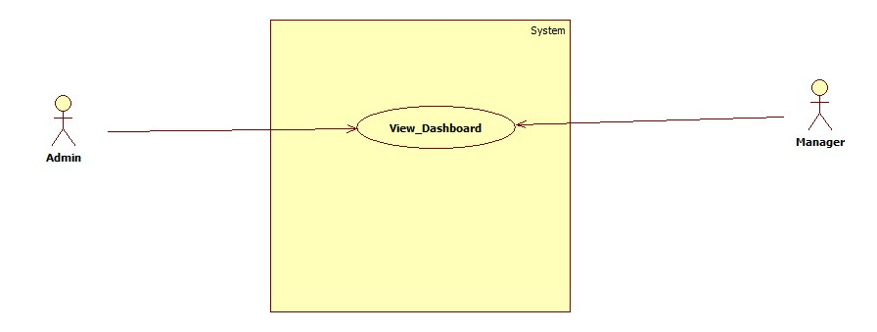

Diagram 14: UC-View User Dashboard

|  |  |
| --- | --- |
| **UC-ID** | 14 |
| **UC-Name** | UC-View_User_Dashboard |
| **UC-Actor** | Admin ,Manager, user or customer |
| **Description** | Admin, Manager, user or customer will sign in to access the system features. |
| **Pre-Condition** | There must be a registered id and password to login. |
| **Post-Condition** | Admin, Manager, user or customer will successfully sign in and they can use services and view dashboard. |
| **Success Scenario** | Admin, Manager, user or customer successfully sign in. |
| **Alternative Scenario** | If Admin, Manager, user or customer entered wrong password then system will prompt a message (Invalid user name or password) |

Table 14: UC-View User Dashboard

### 2.15 UC-Generate_Report

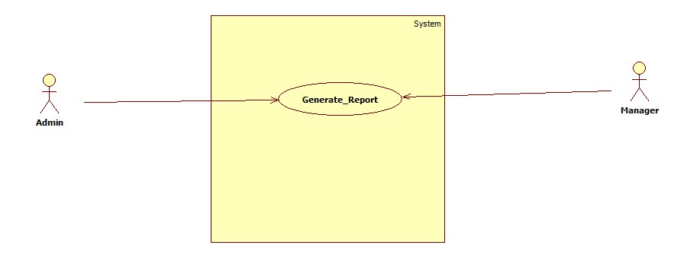

Diagram 15: UC-Generate_Report

|  |  |
| --- | --- |
| **UC-ID** | 15 |
| **UC-Name** | UC-Generate_Report |
| **UC-Actor** | Admin and Manager |
| **Description** | Admin and Manager will sign in to access this system feature. |
| **Pre-Condition** | There must be a registered id and password to login and user or customer request for report. |
| **Post-Condition** | Admin and Manager will successfully sign in and they can use services and generate user report. |
| **Success Scenario** | Admin and Manager successfully sign in and generate user reports. |
| **Alternative Scenario** | If Admin and Manager entered wrong password then system will prompt a message (Invalid user name or password) OR user not exist on our system, |

Table 15: UC-Generate_Report

### 2.16 UC-Generate_Organization_Report

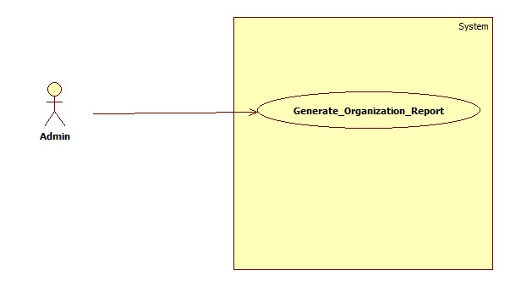

Diagram 16: UC-Generate_Organization_Report

|  |  |
| --- | --- |
| **UC-ID** | 16 |
| **UC-Name** | UC-Generate_Organization_Report |
| **UC-Actor** | Admin |
| **Description** | Admin first sign in to access the system features then create all system activities report. |
| **Pre-Condition** | There must be a registered id and password to login. |
| **Post-Condition** | Admin generated organization report and able to download it as pdf. |
| **Success Scenario** | Admin successfully generate organization report and download it on local device. |
| **Alternative Scenario** | If Admin wrong password then system will prompt a message (Invalid user name or password) |

Table 16: UC-Generate_Organization_Report

### 2.17 UC_Generate_User_report

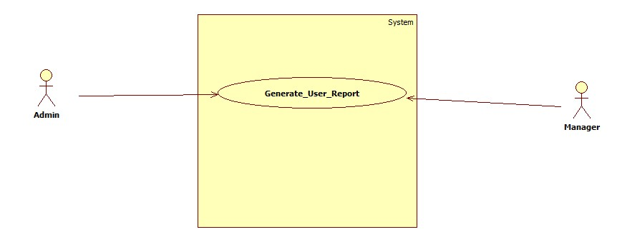

Diagram 17: UC_Generate_User_report

|  |  |
| --- | --- |
| **UC-ID** | 17 |
| **UC-Name** | UC_Generate_User_report |
| **UC-Actor** | Admin and Manager |
| **Description** | Admin and Manager will sign in to access this system feature. |
| **Pre-Condition** | There must be a registered id and password to login and user or customer request for report. |
| **Post-Condition** | Admin and Manager will successfully sign in and they can use services and generate user report. |
| **Success Scenario** | Admin and Manager successfully sign in and generate user reports. |
| **Alternative Scenario** | If Admin and Manager entered wrong password then system will prompt a message (Invalid user name or password) OR user not exist on our system, |

Table 17: UC_Generate_User_report

### 2.18 UC-Manage_Feedback

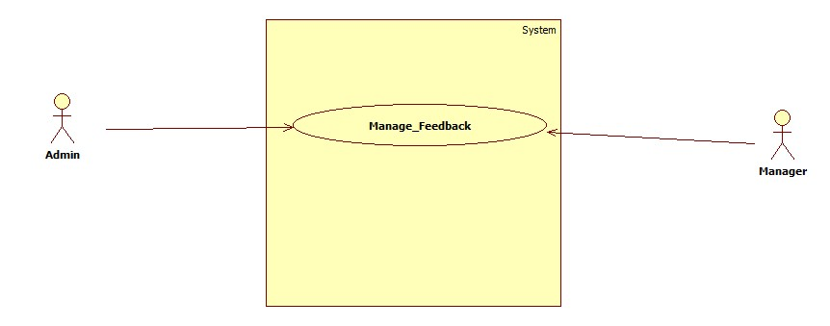

Diagram 18: UC-Manage_Feedback

|  |  |
| --- | --- |
| **UC-ID** | 18 |
| **UC-Name** | UC-Manage_Feedback |
| **UC-Actor** | Admin and Manager |
| **Description** | Admin and manager will sign in to access this system feature in which they can handle user inquiries and feedbacks. |
| **Pre-Condition** | There must be a registered id and password to login. And User send a feedback request. |
| **Post-Condition** | Admin and manager will send feedback against user inquiries. |
| **Success Scenario** | Admin and manager able to view feedbacks and reply to these feedbacks. |
| **Alternative Scenario** | If Admin or manager wrong password then system will prompt a message (Invalid user name or password) |

Table 18: UC-Manage_Feedback

### 2.19 UC-Verify_User

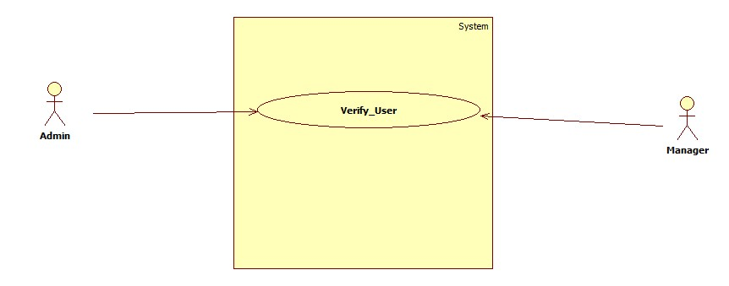

Diagram 19: UC-Verify_User

|  |  |
| --- | --- |
| **UC-ID** | 19 |
| **UC-Name** | UC-Verify_User |
| **UC-Actor** | Admin and manager |
| **Description** | Admin and manager will sign in to access this system feature in which they can handle user signup verify requests. |
| **Pre-Condition** | User must be sign up and submit their data to get a verify login. |
| **Post-Condition** | User able to login after their data verified by admin or manager. |
| **Success Scenario** | Admin and manager able to verify users and user able to login now. |
| **Alternative Scenario** | If Admin or manager wrong password then system will prompt a message (Invalid user name or password). |

Table 19: UC-Verify_User

### 2.20 UC-Add_Auctioneer

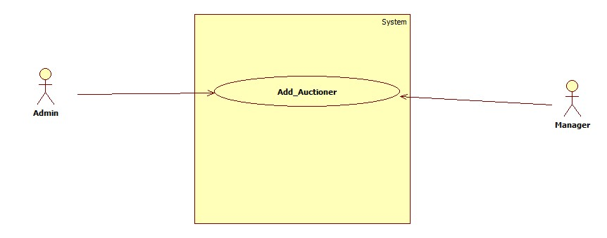

Diagram 20: UC-Add_Auctioneer

|  |  |
| --- | --- |
| **UC-ID** | 20 |
| **UC-Name** | UC-Add_Auctioneer |
| **UC-Actor** | Admin and Manager |
| **Description** | Admin and Manager can be able to add the user type auction on the system |
| **Pre-Condition** | There must be user data to register that user on the system. |
| **Post-Condition** | Added user can login on the system and then start auction. |
| **Success Scenario** | User able to login on the system and use system feature to fulfill their goals. |
| **Alternative Scenario** | If Admin or manager entered wrong password then system will prompt a message (Invalid user name or password) OR Unable to add user on the system because user is already exist on the system. |

Table 20: UC-Add_Auctioneer

### 2.21 UC-Add_Bidder

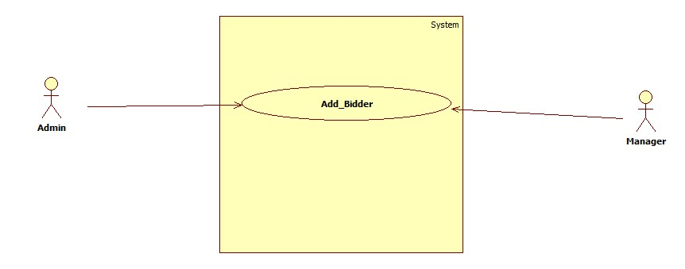

Diagram 21: UC-Add_Bidder

|  |  |
| --- | --- |
| **UC-ID** | 21 |
| **UC-Name** | UC-Add_Bidder |
| **UC-Actor** | Admin and Manager |
| **Description** | Admin and Manager can be able to add the user type bidder on the system |
| **Pre-Condition** | There must be user data to register that user on the system. |
| **Post-Condition** | Added user can login on the system and then start bidding on the auction. |
| **Success Scenario** | User able to login on the system and use system feature to fulfill their goals. |
| **Alternative Scenario** | If Admin or manager entered wrong password then system will prompt a message (Invalid user name or password) OR Unable to add user on the system because user is already exist on the system. |

Table 21: UC-Add_Bidder

### 2.22 UC-Update_Auctioneer_Record

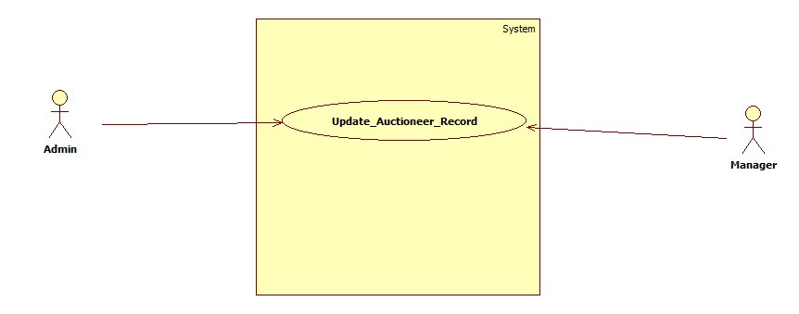

Diagram 22: UC-Update_Auctioneer_Record

|  |  |
| --- | --- |
| **UC-ID** | 22 |
| **UC-Name** | UC-Update_Auctioneer_Record |
| **UC-Actor** | Admin and Manager |
| **Description** | Admin and manager will sign in to access the system feature and update record and history of the user on the system as auctioneer. |
| **Pre-Condition** | There must be a register auctioneer user on the system for which we change the record. |
| **Post-Condition** | Auctioneer record successfully updated on the system. |
| **Success Scenario** | Admin and manager modify auctioneer record and save it on the system. |
| **Alternative Scenario** | If Admin or manager entered wrong password then system will prompt a message (Invalid user name or password) or you do not have permission to change the record please contact admin. |

Table 22: UC-Update_Auctioneer_Record

### 2.23 UC-View_Auctioneer_Record

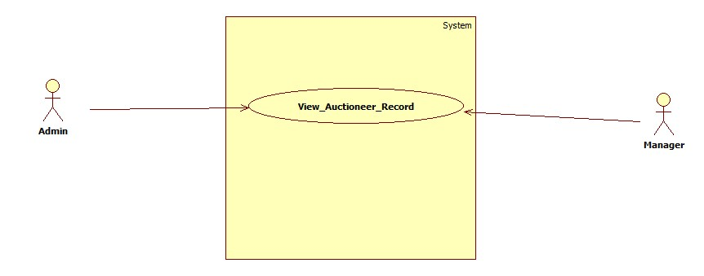

Diagram 23: UC-View_Auctioneer_Record

|  |  |
| --- | --- |
| **UC-ID** | 23 |
| **UC-Name** | UC-View_Auctioneer_Record |
| **UC-Actor** | Admin and manager |
| **Description** | Admin and manager will sign in to access the system feature and view record and history of the user on the system as auctioneer. |
| **Pre-Condition** | There must be a register auctioneer user on the system for which we view the record. |
| **Post-Condition** | Admin and manager viewed the record of the auctioneer. |
| **Success Scenario** | Admin and manager successfully view the record of the auctioneer. |
| **Alternative Scenario** | If Admin or manager entered wrong password then system will prompt a message (Invalid user name or password) or you do not have permission to view the record please contact admin. |

Table UC-View_Auctioneer_Record

### 2.24 UC-Delete_Customer_Record

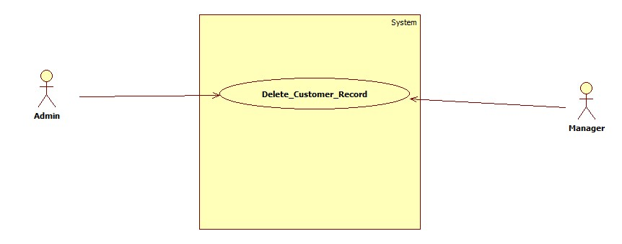

Diagram 24: UC-Delete_Customer_Record

|  |  |
| --- | --- |
| **UC-ID** | 24 |
| **UC-Name** | UC_Delete_Customer_Record |
| **UC-Actor** | Admin and manager |
| **Description** | Admin and manager will sign in to access the system feature and view record and history of the user on the system and delete the record. |
| **Pre-Condition** | There must be a register user on the system for which we delete the record. |
| **Post-Condition** | Admin and manager delete the record of the auctioneer. |
| **Success Scenario** | Admin and manager successfully delete the record of the customer. |
| **Alternative Scenario** | If Admin or manager entered wrong password then system will prompt a message (Invalid user name or password) or you do not have permission to delete the record please contact admin. |

Table 24: UC-Delete_Customer_Record

### 2.25 UC-Start_User_Auction

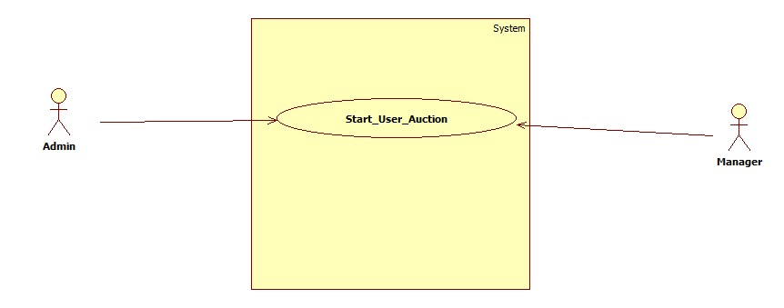

Diagram 25: UC-Start_User_Auction

|  |  |
| --- | --- |
| **UC-ID** | 25 |
| **UC-Name** | UC-Start_User_Auction |
| **UC-Actor** | Admin Manager |
| **Description** | Admin and manager |
| **Pre-Condition** | User must be registered on the system and request for start auction on the behalf of himself. |
| **Post-Condition** | User auction start displaying on the system. |
| **Success Scenario** | Admin and manager successfully add an auction for user on the system. |
| **Alternative Scenario** | If Admin or manager entered wrong password then system will prompt a message (Invalid user name or password) OR selected user already have an auction ongoing please complete this before starting another. |

Table 25: UC-Start_User_Auction

### 2.26 UC-View_Customer_Reports

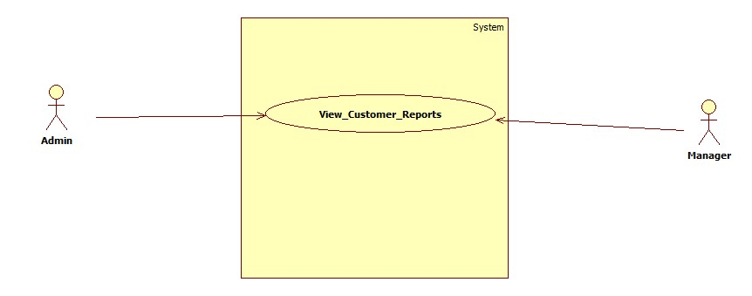

Diagram 26: UC-View_Customer_Reports

|  |  |
| --- | --- |
| **UC-ID** | 26 |
| **UC-Name** | UC-View_Customer_Reports |
| **UC-Actor** | Admin and manager |
| **Description** | Admin and manager will sign in to access the system feature and view report and history of the user on the system. |
| **Pre-Condition** | There must be a register user on the system for which we view the record. |
| **Post-Condition** | Admin and manager viewed the record of the customer. |
| **Success Scenario** | Admin and manager successfully able to view the record of the customer in the form of tabular and graphs. |
| **Alternative Scenario** | If Admin or manager entered wrong password then system will prompt a message (Invalid user name or password) or you do not have permission to view the report please contact admin. |

Table 26: UC-View_Customer_Reports

### 2.27 UC-Respond_Verification_Request

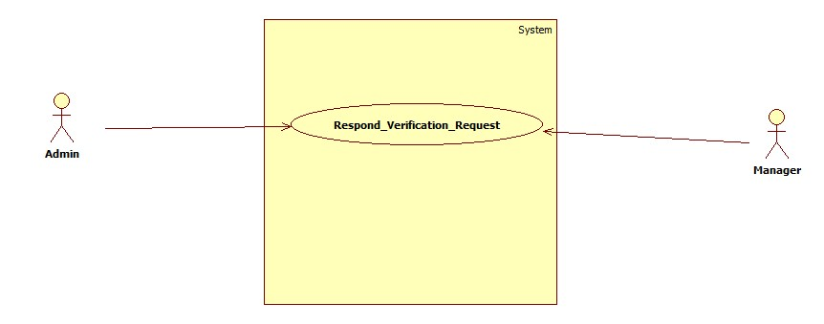

Diagram 27: UC-Respond_Verification_Request

|  |  |
| --- | --- |
| **UC-ID** | 27 |
| **UC-Name** | UC-Respond_Verification_Request |
| **UC-Actor** | Admin and manager |
| **Description** | Admin and manager will sign in to access this system feature in which they can handle user signup verify requests. |
| **Pre-Condition** | Admin or manager must be a registered id and password to login to verify user. |
| **Post-Condition** | User able to login after their data verified by admin or manager. |
| **Success Scenario** | Admin and manager able to verify users and user able to login now. |
| **Alternative Scenario** | If Admin or manager wrong password then system will prompt a message (Invalid user name or password). |

Table 27: UC-Respond_Verification_Request

### 2.28 UC-View_block_User

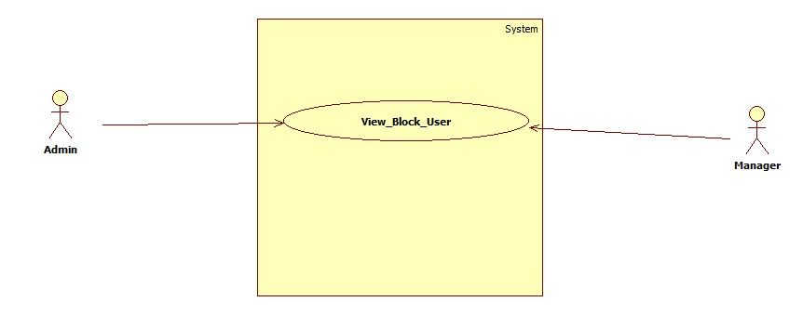

Diagram 28: UC-View_block_User

|  |  |
| --- | --- |
| **UC-ID** | 28 |
| **UC-Name** | UC-View_block_User |
| **UC-Actor** | Admin and Manager |
| **Description** | Admin and manager will sign in to access the system feature and view block user and history of the user on the system. |
| **Pre-Condition** | There must be a register and blocked user on the system for which we view block user records. |
| **Post-Condition** | Admin and manager viewed block user. |
| **Success Scenario** | Admin and manager successfully able to view block user. |
| **Alternative Scenario** | If Admin or manager entered wrong password then system will prompt a message (Invalid user name or password) or you do not have permission to view block user please contact admin. |

Table 28: UC-View_block_User

### 2.29 UC-Add_User_To_Block

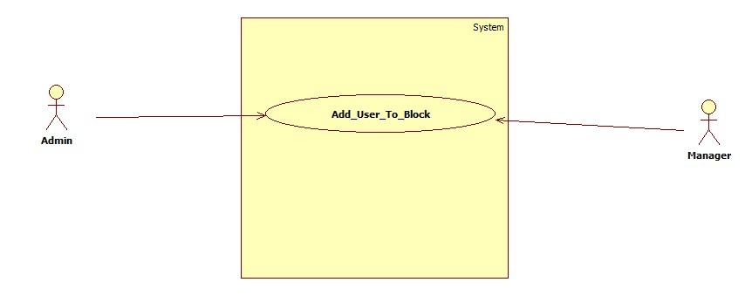

Diagram 29: UC-Add_User_To_Block

|  |  |
| --- | --- |
| **UC-ID** | 29 |
| **UC-Name** | UC-Add_User_To_Block |
| **UC-Actor** | Admin and Manager |
| **Description** | Admin and Manager can be able to add the user to block list on the system |
| **Pre-Condition** | There must be register user who violate system terms and condition, that user on the system add to the block list. |
| **Post-Condition** | Added user cannot be able to access the system features. |
| **Success Scenario** | User added to the block list successfully. |
| **Alternative Scenario** | If Admin or manager entered wrong password then system will prompt a message (Invalid user name or password) OR Unable to add user on the block list. |

Table 29: UC-Add_User_To_Block

### 2.30 UC-Delete_Block_User

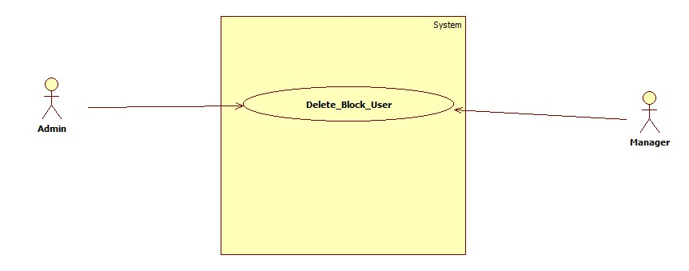

Diagram 30: UC-Delete_Block_User

|  |  |
| --- | --- |
| **UC-ID** | 30 |
| **UC-Name** | UC-Delete_Block_User |
| **UC-Actor** | Admin and manager |
| **Description** | Admin and manager will sign in to access the system feature and view record and history of the user on the system and delete the user in the block list. |
| **Pre-Condition** | There must be a register user on the system for which added to block list previously. |
| **Post-Condition** | Admin and manager delete the block user on the system. |
| **Success Scenario** | Admin and manager successfully delete the record of the block user. |
| **Alternative Scenario** | If Admin or manager entered wrong password then system will prompt a message (Invalid user name or password) or you do not have permission to delete the record please contact admin. |

Table 30: UC-Delete_Block_User

### 2.31 UC-Unblock_User

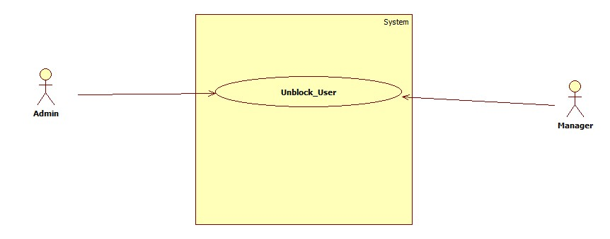

Diagram 31: UC-Unblock_User

|  |  |
| --- | --- |
| **UC-ID** | 31 |
| **UC-Name** | UC-Unblock_User |
| **UC-Actor** | Admin and Manager |
| **Description** | Admin and Manager can be able to unblock the on the system |
| **Pre-Condition** | There must be register user who violate system terms and condition, that user on the system add to the block list and request to unblock. |
| **Post-Condition** | Unblocked user able to access the system features again. |
| **Success Scenario** | User unblocked block successfully. |
| **Alternative Scenario** | If Admin or manager entered wrong password then system will prompt a message (Invalid user name or password) OR Unable to remove user from the block list please contact admin. |

Table 31: UC-Unblock_User

### 2.32 UC-Admin_Generate_Report

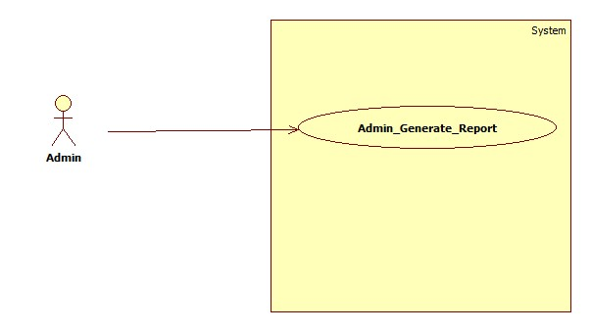

Diagram 32: UC-Admin_Generate_Report

|  |  |
| --- | --- |
| **UC-ID** | 32 |
| **UC-Name** | UC-Admin_Generate_Report |
| **UC-Actor** | Admin |
| **Description** | Admin first sign in to access the system features then create all system activities report or create a user report. |
| **Pre-Condition** | Admin must have a registered id and password to login and create reports. |
| **Post-Condition** | Admin generated report for the organization or users and able to download it as pdf. |
| **Success Scenario** | Admin successfully generate reports and download it on local device. |
| **Alternative Scenario** | If Admin wrong password then system will prompt a message (Invalid user name or password) |

Table 32: UC-Admin_Generate_Report

### 2.33 UC-View_Auctioneer

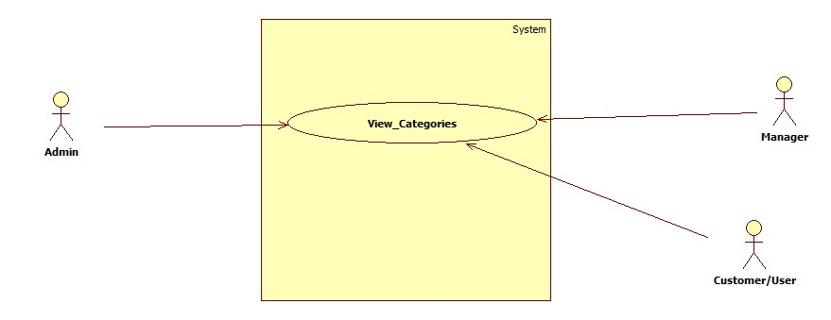

Diagram 33: UC-View Auctioneer

|  |  |
| --- | --- |
| **UC-ID** | 33 |
| **UC-Name** | UC-View_Auctioneer |
| **UC-Actor** | Admin, Manager and customer |
| **Description** | Admin, Manager and customer able to view the auctioneer, |
| **Pre-Condition** | There must be a registered id and password to login to use the system features. |
| **Post-Condition** | Admin, Manager and customer successfully sign in and they can use services such as view auctioneer. |
| **Success Scenario** | Admin, Manager and customer successfully sign in and view auctioneer. |
| **Alternative Scenario** | If Admin, Manager and customer entered wrong password then system will prompt a message (Invalid user name or password) |

Table 33: UC-View_Auctioneer

### 2.34 UC-Auctioneer_Auction

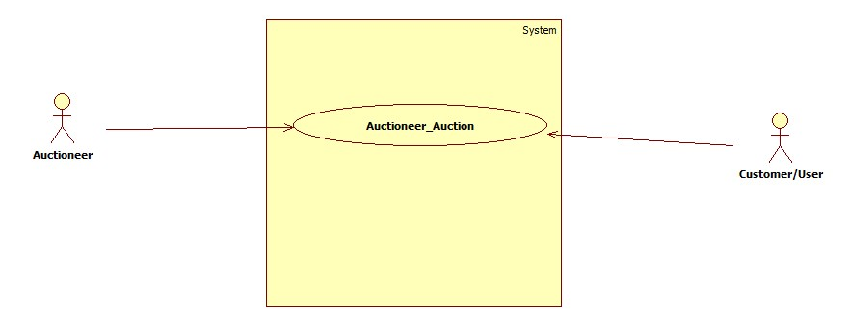

Diagram 34: UC-Auctioneer_Auction

|  |  |
| --- | --- |
| **UC-ID** | 34 |
| **UC-Name** | UC-Auctioneer_Auction |
| **UC-Actor** | Admin and Manager |
| **Description** | Admin and Manager will sign in to access this system feature in which they can add user auction on the system. |
| **Pre-Condition** | There must be a registered id and password to login to access system features. |
| **Post-Condition** | Admin and Manager will successfully sign in and they used Add Auction Feature. |
| **Success Scenario** | Admin and manger successfully add new auction on the system. |
| **Alternative Scenario** | If Admin or manager entered wrong password then system will prompt a message (Invalid user name or password) OR this id already have one auction complete it first to add new one. |

Table 34: UC-Auctioneer_Auction

### 2.35 UC-Auction_Location

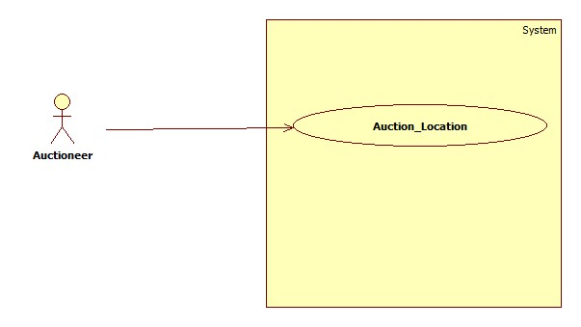

Diagram 35: UC-Auction_Location

|  |  |
| --- | --- |
| **UC-ID** | 35 |
| **UC-Name** | UC-Auction_Location |
| **UC-Actor** | Auctioneer |
| **Description** | Auctioneer sign in to access the system features and start an auction. |
| **Pre-Condition** | There must be an auction which auctioneer want to add on the system |
| **Post-Condition** | Auctioneer successfully sign in and add an auction on the system. |
| **Success Scenario** | Auctioneer able to add location in auction |
| **Alternative Scenario** | Auctioneer have an auction ongoing, please complete previous auction to start a new auction. |

Table 35: UC-Auction_Location

### 2.36 UC-Add_Auction_Time

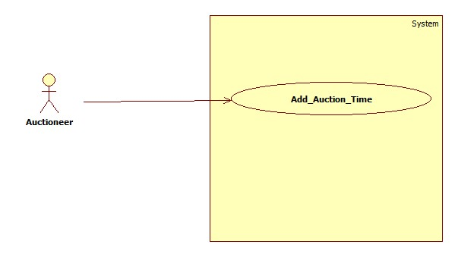

Diagram 36: UC-Add_Auction_Time

|  |  |
| --- | --- |
| **UC-ID** | 36 |
| **UC-Name** | UC-Add_Auction_Time |
| **UC-Actor** | Auctioneer |
| **Description** | Auctioneer sign in to access the system features and start an auction. |
| **Pre-Condition** | There must be an auction which auctioneer want to add on the system |
| **Post-Condition** | Auctioneer successfully sign in and add an auction on the system. |
| **Success Scenario** | Auctioneer able to add auction time in the auction. |
| **Alternative Scenario** | Auctioneer have an auction ongoing, please complete previous auction to start a new auction. OR Select time in the future please. |

Table 36: UC-Add_Auction_Time

### 2.37 UC-Request_Report

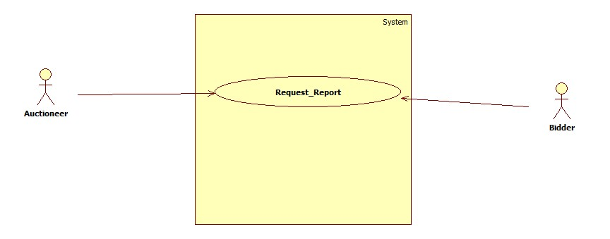

Diagram 37: UC-Request_Report

|  |  |
| --- | --- |
| **UC-ID** | 37 |
| **UC-Name** | UC-Request_Report |
| **UC-Actor** | Auctioneer and bidder |
| **Description** | Auctioneer and bidder will sign in to access the system feature and request for report. |
| **Pre-Condition** | There must be a registered auctioneer and bidder who request for the report. |
| **Post-Condition** | Admin or manager generate report and send to auctioneer or bidder which request for report. |
| **Success Scenario** | Auctioneer and bidder successfully send the request which is view by admin or manager. |
| **Alternative Scenario** | Please try again later if you send too many requests before. |

Table 37: UC-Request_Report

### 2.38 UC-Auction_Picture_Post

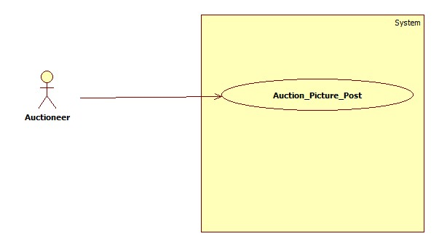

Diagram 38: UC-Auction_Picture_Post

|  |  |
| --- | --- |
| **UC-ID** | 38 |
| **UC-Name** | UC-Auction_Picture_Post |
| **UC-Actor** | Auctioneer |
| **Description** | Auctioneer sign in to access the system features and start an auction in which auctioneer add product picture. |
| **Pre-Condition** | There must be an auction which auctioneer want to add pictures. |
| **Post-Condition** | Auctioneer successfully sign in and add auction pictures on the system. |
| **Success Scenario** | Auctioneer able to add auction pictures in the auction. |
| **Alternative Scenario** | Auctioneer have an auction ongoing, please complete previous auction to start a new auction. OR picture are necessary to start an auction on the system. |

Table 38: UC-Auction Picture Post

### 2.39 UC-Select_Location

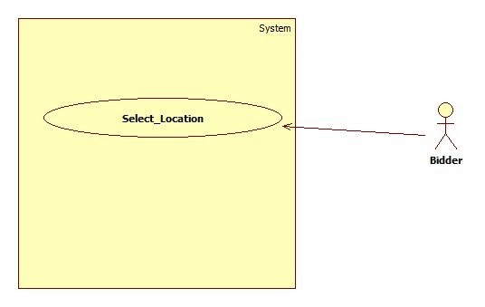

Diagram 39: UC-Select_Location

|  |  |
| --- | --- |
| **UC-ID** | 39 |
| **UC-Name** | UC-Select_Location |
| **UC-Actor** | Bidder |
| **Description** | Bidder sign in to access this system feature and bidder can select auction location in which bidder take part. |
| **Pre-Condition** | There must be a registered id and password to login and bidder is verified to access this feature. |
| **Post-Condition** | Bidder will successfully sign in and they select location to view auctions location vise. |
| **Success Scenario** | Bidder able to select location successfully. |
| **Alternative Scenario** | If Bidder entered wrong password then system will prompt a message (Invalid user name or password) |

Table 39: UC-Select_Location

### 2.40 UC-View_Auction_Categories

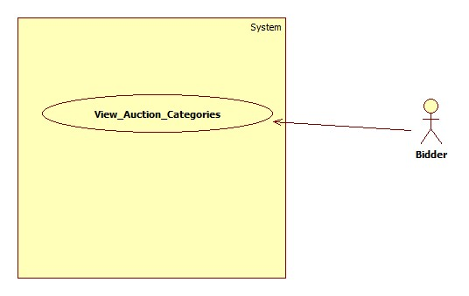

Diagram 40: UC-View_Auction_Categories

|  |  |
| --- | --- |
| **UC-ID** | 40 |
| **UC-Name** | UC-View_Auction_Categories |
| **UC-Actor** | Bidder |
| **Description** | Bidder will sign in to access the system features and view the auction categories. |
| **Pre-Condition** | There must be a registered id and password to login. |
| **Post-Condition** | Bidder successfully sign in and they can view auction categories in the menu bar. |
| **Success Scenario** | Bidder successfully sign in and view auction categories available on the system. |
| **Alternative Scenario** | If bidder entered wrong password then system will prompt a message (Invalid user name or password) |

Table 40: UC-View_Auction_Categories

### 2.41 UC_View_Location_Vise

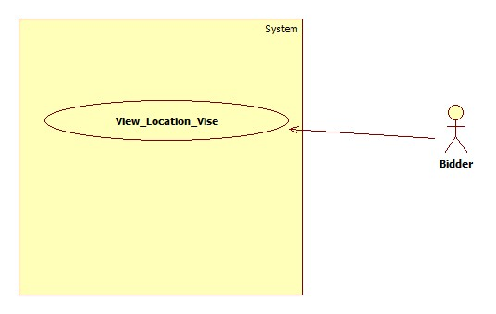

Diagram 41: UC_View_Location_Vise

|  |  |
| --- | --- |
| **UC-ID** | 41 |
| **UC-Name** | UC_View_Location_Vise |
| **UC-Actor** | Bidder |
| **Description** | Bidder sign in to access this system feature and bidder can select auction location in which bidder take part and get the view of auctions location vise categoriese. |
| **Pre-Condition** | There must be a registered id and password to login and bidder is verified to access this feature. |
| **Post-Condition** | Bidder will successfully sign in and they select location to view auctions location vise. |
| **Success Scenario** | Bidder able to select location successfully and view auctions location wise. |
| **Alternative Scenario** | If Bidder entered wrong password then system will prompt a message (Invalid user name or password) |

Table 41: UC_View_Location_Vise

### 2.42 UC_Select_Auction

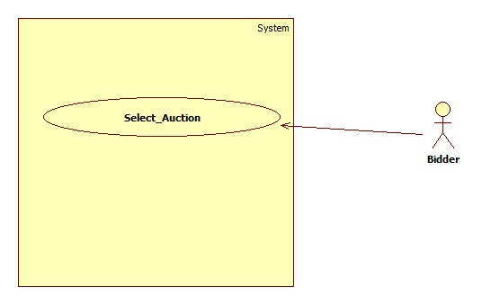

Diagram 42: UC_Select_Auction

|  |  |
| --- | --- |
| **UC-ID** | 42 |
| **UC-Name** | UC_Select_Auction |
| **UC-Actor** | Bidder |
| **Description** | Bidder sign in to access this system feature and bidder can select auction. |
| **Pre-Condition** | There must be a registered id and password to login and bidder is verified to access this feature. |
| **Post-Condition** | Bidder will successfully sign in and they select location to view auctions and select a specific auction to view. |
| **Success Scenario** | Bidder able to select auction successfully. |
| **Alternative Scenario** | If Bidder entered wrong password then system will prompt a message (Invalid user name or password) |

Table 42: UC_Select_Auction

### 2.43 UC-View_selected_Auction

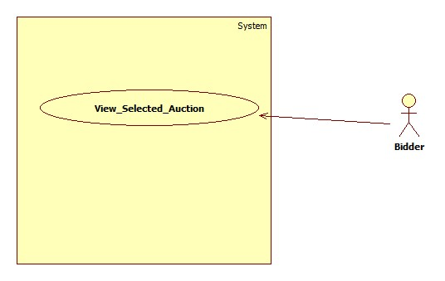

Diagram 43: UC-View_selected_Auction

|  |  |
| --- | --- |
| **UC-ID** | 43 |
| **UC-Name** | UC-View_selected_Auction |
| **UC-Actor** | Bidder |
| **Description** | Bidder will sign in to access the system features and view the selected auction. |
| **Pre-Condition** | There must be a registered id and password to login. |
| **Post-Condition** | Bidder successfully sign in and they can view auction categories in the menu bar and view a specific auction among other auctions. |
| **Success Scenario** | Bidder successfully sign in and view a selected auction. |
| **Alternative Scenario** | If bidder entered wrong password then system will prompt a message (Invalid user name or password) OR bidder must be paid user to bid on the auction. |

Table 43: UC-View_selected_Auction

### 2.44 UC-Bid_On_Auction

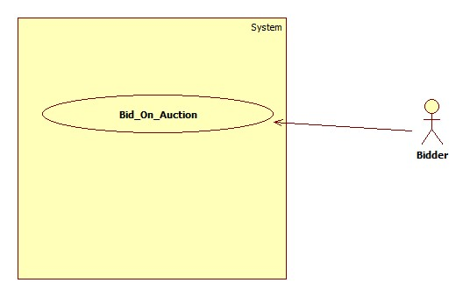

Diagram 44: UC-Bid_On_Auction

|  |  |
| --- | --- |
| **UC-ID** | 44 |
| **UC-Name** | UC-Bid_On_Auction |
| **UC-Actor** | Bidder |
| **Description** | Bidder will sign in to access the system features and view the selected auction to bid on that auction. |
| **Pre-Condition** | There must be a registered id and password to login. |
| **Post-Condition** | Bidder successfully sign in and they can view auction categories in the menu bar and view a specific auction among other auctions and bidder bid show under the auction detail. |
| **Success Scenario** | Bidder successfully sign in and bid on an auction. |
| **Alternative Scenario** | If bidder entered wrong password then system will prompt a message (Invalid user name or password) OR bidder must be paid user to bid on the auction. if bidder withdraw auction three time continuously bidder must be blocked. |

Table 44: UC-Bid_On_Auction

### 2.45 UC-Withdraw_Bid

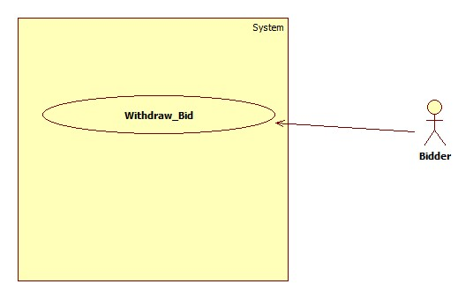

Diagram 45: UC-Withdraw_Bid

|  |  |
| --- | --- |
| **UC-ID** | 45 |
| **UC-Name** | UC-Withdraw_Bid |
| **UC-Actor** | Bidder |
| **Description** | Bidder will sign in to access the system features and view the selected auction to bid on that auction then withdraw bids on an auction. |
| **Pre-Condition** | There must be a bid on an auction by the bidder to withdrawn |
| **Post-Condition** | Bidder successfully sign in and they can view auction categories in the menu bar and view a specific auction among other auctions and bidder bid show under the auction detail then bidder withdrawn all bids on an auction. |
| **Success Scenario** | Bidder successfully delete their bids on an auction. |
| **Alternative Scenario** | If bidder entered wrong password then system will prompt a message (Invalid user name or password) OR bidder must be paid user to bid on the auction. if bidder withdraw auction three time continuously bidder must be blocked. |

Table 45: UC-Withdraw_Bid

### 2.46 UC-View_Auction_start_Time

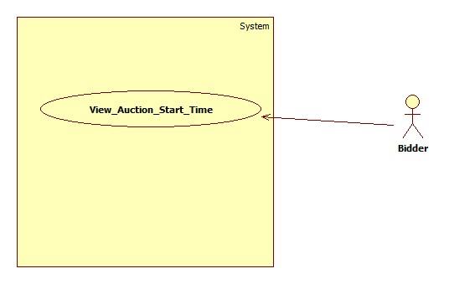

Diagram 46: UC-View_Auction_start_Time

|  |  |
| --- | --- |
| **UC-ID** | 46 |
| **UC-Name** | UC-View_Auction_start_Time |
| **UC-Actor** | Bidder |
| **Description** | Bidder will sign in to access the system features and view the selected auction time to start bidding. |
| **Pre-Condition** | There must be a registered id and password to login and bidder open the specific location view. |
| **Post-Condition** | Bidder successfully sign in and they can view auction categories in the menu bar and view a specific auction among other auctions with the start time to bidding on that selected auction view. |
| **Success Scenario** | Bidder successfully sign in and view a selected auction time to start bidding. |
| **Alternative Scenario** | If bidder entered wrong password then system will prompt a message (Invalid user name or password) . |

Table 46: UC-View_Auction_start_Time

### 2.47 UC-View_Auctioneer_Profile

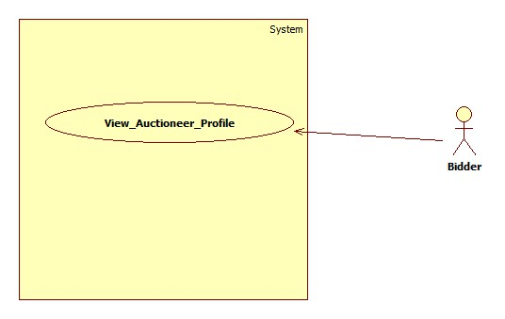

Diagram 47: UC-View_Auctioneer_Profile

|  |  |
| --- | --- |
| **UC-ID** | 47 |
| **UC-Name** | UC-View_Auctioneer_Profile |
| **UC-Actor** | Bidder |
| **Description** | Bidder able to view the auctioneer profile. |
| **Pre-Condition** | There must be a registered id and password to login to use the system features. |
| **Post-Condition** | Bidder customer successfully sign in and they can use services to view auctioneer profile and ratings plus auctioneer detail. |
| **Success Scenario** | Bidder successfully view auctioneer profile. |
| **Alternative Scenario** | If Bidder wrong password then system will prompt a message (Invalid user name or password) |

Table 47: UC-View_Auctioneer_Profile

### 2.48 UC-Win_Auction

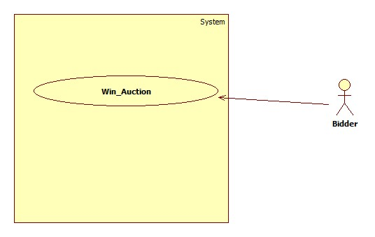

Diagram 48: UC-Win_Auction

|  |  |
| --- | --- |
| **UC-ID** | 48 |
| **UC-Name** | UC-Win_Auction |
| **UC-Actor** | Bidder |
| **Description** | Bidder get notified when bidder win an auction by default or auctioneer send an offer. |
| **Pre-Condition** | Bidder Must take part in an auction and bid. |
| **Post-Condition** | Bidder get acceptance offer from the auctioneer. |
| **Success Scenario** | Bidder win auction and get acceptance offer from the auctioneer. |
| **Alternative Scenario** | Auctioneer may select another bidder to send offer Or bidder able to reject the offer. |

Table 48: UC-Win_Auction

### 2.49 UC-Update_Profile

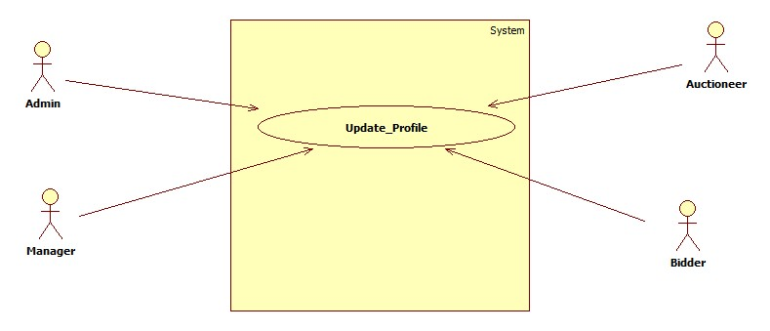

Diagram 49: UC-Update_Profile

|  |  |
| --- | --- |
| **UC-ID** | 48 |
| **UC-Name** | UC-Update_Profile |
| **UC-Actor** | Admin, Manager, Auctioneer and bidder |
| **Description** | Admin, Manager, Auctioneer and bidder update profile their profile details. |
| **Pre-Condition** | There must be a registered id and password to login. |
| **Post-Condition** | Admin, Manager, Auctioneer and bidder able to save changes to profile picture. |
| **Success Scenario** | Admin, Manager, Auctioneer and bidder successfully update their profile. |
| **Alternative Scenario** | If Admin, Manager, Auctioneer and bidder entered wrong password then system will prompt a message (Invalid user name or password) Or user unable to update profile, Please contact admin. |

Table 49: UC-Update_Profile

### 2.50 UC-View_Support

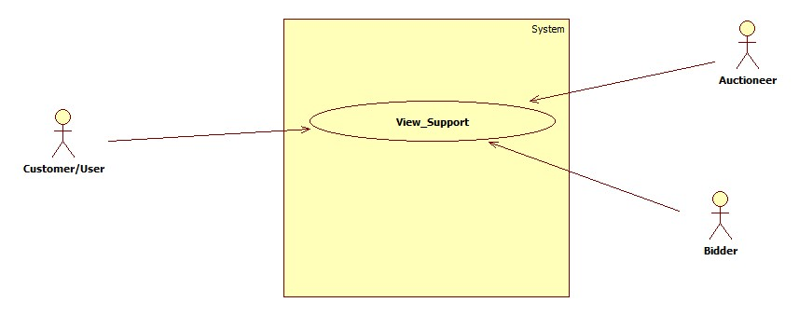

Diagram 50: UC-View_Support

|  |  |
| --- | --- |
| **UC-ID** | 50 |
| **UC-Name** | UC-View_Support |
| **UC-Actor** | Customer, Auctioneer and bidder |
| **Description** | Customer, Auctioneer and bidder will sign in to access the system feature view support. |
| **Pre-Condition** | There must be an inquiry or feedback. |
| **Post-Condition** | Customer, Auctioneer and bidder inquiry or feedback sent to the admin or manager |
| **Success Scenario** | Customer, Auctioneer and bidder inquiry or feedback successfully send. |
| **Alternative Scenario** | If Customer, Auctioneer and Bidder entered wrong password then system will prompt a message (Invalid user name or password) |

Table 50: UC-View_Support

### 2.51 UC-Request_Bidder_Report

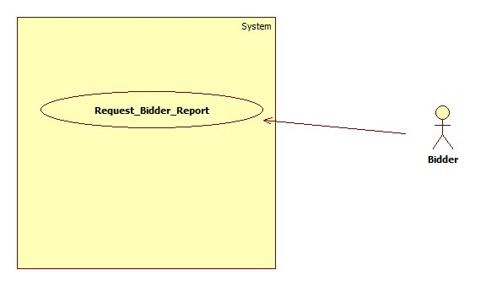

Diagram 51: UC-Request_Bidder_Report

|  |  |
| --- | --- |
| **UC-ID** | 51 |
| **UC-Name** | UC-Request_Bidder_Report |
| **UC-Actor** | Bidder |
| **Description** | Bidder will sign in to access the system feature request report. |
| **Pre-Condition** | There must be a registered id and password to login. |
| **Post-Condition** | Admin or manager view the report request of bidder. |
| **Success Scenario** | Bidder will successfully send report request. |
| **Alternative Scenario** | If Bidder entered wrong password then system will prompt a message (Invalid user name or password) |

Table 51: UC-Request_Bidder_Report

### 2.52 UC-View_Winning_Auction

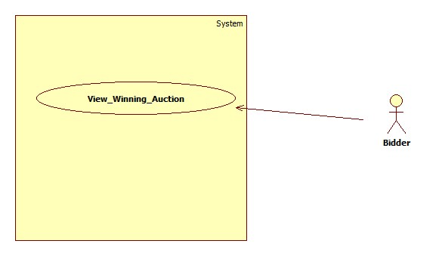

Diagram 52: UC-View_Winning_Auction

|  |  |
| --- | --- |
| **UC-ID** | 52 |
| **UC-Name** | UC-View_Winning_Auction |
| **UC-Actor** | Bidder |
| **Description** | Bidder winning auctions record shows in the view of winning auction. |
| **Pre-Condition** | There must be a registered id and password to login and participate and win an auction. |
| **Post-Condition** | Bidder view the history record of winning auctions. |
| **Success Scenario** | Bidder successfully able to view their winning auction record. |
| **Alternative Scenario** | If Bidder Visitor entered wrong password then system will prompt a message (Invalid user name or password). |

Table 52: UC-View_Winning_Auction

### 2.53 UC-View_Bids

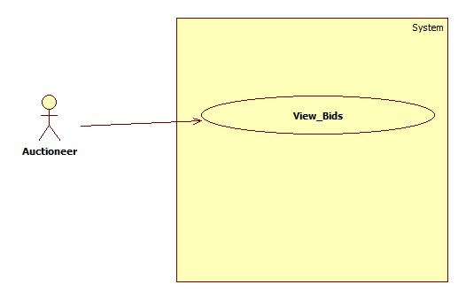

Diagram 53: UC-View_Bids

|  |  |
| --- | --- |
| **UC-ID** | 53 |
| **UC-Name** | UC-View_Bids |
| **UC-Actor** | Auctioneer |
| **Description** | Auctioneer will start an auction and watch biddings on auction, auctioneer started. |
| **Pre-Condition** | There must be a registered id and password to login and start an auction. |
| **Post-Condition** | Auctioneer will successfully view bids on his/her auction after start an auction. |
| **Success Scenario** | Auctioneer will successfully view bids on his/her auction. |
| **Alternative Scenario** | If auctioneer enter wrong password then system will prompt a message (Invalid user name or password) OR auctioneer does not have ongoing auction. |

Table 53: UC-View_Bids

### 2.54 UC-Manager_Auction_Start

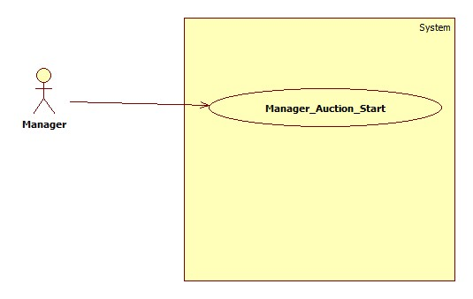

Diagram 54: UC-Manager_Auction_Start

|  |  |
| --- | --- |
| **UC-ID** | 54 |
| **UC-Name** | UC-Manager_Auction_Start |
| **UC-Actor** | Manager |
| **Description** | Manager will sign in to access the system feature star an auction for an auctioneer. |
| **Pre-Condition** | There must be a registered auctioneer who request to start an auction for himself. |
| **Post-Condition** | Auctioneer successfully started and show on the auctioneer dashboard. |
| **Success Scenario** | Manager successfully fill the form of new auction and submit. |
| **Alternative Scenario** | Auctioneer already have one auction running complete it before start new auction. |

Table 54: UC-Manager_Auction_Start

### 2.55 UC-Offer_To_Bid_Winner

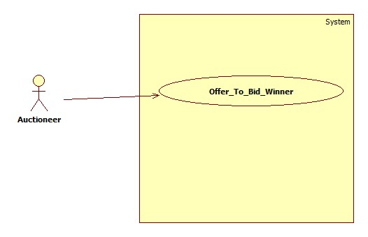

Diagram 55: UC-Offer_To_Bid_Winner

|  |  |
| --- | --- |
| **UC-ID** | 55 |
| **UC-Name** | UC-Offer_To_Bid_Winner |
| **UC-Actor** | Auctioneer |
| **Description** | Auctioneer send offer to the bidder who win auction. |
| **Pre-Condition** | There must be an auction which bidder win. |
| **Post-Condition** | Bidder successfully receive the offer request of the seller or auctioneer. |
| **Success Scenario** | Auctioneer successfully sent offer to the bidder. |
| **Alternative Scenario** | User is not exist on the system, try again message. OR selected bidder is blocked try another one. |

Table 55: UC-Offer_To_Bid_Winner

### 2.56 UC-View_Bidder_Profile

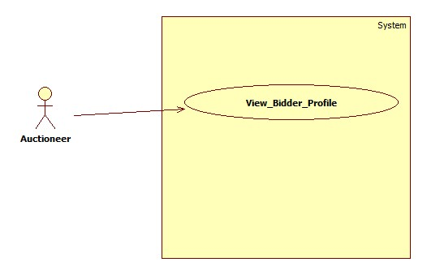

Diagram 56: UC-View_Bidder_Profile

|  |  |
| --- | --- |
| **UC-ID** | 56 |
| **UC-Name** | UC-View_Bidder_Profile |
| **UC-Actor** | Auctioneer |
| **Description** | Auctioneer able to view the bidder profile. |
| **Pre-Condition** | There must be a registered id and password to login to use the system features. |
| **Post-Condition** | Bidder customer successfully sign in and they can use services to view bidder profile and ratings plus bidder detail. |
| **Success Scenario** | Auctioneer successfully view bidder profile. |
| **Alternative Scenario** | If Auctioneer enter wrong password then system will prompt a message (Invalid user name or password) |

Table 56: UC-View_Bidder_Profile

### 2.57 UC-Give_Rating_To_Seller

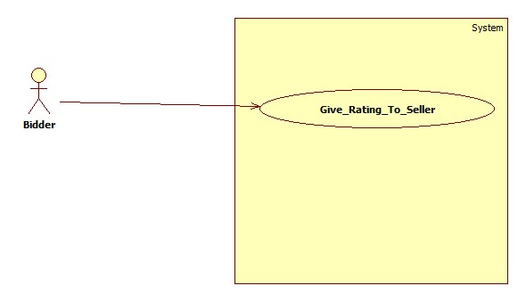

Diagram 57: UC-Give_Rating_To_Seller

|  |  |
| --- | --- |
| **UC-ID** | 57 |
| **UC-Name** | UC-Give_Rating_To_Seller |
| **UC-Actor** | Bidder, Buyer |
| **Description** | Bidder give rating to the seller or auctioneer at the end of auction process in which a bid winner selected. |
| **Pre-Condition** | There must be an auction in which auctioneer send offer to the bidder at the end. |
| **Post-Condition** | Bidder/buyer will receive seller offer and accept the offer. |
| **Success Scenario** | Bidder give successfully rating to the seller or auctioneer. |
| **Alternative Scenario** | User is not exist on the system, try again message. OR selected auctioneer is blocked try another one OR offer not accepted by bidder. |

Table 57: UC-Give_Rating_To_Seller

### 2.58 UC-Give_Rating_To_Buyer

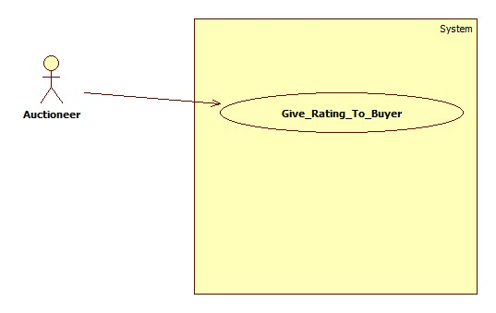

Diagram 58: UC-Give_Rating_To_Buyer

|  |  |
| --- | --- |
| **UC-ID** | 58 |
| **UC-Name** | UC-Give_Rating_To_Buyer |
| **UC-Actor** | Auctioneer/ Seller |
| **Description** | Auctioneer/Seller give rating to the buyer or buyer at the end of auction process in which a bid winner selected. |
| **Pre-Condition** | There must be an auction in which auctioneer send offer to the bidder at the end. |
| **Post-Condition** | Auctioneer/Seller will sent offer and offer accepted to the buyer |
| **Success Scenario** | Auctioneer/Seller give successfully rating to the buyer or bidder. |
| **Alternative Scenario** | User is not exist on the system, try again message. OR selected bidder is blocked try another one OR offer not accepted. |

Table 58: UC-Give_Rating_To_Buyer

## 3. Sequence Diagrams

### 3.1 SD-Login

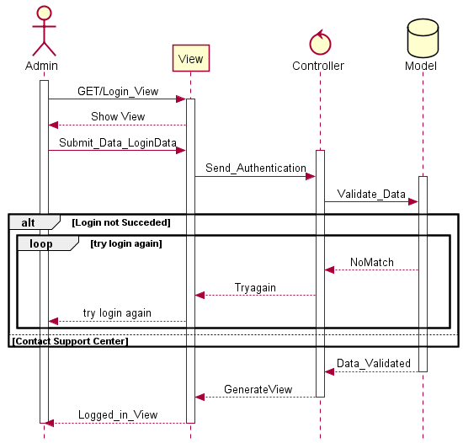

Diagram 01: SD-Login-Admin

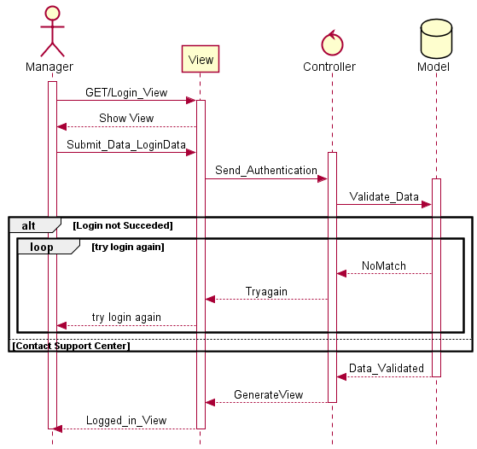

Diagram 01: SD-Login-Manager

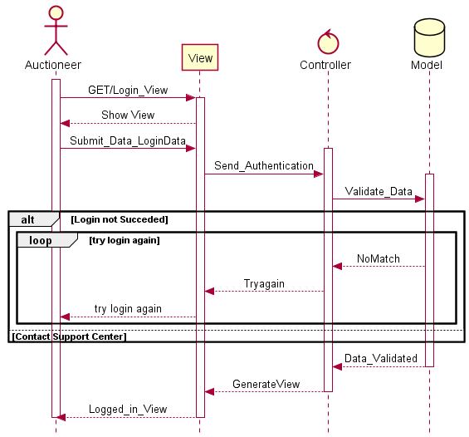

Diagram 01: SD-Login-Auctioneer

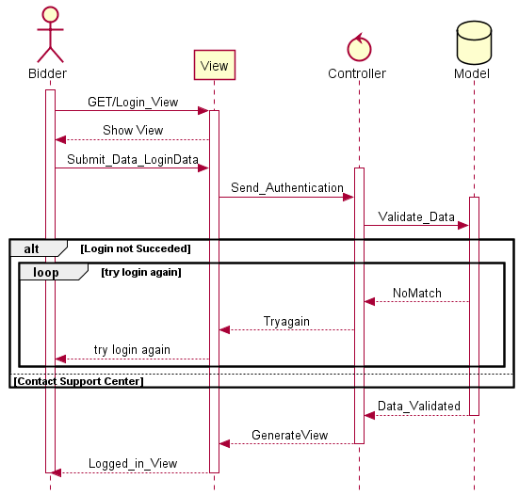

Diagram 01: SD-Login-Bidder

### 3.2 SD-Add_Employee

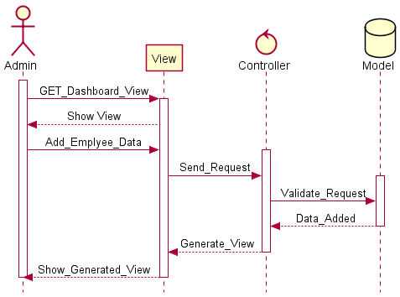

Diagram 02: SD-Add_Employee

### 3.3 SD-View_Employee

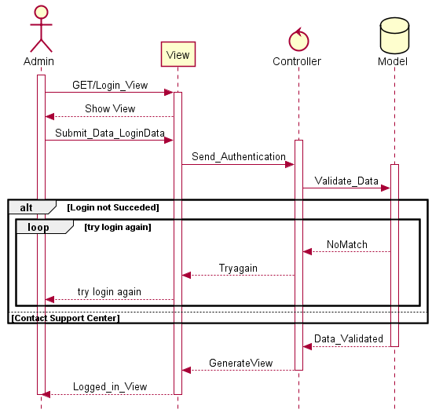

Diagram 03: SD-View_Employee

### 3.4 SD-Update_Employee

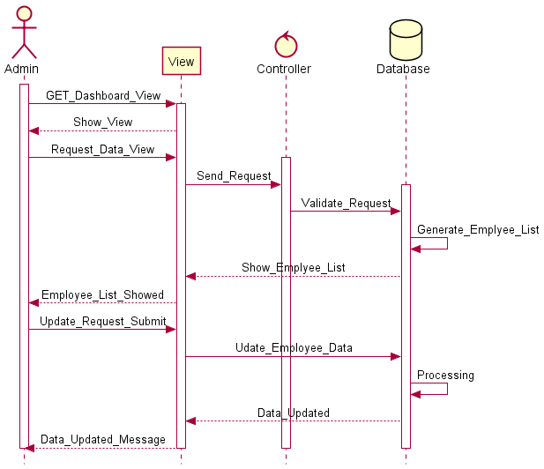

Diagram 04: SD-Update_Employee

### 3.5 SD-Search_Employee

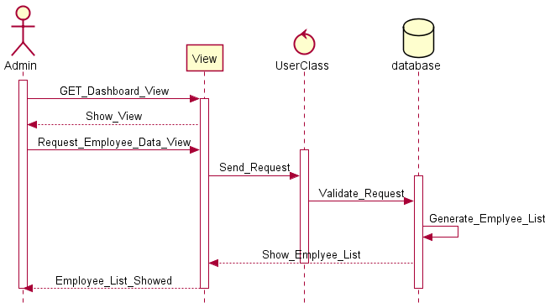

Diagram 05: SD-Search_Employee

### 3.6 SD-Delete_Employee



Diagram 06: SD-Delete_Employee

### 3.7 SD-SignUp

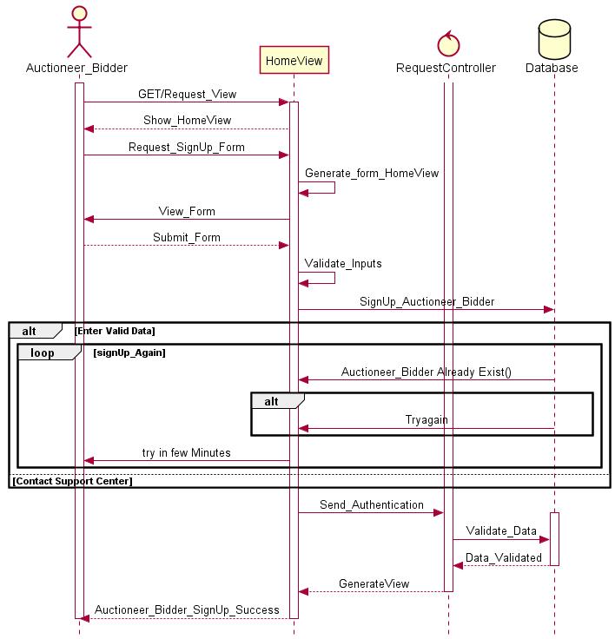

Diagram 07: SD-SignUp

### 3.8 SD-Add_User

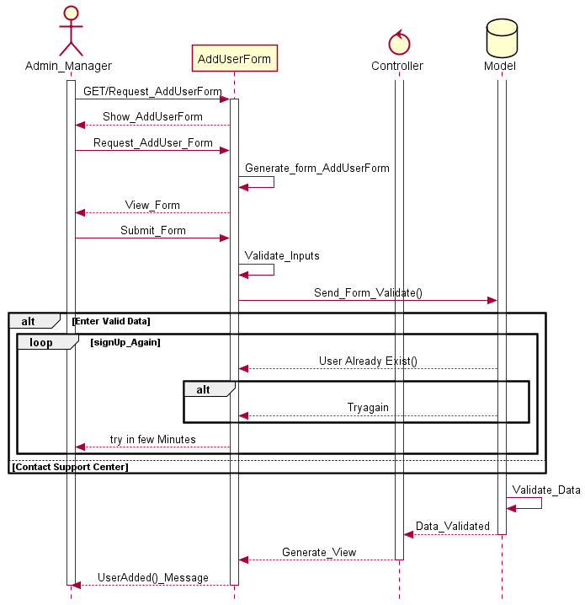

Diagram 08: SD-Add_User

### 3.9 SD-Add_Auction

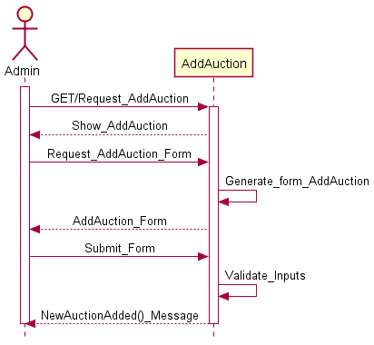

Diagram 09: SD-Add_Auction

### 3.10 SD-View_User_Record

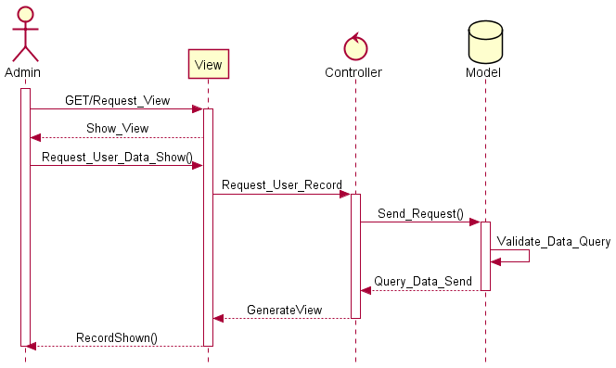

Diagram 10: SD-View_User_Record

### 3.11 SD-View_User_Data

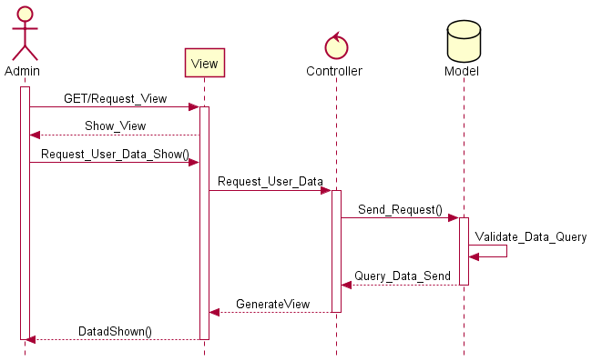

Diagram 11: SD-View_User_Data

### 3.12 SD-Update_Auction

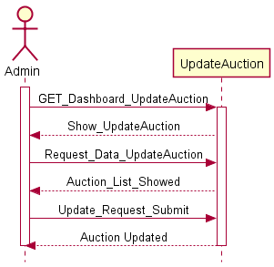

Diagram 12: SD-Update_Auction

### 3.13 SD-Delete_User

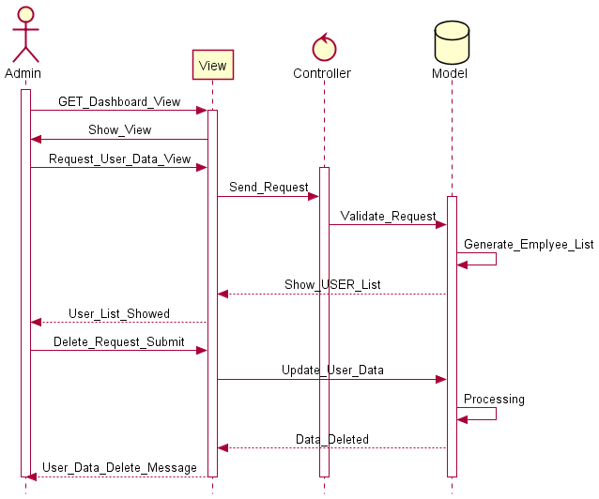

Diagram 13: SD-Delete_User

### 3.14 SD-View_dashboard

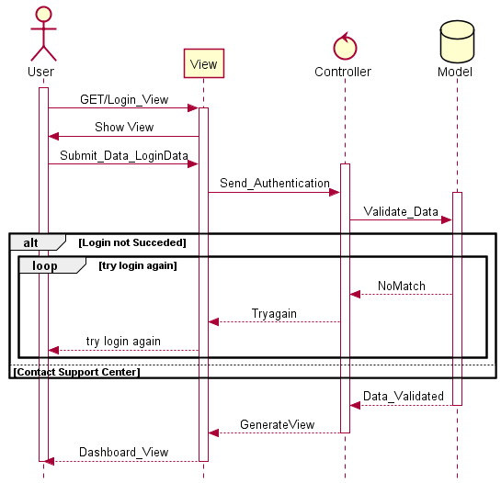

Diagram 14: SD-View_dashboard

### 3.15 SD-Generate_Report

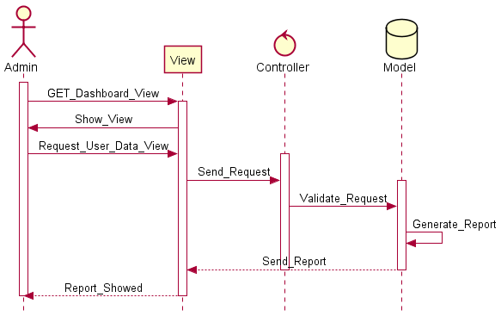

Diagram 15: SD-Generate_Report

### 3.16 SD-Generate_organization_report

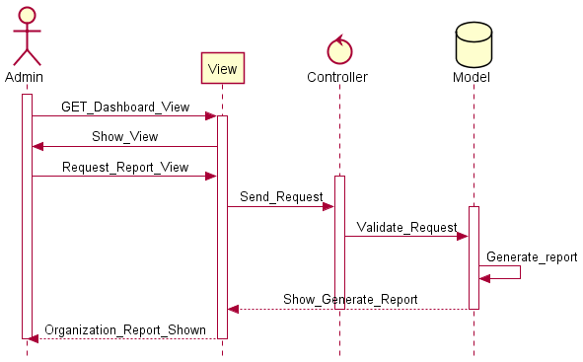

Diagram 16: SD-Generate_Organization_Report

### 3.17 SD-Generate_User_Report

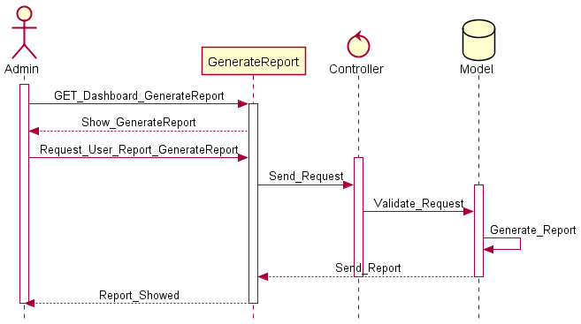

Diagram 17: SD-Generate_User_Report

### 3.18 SD-Manage_Feedback

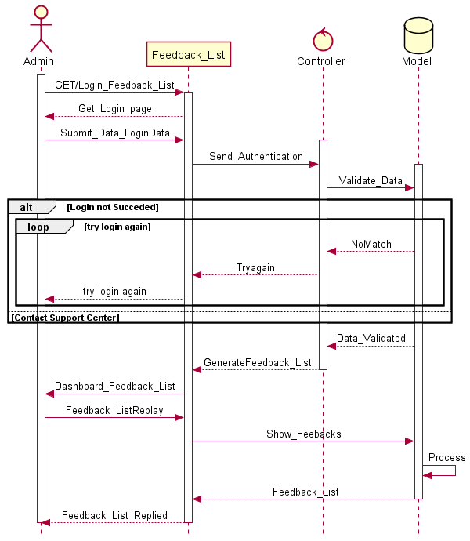

Diagram 18: SD-Manage_Feedback

### 3.19 SD-Verify_User

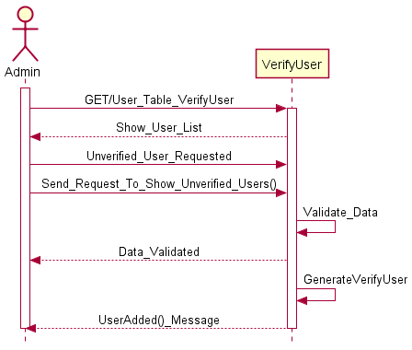

Diagram 19: SD-Verify_User

### 3.20 SD-Add_Auctioneer

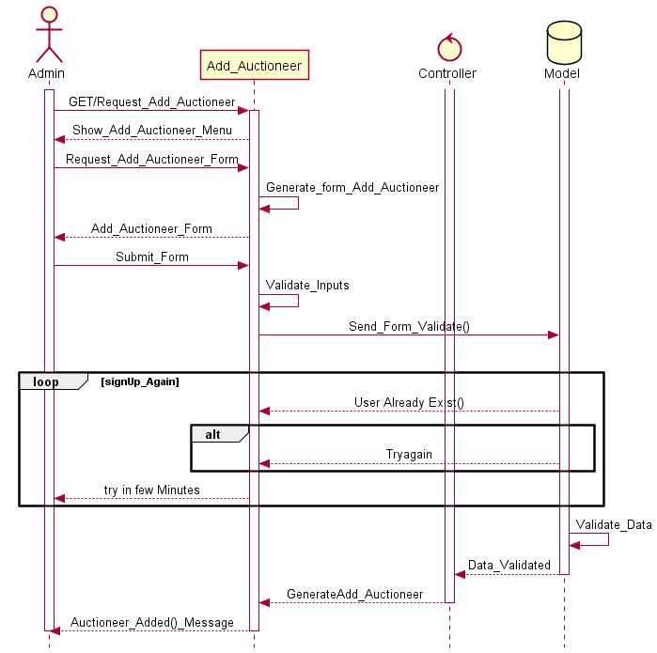

Diagram 20: SD-Add_Auctioneer

### 3.21 SD-Add_Bidder

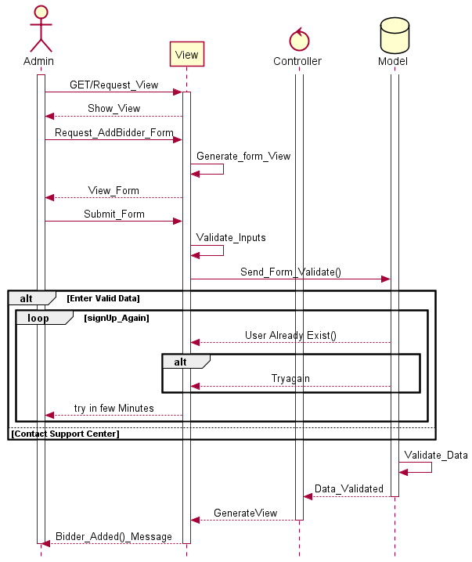

Diagram 21: SD-Add_Bidder

### 3.22 SD-View_Auctioneer_Record

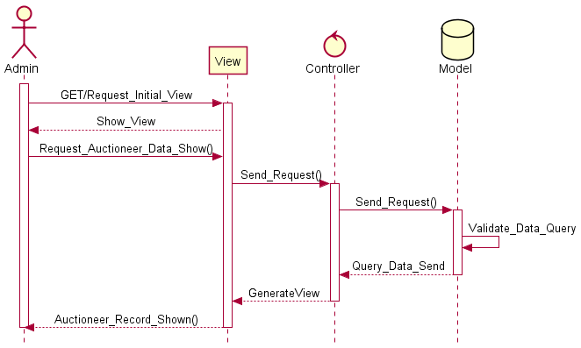

Diagram 22: SD-View_Auctioneer_Record

### 3.23 SD-Update_Auctioneer_Record

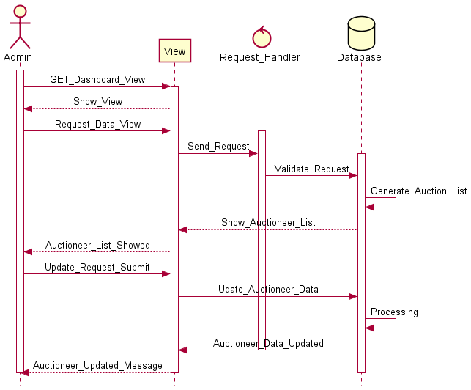

Diagram 23: SD-Update_Auctioneer_Record

### 3.24 SD-Delete_Customer_Record

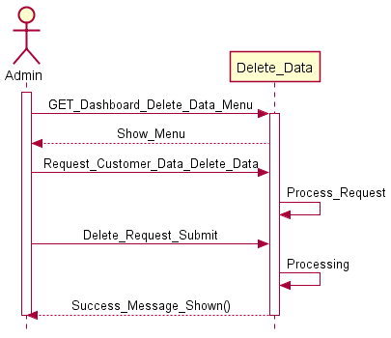

Diagram 24: SD-Delete_Customer_Record

### 3.25 SD-Add_Auction

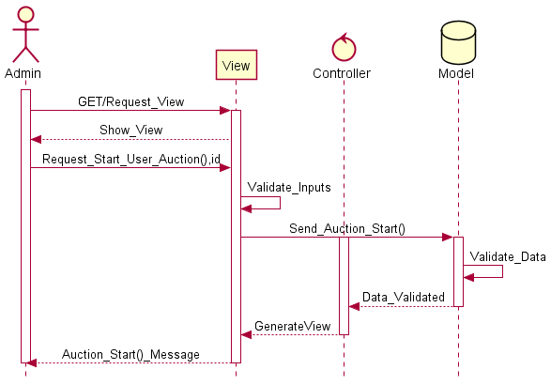

Diagram 25: SD-Add_Auction

### 3.26 SD-View_Customer_Report

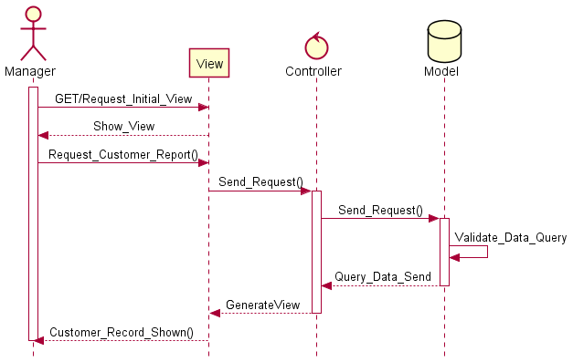

Diagram 26: SD-View_Customer_Report

### 3.27 SD-Respond_Verification_Request

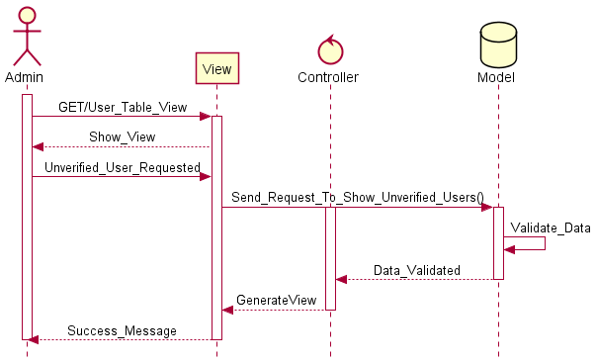

Diagram 27: SD-Respond Verification Request

### 3.28 SD-View_Block_User

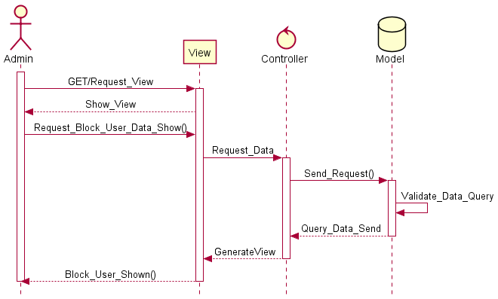

Diagram 28: SD-View_Block_User

### 3.29 SD-Add_User_To_Block

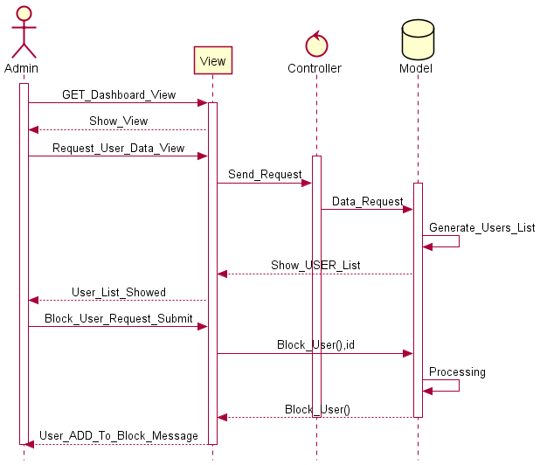

Diagram 29: SD-Add_User_To_Block

### 3.30 SD-Delete_Block_User

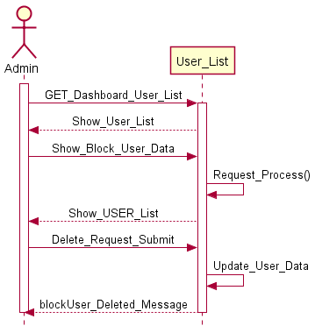

Diagram 30: SD-Delete_Block_User

### 3.31 SD-UnBlock_User

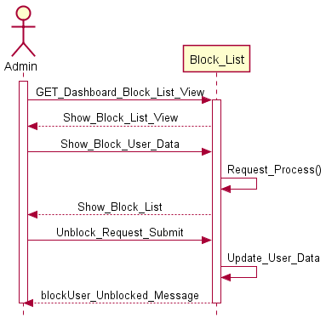

Diagram 31: SD-UnBlock_User

### 3.32 SD-Admin_Generate_Report

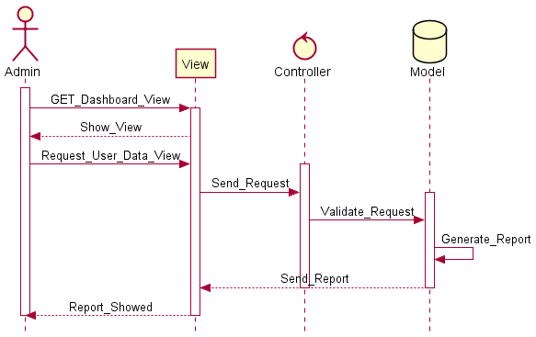

Diagram 32: SD-Admin_Generate_Report

### 3.33 SD-View_Categories

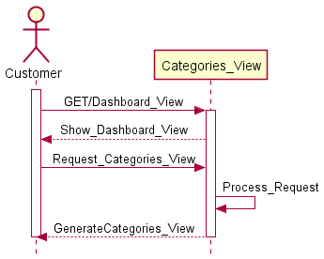

Diagram 33: SD-View_Categories

### 3.34 SD-Auctioneer_Auction

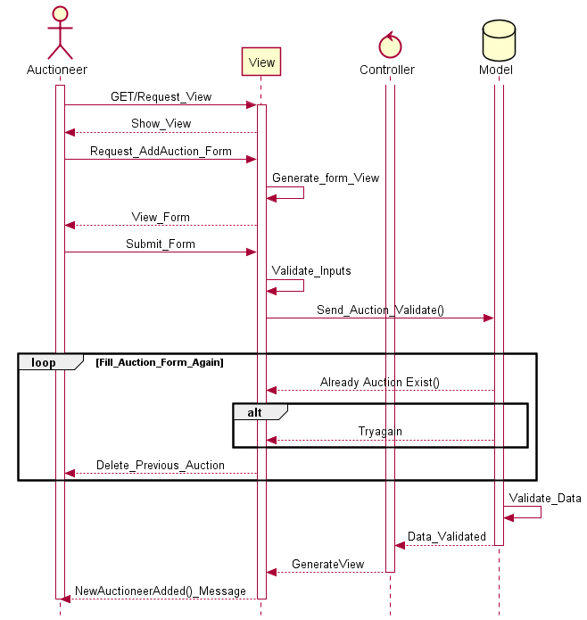

Diagram 34: SD-Auctioneer_Auction

### 3.35 SD-Auction_Location

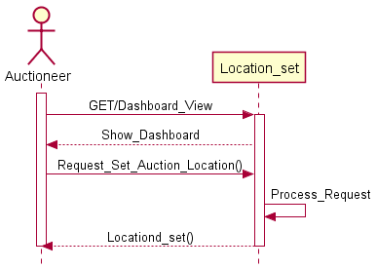

Diagram 35: SD-Auction_Location

### 3.36 SD-Add_Auction_Time

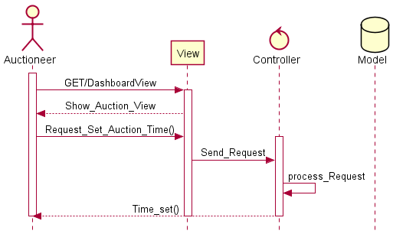

Diagram 36: SD-Add_Auction_Time

### 3.37 SD-Request_Report

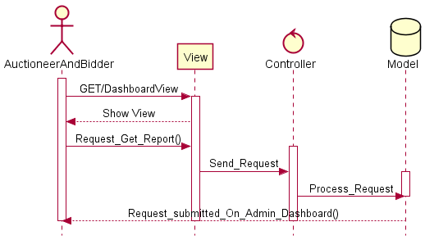

Diagram 37: SD-Request_Report

### 3.38 SD-Auction_Picture_Post

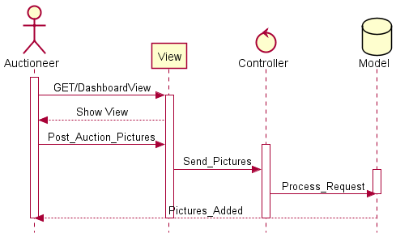

Diagram 38: SD-Auction_Picture_Post

### 3.39 SD-Select_location

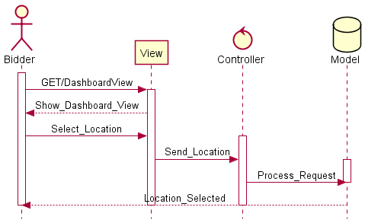

Diagram 39: SD-Select_location

### 3.40 SD-View_Auction_Categories

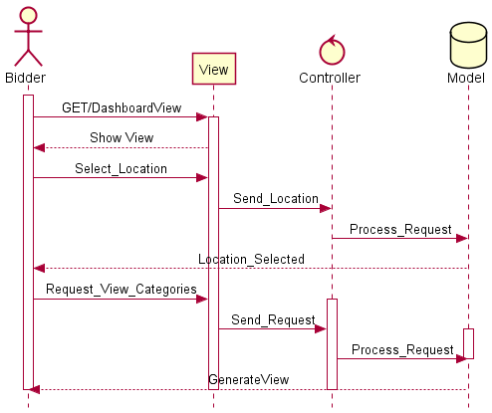

Diagram SD-View_Auction_Categories

### 3.41 SD-View_Location_Vise

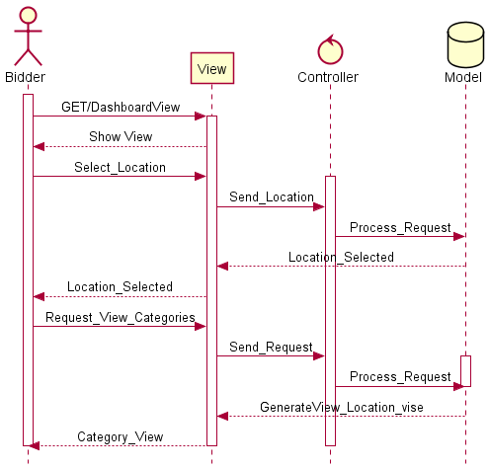

Diagram 41: SD-View_Location_Vise

### 3.42 SD-Select_Auction

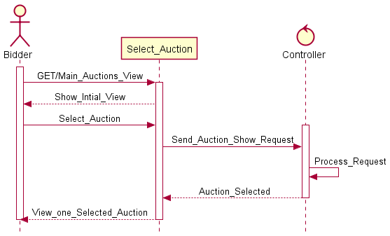

Diagram 42: SD-Select_Auction

### 3.43 SD-View_Selected_Auction

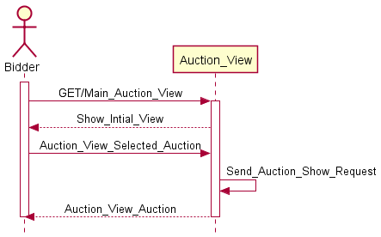

Diagram 43: SD-View_Selected_Auction

### 3.44 SD-Bid_On_Selected_Auction

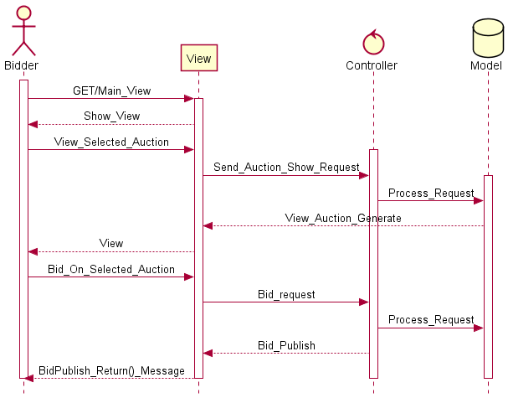

Diagram 44: SD-Bid_On_Selected_Auction

### 3.45 SD-Withdraw_Bid

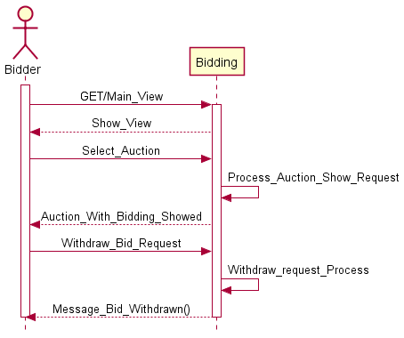

Diagram 45: SD-Withdraw_Bid

### 3.46 SD-View_Auction_Time

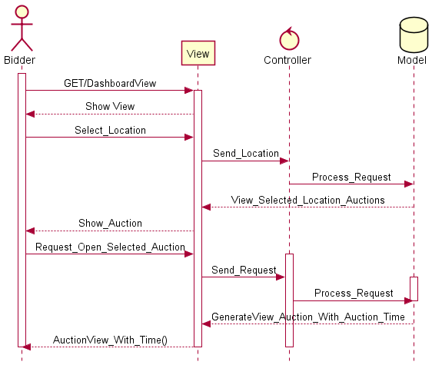

Diagram 46 SD-View_Auction_Time

### 3.47 SD-View_Auctioneer_Profile

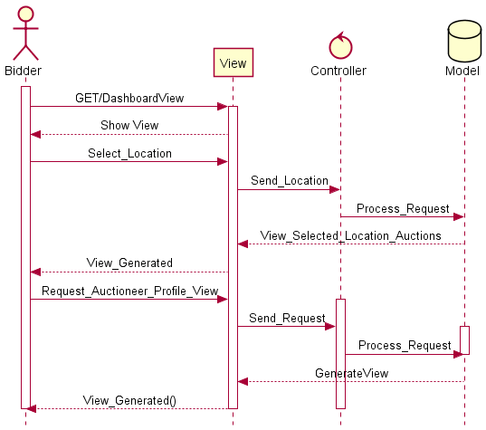

Diagram 47: SD-View_Auctioneer_Profile

### 3.48 SD-Win_Auction

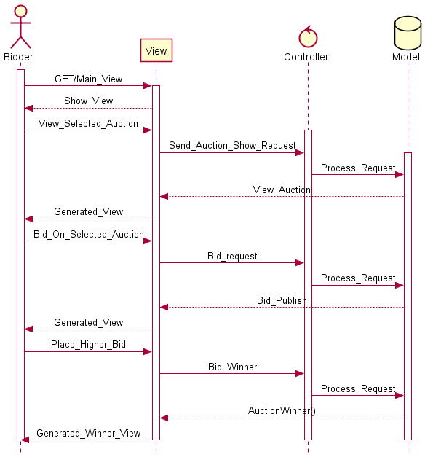

Diagram 48: SD-Win_Auction

### 3.49 SD-Update_Profile

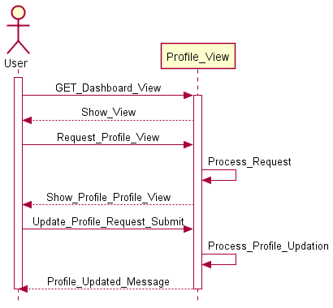

Diagram 49: SD-Update_Profile

### 3.50 SD-View_Support

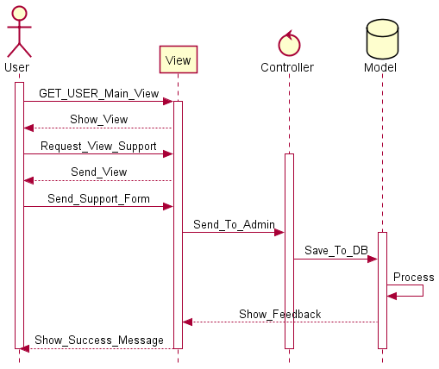

Diagram 50: SD-View_Support

### 3.51 SD-Bidder_Request_Report

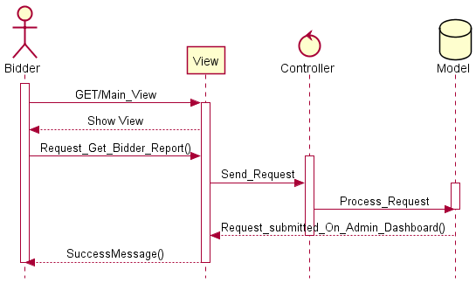

Diagram 51: SD-Bidder_Request_Report

### 3.52 SD-View_Winning_Auction

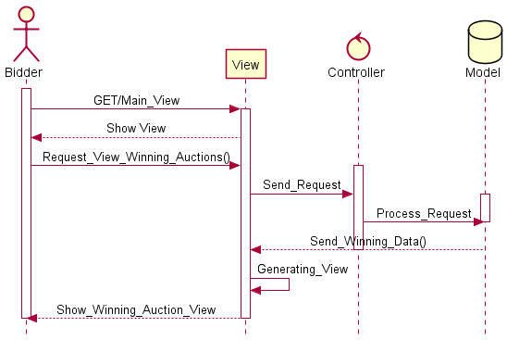

Diagram 52: SD-View Winning Auction

### 3.53 SD-View_Bids

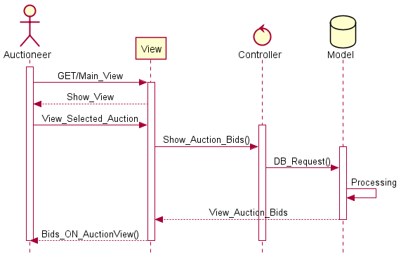

Diagram 53: SD-View_Bids

### 3.54 SD-Offer_To_Winner

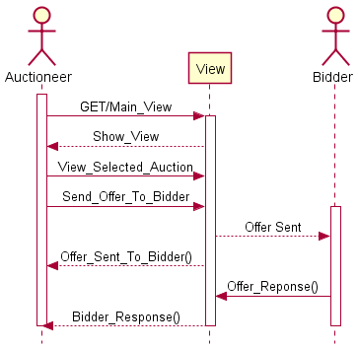

Diagram 54: SD-Offer_To_Winner

### 3.55 SD-View_Bidder_Profile

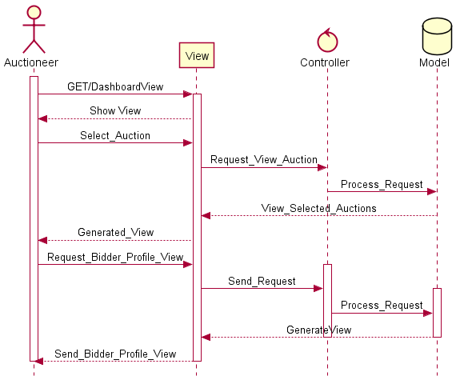

Diagram 55: SD-View_Bidder_Profile

### 3.56 SD-Manager_Auction_start

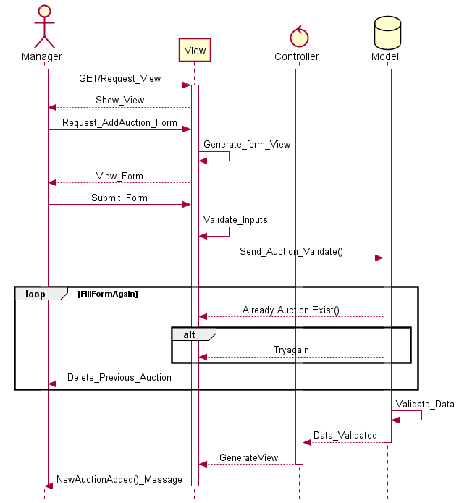

Diagram 56: SD-Manager_Auction_start

### 3.57 SD-Give_Rating_To_Seller

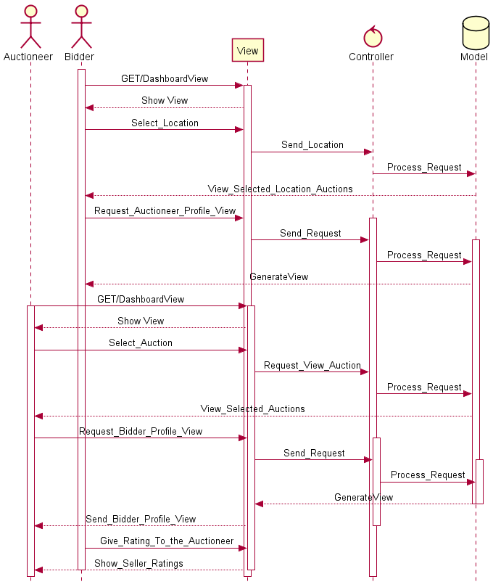

Diagram 57: SD-Give_Rating_To_Seller

### 3.58 SD-Give_Rating_To_buyer

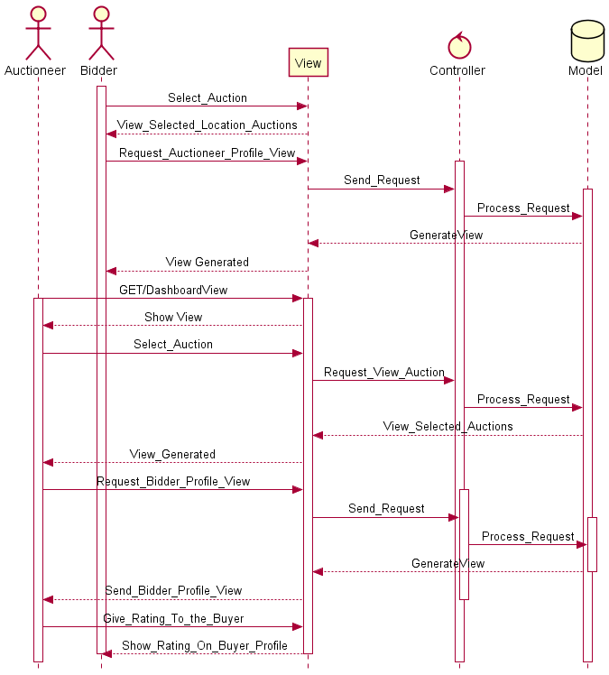

Diagram 58: SD-Give_Rating_To_buyer

# Chapter 11 : Class Diagrams

## 4. Class Diagram

### 4.1 Class Diagram Auction

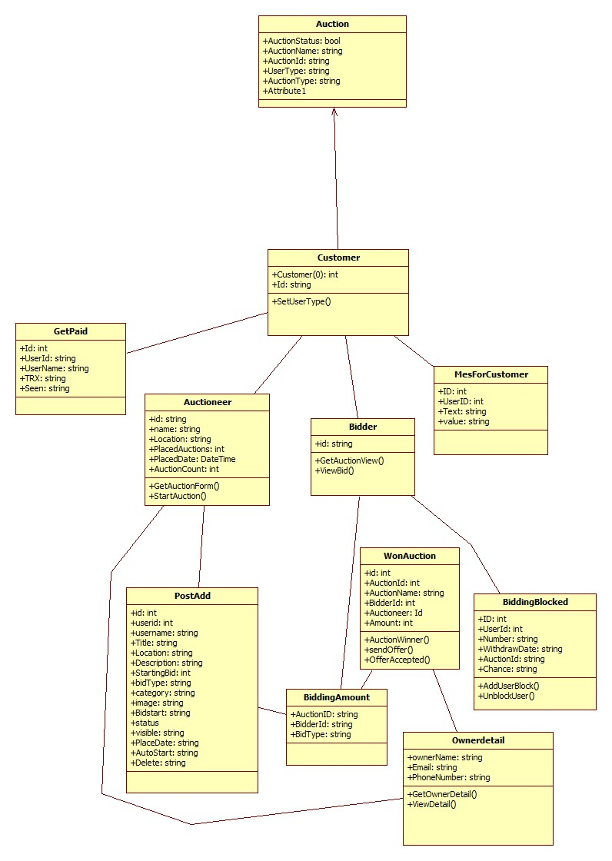

**(Class Diagram 01)**

### 4.2 Class Diagram User

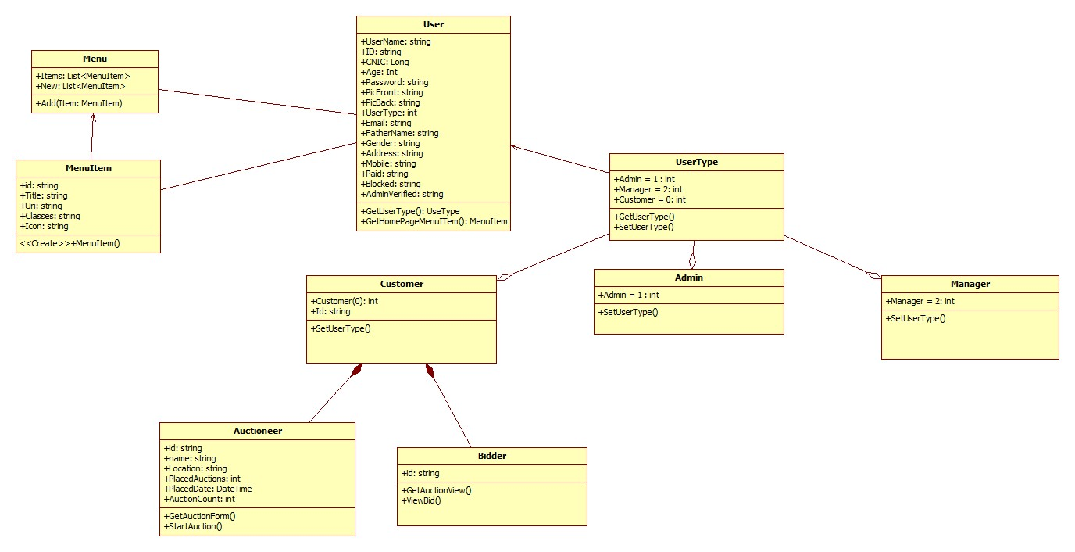

**(Class Diagram 02)**

### 4.3 Class Diagram

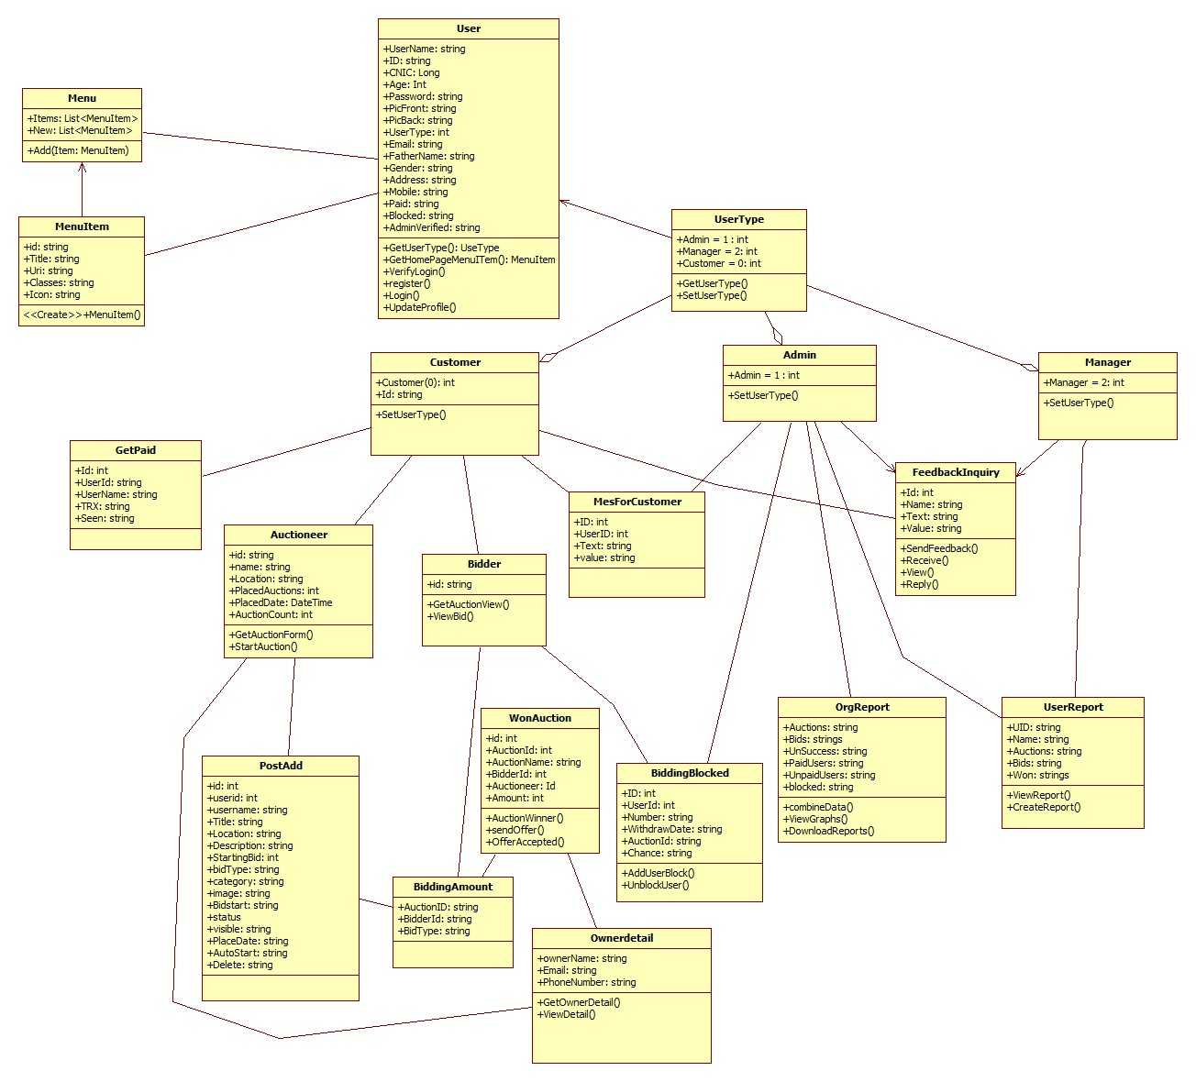

**(Class Diagram 03)**

# Chapter 12 : Data Model

## 5. Data Model

### 5.1 ERD (Entity Relationship Diagram)

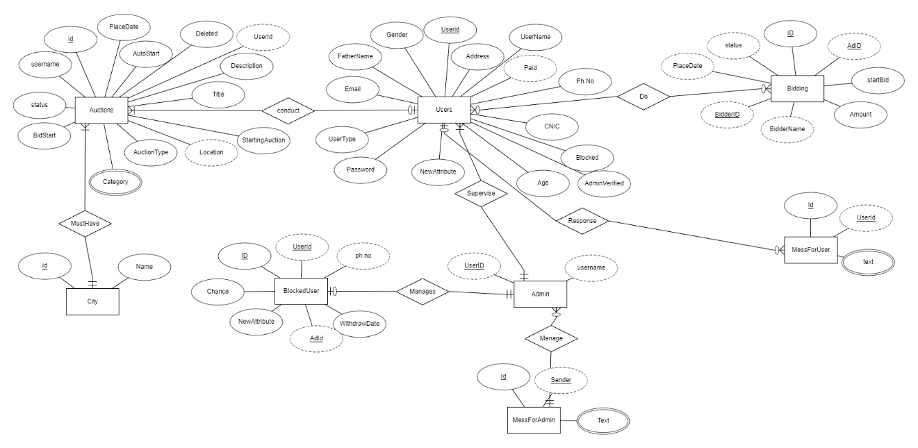

**(ERD Diagram 01)**

### 5.2 ERD Diagram

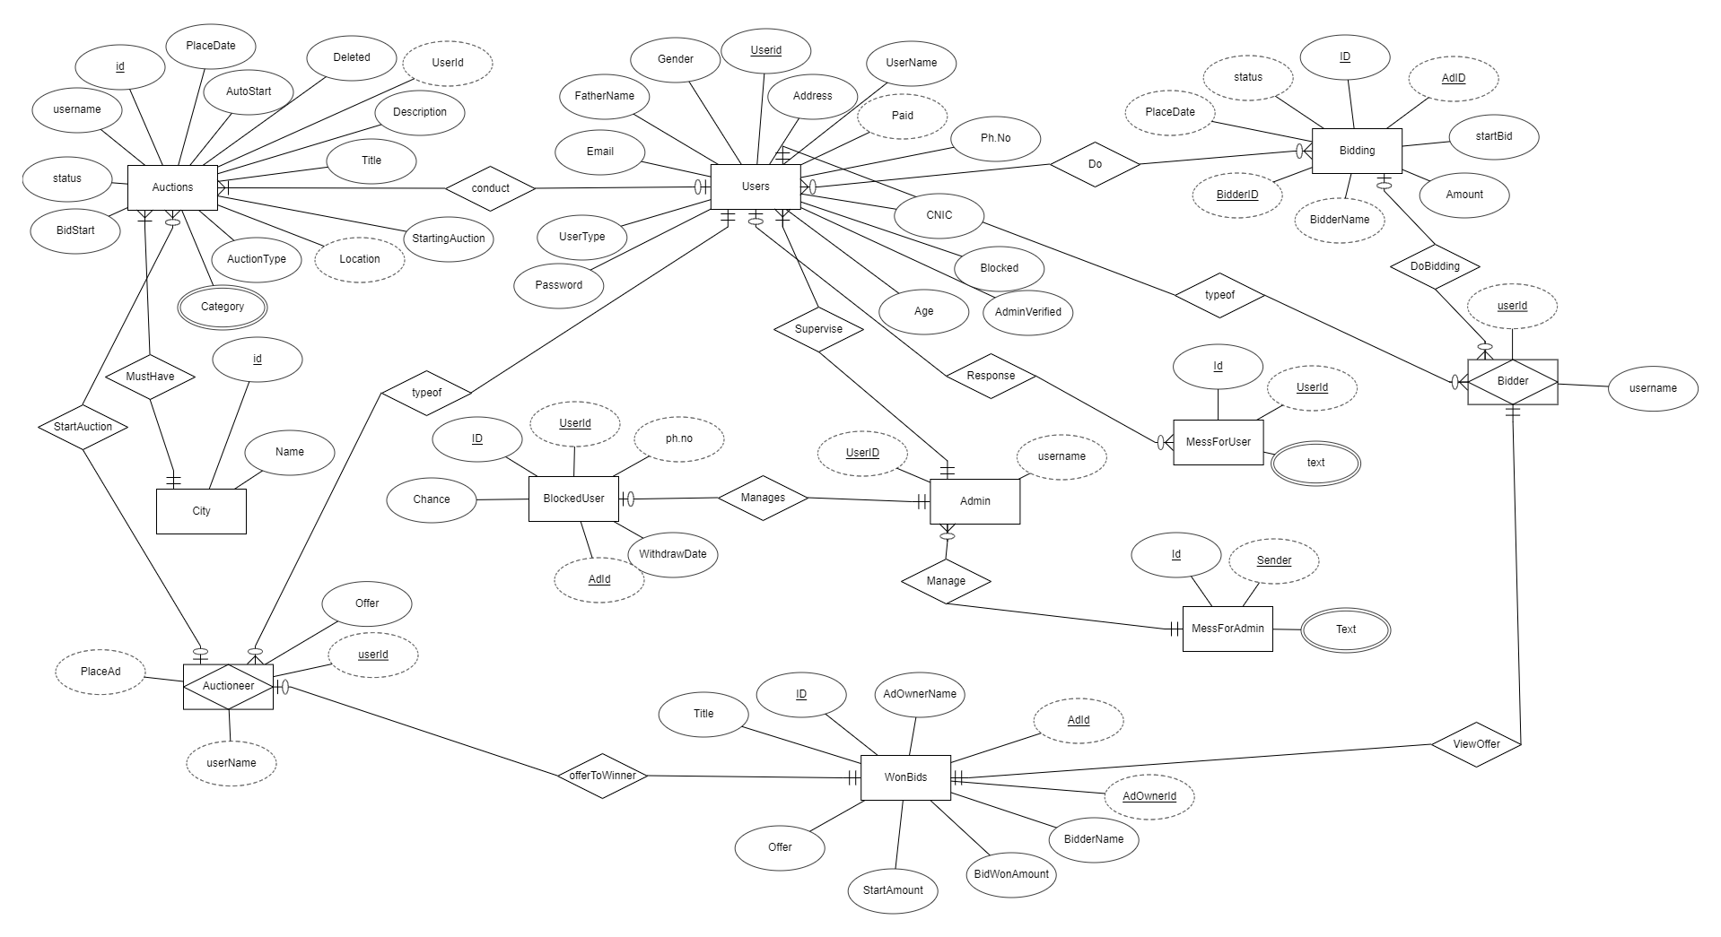

**(ERD Diagram 02)**

### 5.3 Relational Schema (a)

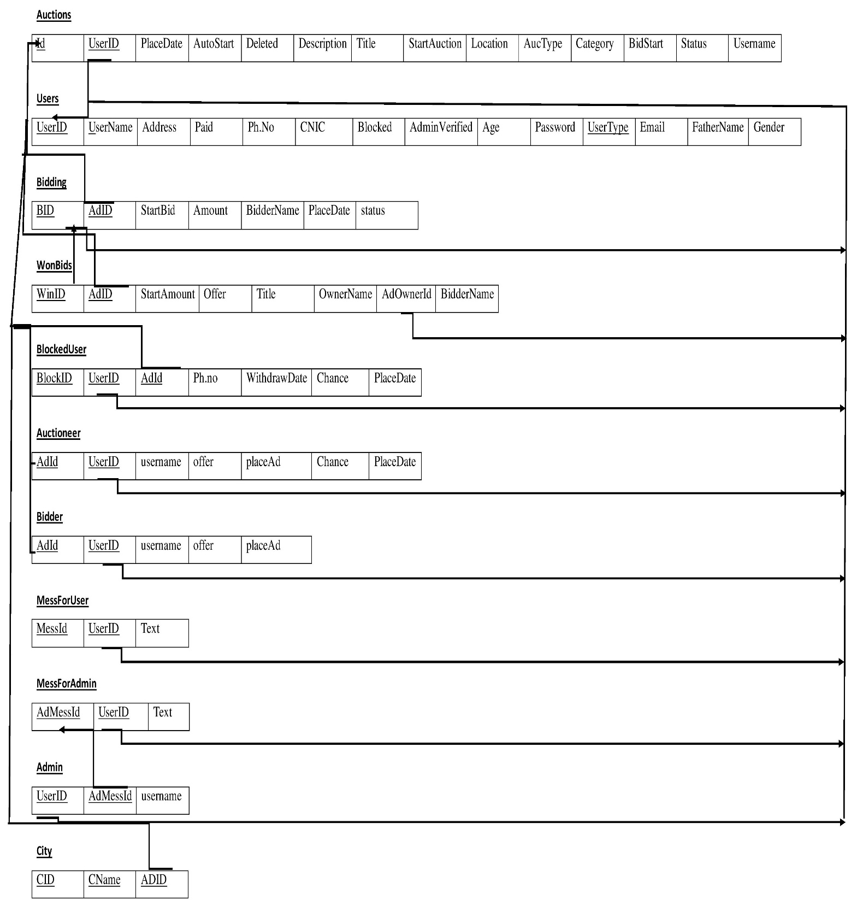

**(Relational Schema Diagram 01)**

### 5.4 Relational Schema (b)

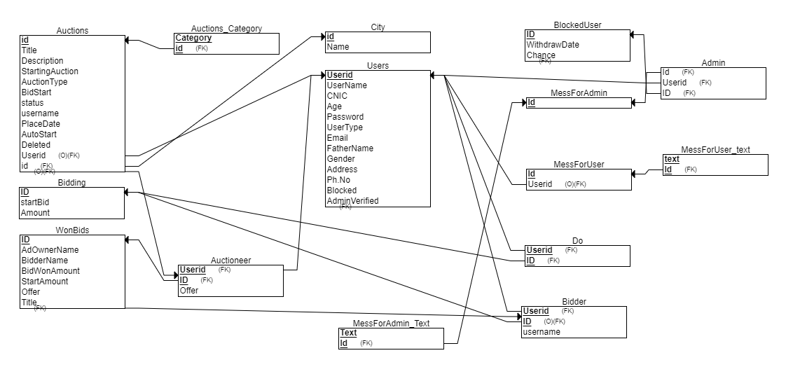

**(Relational Schema Diagram 02)**

# Chapter 13 : Conclusion

## 6.1 Conclusion:

Basically we develop a system for our organization which is unique product for our organization and solve problem with conventional auction system through online auction system. Online auction will be a type of product in which the items are sold through price bidding. Usually bidding have start price and ending time. Actual buyers in auction and the winner is the one who bids the item for highest price. For buying product online through auction first user have to provide his personal details like email address, license number, National identity number. Only the valid user will have authority to bid. This help us to prevent various hurdles and frauds happened in online shopping like managing and organizing auctions online effectively. Online Auction system provide services through internet anywhere in the world like selling and purchasing services or products and access by using your smartphones and personal computers. Easy to sell and purchase by auction and bidding in the world without having a physical location and place.

Comments of the supervisor

(This page is for office use only)

|  |
| --- |
|  |

Signature of the supervisor

This proposal duly recommend by the Undergraduate Committee of the department of the Computer Science is hereby forwarded to the HOD for approval.

HOD. Department of Computer Science